
N
N

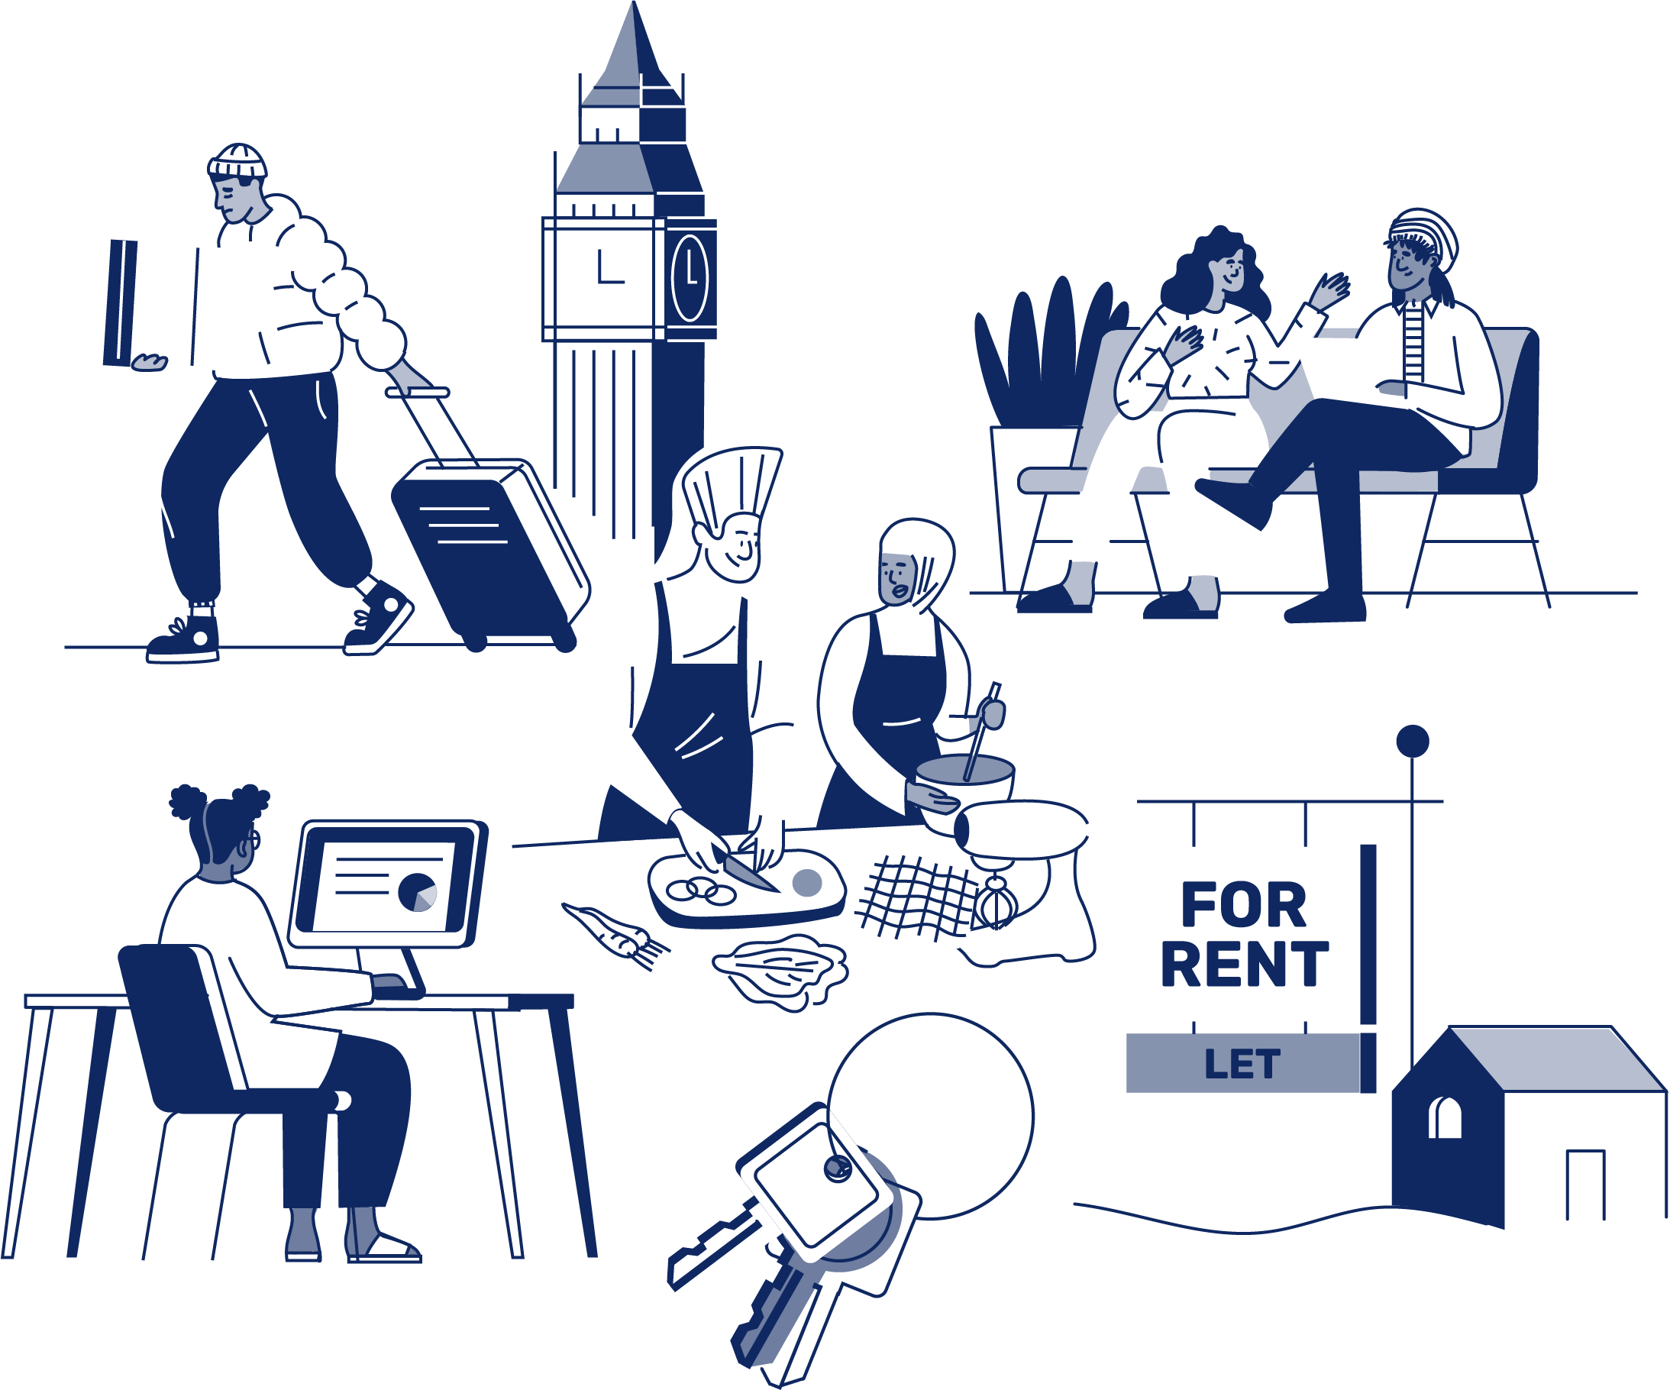
JOB APPLICATION PACK
Youth Worker (Young Women)

October 2026
OUR STORY

London is a fantastic city to call home, but a central truth remains in the capital. Every year thousands of young people find themselves unhoused, unsupported and unsafe.

That's why New Horizon Youth Centre exists.

Founded in 1967 by Lord Longford to address the needs of young people who were homeless and misusing drugs in the West End of London, today New Horizon Youth Centre continues to be a vital support network for 16–24-year-olds with nowhere else to go.

Through the services we provide at our day centre, via outreach and remotely, our multidisciplinary team of over 70 staff support thousands of young people experiencing homelessness in London to find safety, improve their wellbeing, develop skills for life and ultimately find somewhere that they can call home.

“For as long as young people are homeless
and unsafe in London, we will be on a
mission to give their potential a home”

For more info about our impact, please take a look at our latest impact report.


COMMITMENT TO EQUITY, DIVERSITY & INCLUSION

New Horizon Youth Centre is committed to recognising and valuing difference and ensuring fairness and equity; and recognising and seeking to redress inequity and disadvantage wherever possible. We have an ongoing action plan to improve our Equity, Diversity and Inclusion (EDI) practices, which every member of our organisation has a role in contributing to.

As a service provider to young people facing homelessness and who are unsafe, we aim to be an empowering, supportive employer and to offer as much flexibility as possible to help each individual realise their full potential as users of New Horizon Youth Centre and as employees. We believe that this approach is key and central to promoting and developing diversity.

We recognise that true diversity in our community and within the staff group also involves a willingness to act, where necessary, by combating the effects of existing barriers to fair and equal treatment. Within society certain groups are unfairly discriminated against – for example on the grounds of race, gender or gender identity, disability, sexuality, age and class - and are, as a result, disadvantaged in terms of their access to services and employment. We will, where appropriate and where possible, seek to positively redress the effects of this discrimination. Any action we take will be legally compliant and consistent with our approach of making young people and staff feel valued and respected.

We recognise that many people have suffered disadvantage and barriers to progress for all kinds of reasons related to them as an individual and not because of their personal characteristics such as homelessness, employment, economic or domestic circumstances, or involvement with the justice system. For this reason, our commitment to diversity includes being supportive, positive and open minded.

We encourage applications from all backgrounds in respect of ethnicity, disability, gender, sexuality, religion, and socio-economic backgrounds.

During the application process we commit to:
- Reimbursing reasonable childcare and other care costs whilst you are attending interviews.
- Reimbursing reasonable return travel costs for interviews (within London/neighbouring counties).
- Making reasonable adjustments – for example, ensuring we have a sign language interpreter organised in advance if you would like them.
- Offering a guaranteed first stage interview for disabled candidates who meet the minimum requirements for the role.

If there is anything else you are concerned about or think we could provide, please let us know.

OUR WORK IS GUIDED BY THREE VALUES:

We champion young people

We collaborate for impact

We are determined to find a way
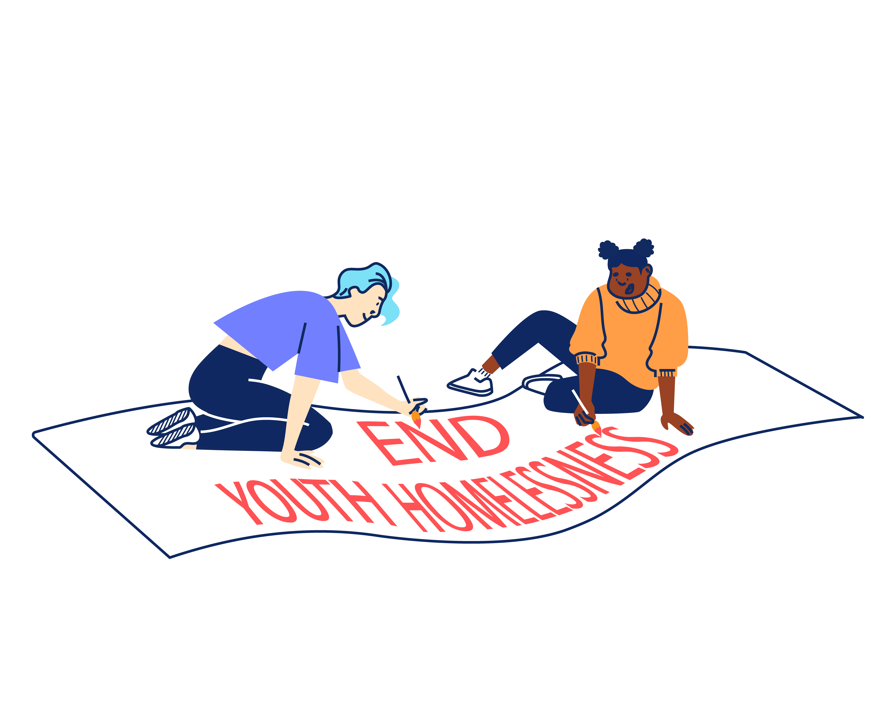

BACK TO OUR BEGINNINGS: ROOTED IN OUR PAST, FOCUSED ON OUR FUTURE – OUR STRATEGY 2025-2030

With rough sleeping at record levels and more young people fleeing violence, there's a pressing need and growing gap for a specialist emergency response that can support young people in crisis and open up housing for thousands more young people in need. ​Rather than trying to provide everything ourselves for all young people until they turn 25, we can focus on being excellent at supporting young people to get the safe homes they deserve as quickly as possible, support with life skills and living independently and helping them create a future without needing our support.
By getting back to our beginnings we will lean on our unique heritage as the only youth-specific day centre and drop-in in London and continue our long and proud history of being here for young people who find themselves homeless in the capital. ​Doing so means making some tough choices about who we cannot support and so our focus will shift to those in more immediate need, prioritising them over those we have already housed and we will be more focused at moving people on successfully. ​
We will support every young Londoner in crisis to access safety, support and stability, then transition them onto independence. We will do this by providing: Successful Services, Productive Partnerships & Confident Campaigning.
Too many young people cannot get the housing help they need.
So we deliver high quality, trauma-informed SERVICES for any young person that needs our support.
We spend 75% of our resources on this.
We spend 15% of our resources on this.
This is complex and difficult work to do.
Because the government under-invests in young people.
Because the services that should help can’t or won’t.
So we need to sustain a WELL-RUN ORGANISATION that invests in staff and celebrates the diversity that makes us a success.
So we CAMPAIGN, saying what others won’t say and doing what others won’t do to ensure that no young person misses out, even the young people we will never meet.
So we work in PARTNERSHIP to optimise our offer and maximise our impact.
We split 10% of our resources across these two areas.


“New Horizon.
It might not be your home.
They might not be your parents.
They might not be your family.
But they want you to win in this world.”

Najma, 21
JOB DESCRIPTION – Youth Worker (Women’s Worker)

Reporting to: Head of Services and Services Manager (Youth Work Team)

INTRODUCTION

New Horizon Youth Centre runs a busy day centre from Monday to Friday. Open from 10:00am – 4pm every day, we provide basic needs to young people experiencing homelessness, such as breakfast and lunch, clothes, toiletries, showers, laundry facilities and Wi-Fi.

This role is part of the NHYC Youth Work Team. The Youth Work Team plans and delivers a range of services for young people experiencing or at risk of homelessness. This includes Jobs. Education and Training, Arts, Sports, Men’s and Women’s sessions, Youth Participation and Activities.

The role is based at the centre a minimum of 3 days per week, working with young people face-to-face. During the week, you will support all young people and work alongside the youth work team, ensuring that young people can access basic needs as well as directly delivering or supporting youth work activities and life skills workshops in our day centre.

The Youth Worker (Young Women) has a specific focus supporting young women in our service experiencing multiple and complex needs. This role will specifically lead on facilitating and delivering our weekly Women’s and Non-Binary Space as well as take the lead in managing a complex casework with young women, many of whom are affected by community-based violence, homelessness, mental health and substance misuse.

We are committed to trans-inclusive, gender-affirming practice throughout our service, and our Women’s Worker will share this commitment and bring it to life in their day-to-day work with young people.

JOB OBJECTIVES

The key objectives of the post are:

- To contribute to the daily running of the day centre, delivering a holistic and trauma informed service to young people aged 16 to 24 who are facing homelessness.

- As part of the Youth Work Team, support the delivery and development of an engaging and multi-faceted life skills programme.

- To lead on delivery of services for young women at the centre, including leading and facilitating our weekly Women’s and Non-Binary Space and leading on young women’s casework.

- To maintain and develop a network of relationships with external agencies and specialists (especially those from the VAWG sector) to expand on and broaden our workshop and activities offer to young people, with a special focus on young women.

MAIN TASKS AND RESPONSIBILITIES

Young People’s Services

To support young people accessing the day centre services. This will include:

- Working within the Youth Work Team to ensure young people receive a high-quality service from the point of initial registration to move-on into accommodation and beyond.

- Planning and delivering a range of 1-1 and group work sessions which respond to the needs of diverse groups of young people, and listening to young people’s views, ideas, and feedback.

- Leading on and developing and delivering specific gender-informed workshops and services for young women who access the centre, including planning and facilitating a regular Women’s and Non-Binary Space.

- Working on a 1-1 basis with a case list of young women with multiple and complex needs, which will include completing risk assessments, goal setting, safety planning, safeguarding referrals (e.g. MARAC), refuge and specialist accommodation referrals, advocacy, identifying appropriate external referrals (e.g. health referrals, VAWG sector) and signposting.

- Developing and managing appropriate external partnerships, especially with partners in the VAWG sector, including sourcing programmes, events, referral pathways, and activities in the community which support young women.

- Completing initial registrations, conducting assessments and action plans with young people accessing the service to identify young people’s skills, needs and personal goals.

- Providing advocacy, advice and guidance, referring all young people to appropriate opportunities and specialist services.

- Ensuring the Women’s Work programme meets the standards required by external assessors and funders.

- Ensuring risk management and safeguarding procedures are followed at all times.

- Contributing to the daily running of the drop-in centre, including attending daily Handovers, and ensuring that Health and Safety issues are addressed at all times.

- Attending Reflective Practice, Staff Meetings, Youth Work Team meetings and away days.

Sharing best practice

To proactively share best practice with internal and external stakeholders to maximise the impact of the work of NHYC. This will include:

- Seeking out and responding to opportunities with specialists and agencies who might offer resources, funding, or individual services relevant to the needs of young people.

- Promoting and representing NHYC at relevant forums, meetings, and events.

Information Management

To produce and maintain accurate and useful information in a range of formats in order to promote effective service delivery and evaluation. This will include:

- Recording all contacts with young people appropriately and maintaining all relevant files and recording systems.

- Inputting and extracting information from monitoring systems, and other accounting and database systems. Utilising other software for the production of reports.

- Being self-servicing in day-to-day administration and following team and NHYC’s administrative procedures.

Reviewing Personal Performance and Development Needs

To be proactive in reviewing and evaluating own performance and identifying and acting upon areas for improvement. This will include:

- Continuously reviewing own working practices in line with young people feedback and current best practice.

- Reviewing and evaluating own performance to identify strengths and areas for development. Identifying own learning/development needs and opportunities.
Other

To contribute positively and constructively to the development of the team, the service, and the Centre. This will include:

- Covering for other members of the team as necessary.

- Following NHYC’s policies, procedures, and performance expectations in all functions of the post.

- Undertaking, as required, any other duties compatible with the level and nature of the post and/or reasonably required by the Leadership Team.

PERSON SPECIFICATION

We are looking for an individual who can demonstrate the following competencies and want to use these to the full in their work.

ESSENTIAL EXPERIENCE, SKILLS AND KNOWLEDGE

- Experience working with young people and/or young women in a relevant setting.

- Ability to work effectively with young people facing homelessness, or a similar vulnerable group, to identify personal goals, overcome barriers and support to find solutions.

- Experience planning and facilitating engaging sessions with young people on both a 1-1 and group basis, which support young people to develop confidence, self-awareness, experience new opportunities and have fun.

- Experience of managing a caseload of young people experiencing multiple disadvantages, including maintaining and updating records, safety planning, completing risk assessments, creating action plans, and making relevant referrals to services.

- A good working knowledge and understanding of the Violence Against Women and Girls (VAWG) sector, gender-based services, and pathways/referrals which support women.

- An understanding of the kinds of behaviour young people, and especially young women, might demonstrate. Ability to understand this behaviour in a trauma-informed way and developing strategies for managing behaviour.

- Experience creating and maintaining external partnerships to achieve organisational aims and objectives.

- The ability to multitask in a pressured environment.

- A working knowledge of and commitment to Equity, Diversity and Inclusion.

- Experience and knowledge around safeguarding policy and procedures for children and adults.

- Experience of using IT systems (including knowledge of databases) to support the achievement of personal and collective work goals.

DESIRABLE EXPERIENCE, SKILLS AND KNOWLEDGE

- A specific youth work qualification or IDVA qualification.

- An understanding of the issues, barriers, and challenges which young people experiencing homelessness might be facing, especially at the point of accessing help and support.

- Demonstrable experience working effectively and communicating with groups of people from a range of backgrounds and with diverse experiences and language levels.

- Up-to date working knowledge of Local and National Government policies relating to employment, education, benefits, housing, healthcare, sexual health, and young people.

- Knowledge or experience working to performance indicators, including monitoring and reporting on service outputs/outcomes, tracking, analysing performance information, and identifying corrective action.

ADDITIONAL REQUIREMENTS

- Willingness and ability to work outside of normal office hours on occasion (within New Horizon’s flexible working hour’s arrangements) and over the Christmas period.

- Willingness to work flexibly in response to changing organisational requirements.

- Willingness to work from different sites including our day centre in Camden.

ADDITIONAL INFORMATION

Location:

The post is based at: New Horizon Youth Centre, 68 Chalton Street, London, NW1 1JR.

Contract:

The contract is ongoing, subject to successful completion of a probationary period.

Hours of work:

The post holder will be required to work 35 hours per week, Monday-Friday. Some work over the Christmas period will be required.

Pay:

The starting salary for role is: £32,136.00.

The salary scale is: AP26 – AP30 (£32,136.00-£35,778.00)

Other benefits:

- 30 days annual leave per year (pro rata), plus bank holidays and some additional time off over Christmas
- Employer contribution of 6% to a group personal pension scheme
- Enhanced Employee Assistance Programme, including 24-hour helpline, access to counselling, contributions towards medical expenses, discounted gym memberships, high street vouchers and more
- Clinical Supervision and Reflective Practice
- Staff Loan Policy, including Cycle to Work scheme
- Generous Training budget and a Diversity Leadership Programme
- Regular Staff Away Days and teambuilding activities

TIMESCALES AND HOW TO APPLY

The timescales for recruitment are as follows:

Closing date and time for applications | 9am, Monday 9th November 2026
Shortlisted candidates will be informed | Friday 13th November
Interviews | Wednesday 18th November

If you wish to apply for this position, you will need to supply:

- A CV setting out your career history, education or qualifications, and other key responsibilities or achievements (2 sides of A4). Please do not include your name, initials, contact details or references in the CV and the file name.

- A supporting statement (1500 words or up to 2 sides of A4) highlighting your suitability for the role and how you meet the criteria listed on the Person Specification. Please do not include your name, contact details or address.

The supporting statement is an essential part of your application and will be assessed for shortlisting purposes.

- Completed diversity and adjustment questions – Your data will be stored separately from your application and will at no time be connected to you or your application by the shortlisting panel.

To apply, visit our careers site: https://jobs.nhyouthcentre.org.uk

We do not consider incomplete applications.

You will be notified if you have not been shortlisted. However, we are unfortunately unable to provide each individual application with feedback.

If you have any questions or would like to arrange a call to discuss the role, please feel free to email us at recruitment@nhyouthcentre.org.uk or call 0207 388 5560.

nhyouthcentre.org.uk
@nhyouthcentre

Charity number: 276943
Company number: 01393561
Giving potential a home since 1967

