
N
N

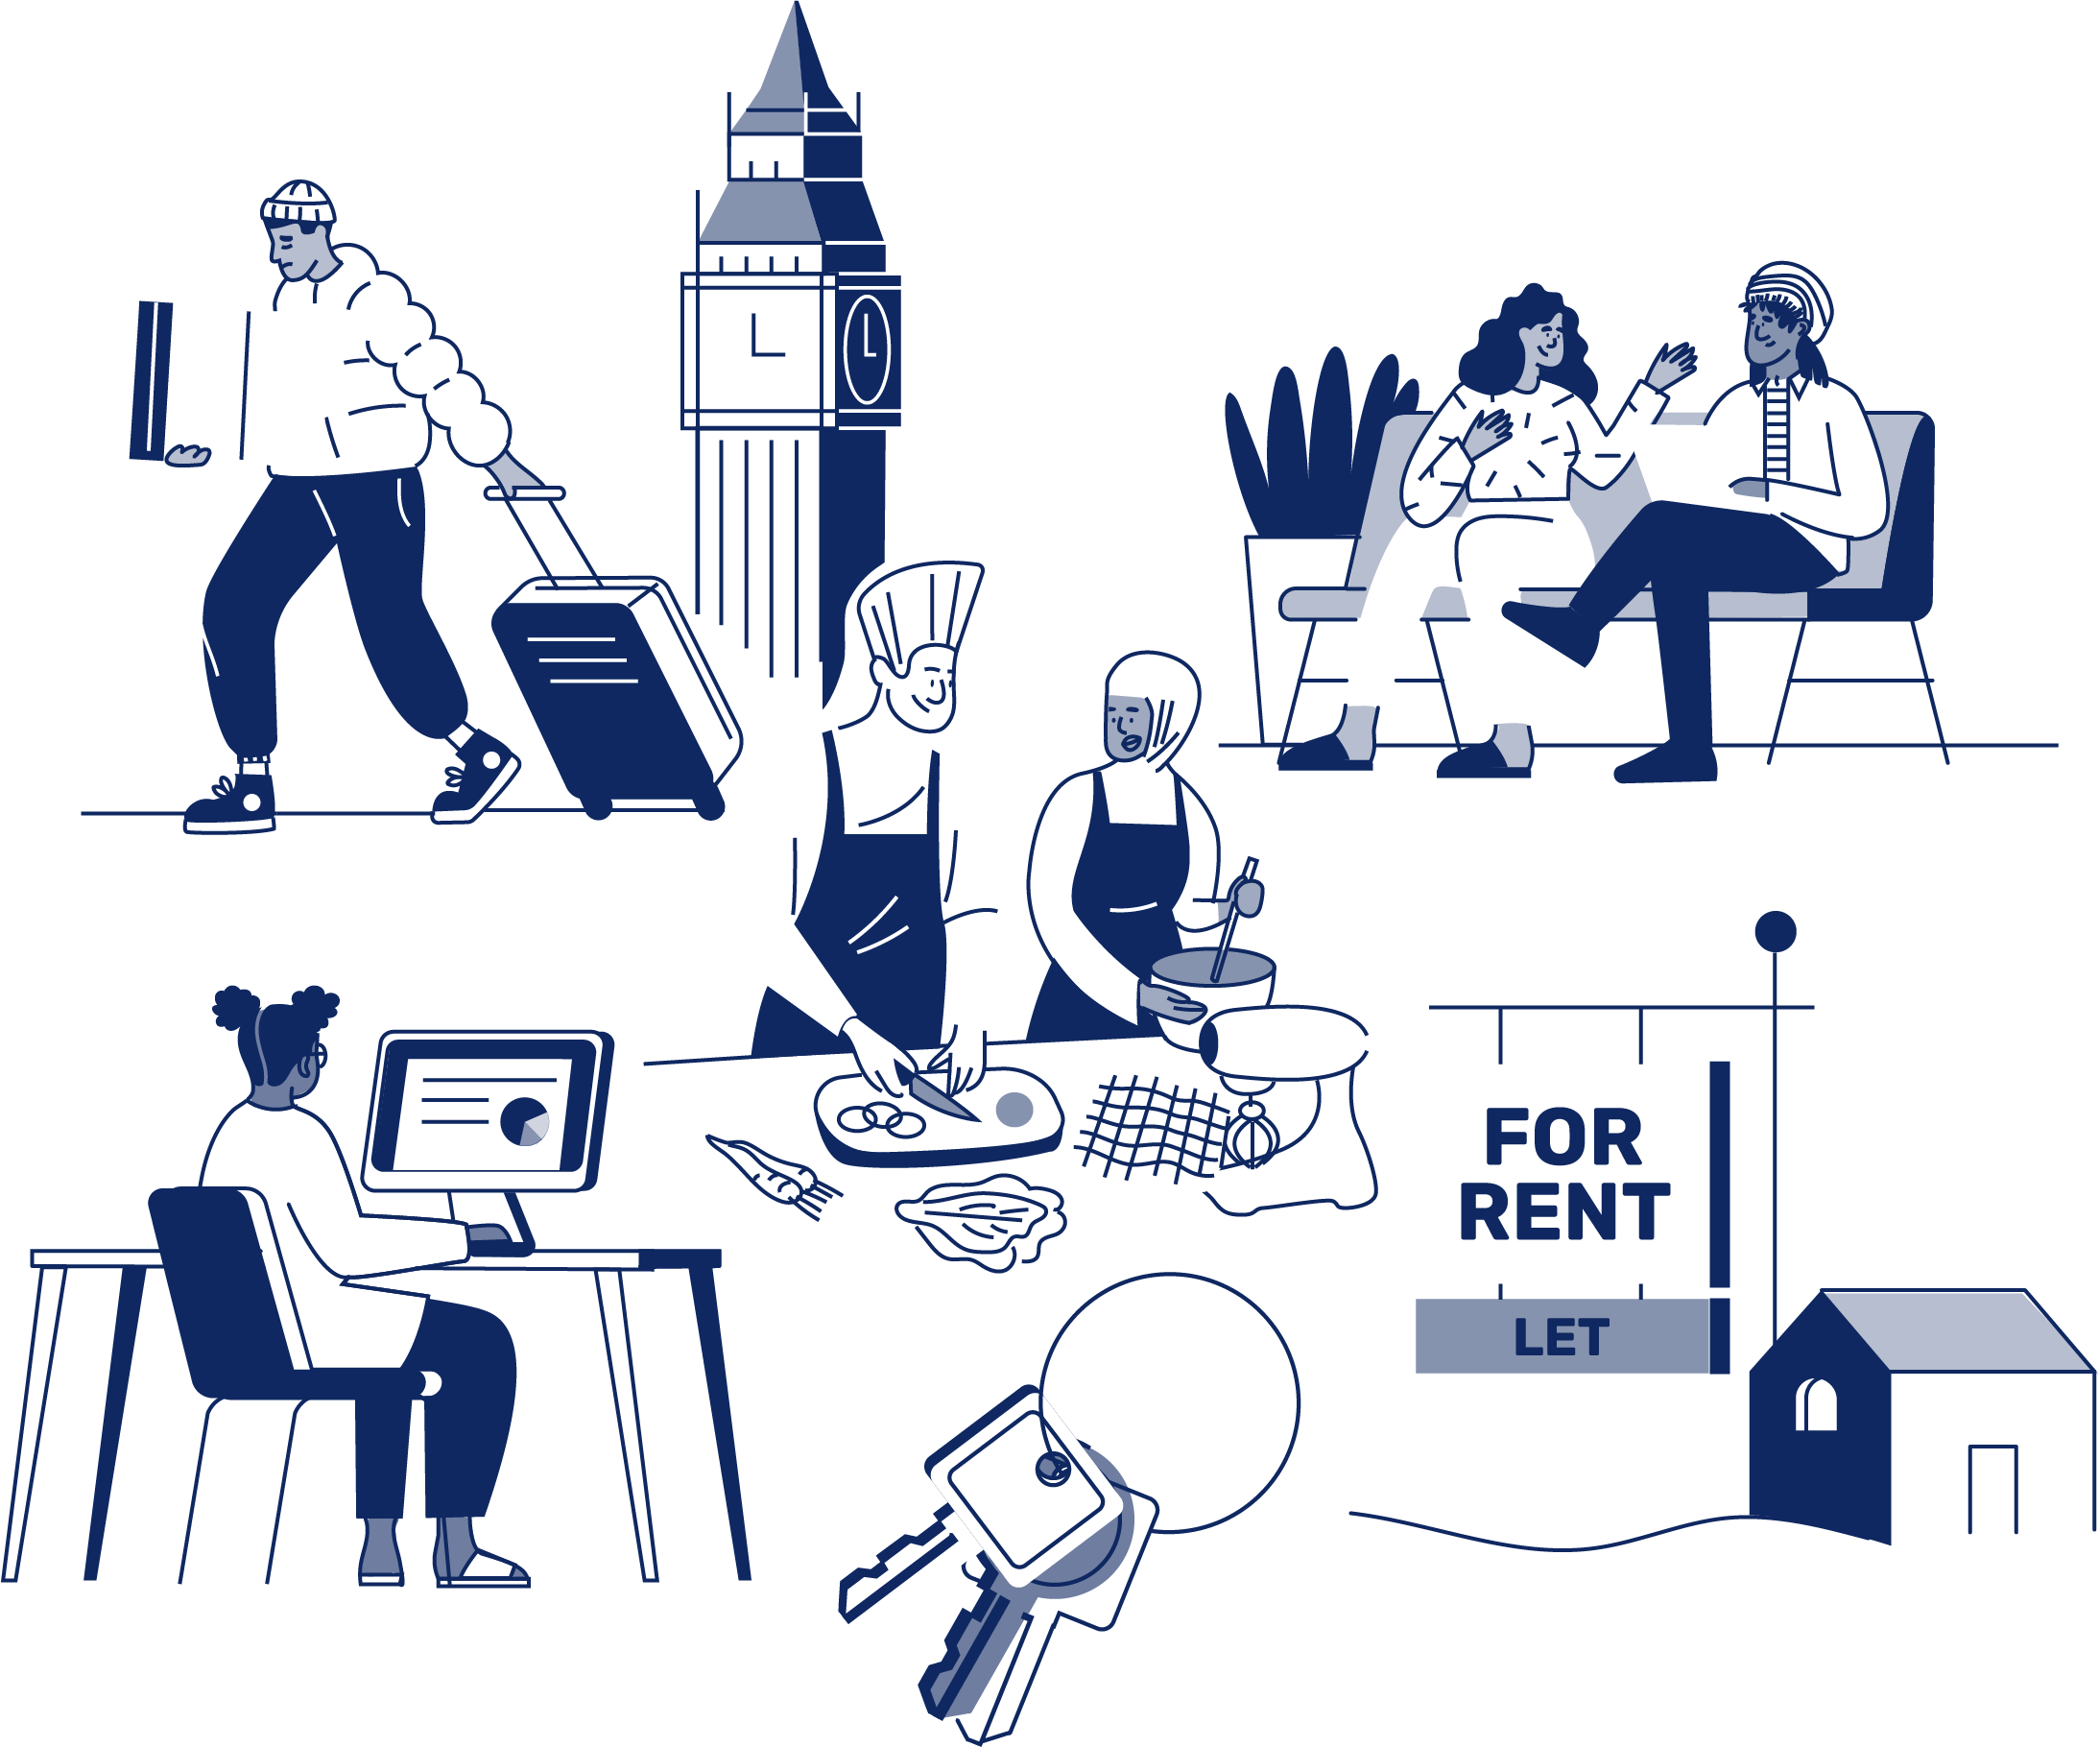
JOB APPLICATION PACK
Outreach Worker (fixed-term)

August 2026
OUR STORY

London is a fantastic city to call home, but a central truth remains in the capital. Every year thousands of young people find themselves unhoused, unsupported and unsafe.

That's why New Horizon Youth Centre exists.

Founded in 1967 by Lord Longford to address the needs of young people who were homeless and misusing drugs in the West End of London, today New Horizon Youth Centre continues to be a vital support network for 16–24-year-olds with nowhere else to go.

Through the services we provide at our day centre, via outreach and remotely, our multidisciplinary team of over 70 staff support thousands of young people experiencing homelessness in London to find safety, improve their wellbeing, develop skills for life and ultimately find somewhere that they can call home.

“For as long as young people are homeless
and unsafe in London, we will be on a
mission to give their potential a home”

For more info about our impact, please take a look at our latest impact report.


COMMITMENT TO EQUITY, DIVERSITY & INCLUSION

New Horizon Youth Centre is committed to recognising and valuing difference and ensuring fairness and equity; and recognising and seeking to redress inequity and disadvantage wherever possible. We have an ongoing action plan to improve our Equity, Diversity and Inclusion (EDI) practices, which every member of our organisation has a role in contributing to.

As a service provider to young people facing homelessness and who are unsafe, we aim to be an empowering, supportive employer and to offer as much flexibility as possible to help each individual realise their full potential as users of New Horizon Youth Centre and as employees. We believe that this approach is key and central to promoting and developing diversity.

We recognise that true diversity in our community and within the staff group also involves a willingness to act, where necessary, by combating the effects of existing barriers to fair and equal treatment. Within society certain groups are unfairly discriminated against – for example on the grounds of race, gender or gender identity, disability, sexuality, age and class - and are, as a result, disadvantaged in terms of their access to services and employment. We will, where appropriate and where possible, seek to positively redress the effects of this discrimination. Any action we take will be legally compliant and consistent with our approach of making young people and staff feel valued and respected.

We recognise that many people have suffered disadvantage and barriers to progress for all kinds of reasons related to them as an individual and not because of their personal characteristics such as homelessness, employment, economic or domestic circumstances, or involvement with the justice system. For this reason, our commitment to diversity includes being supportive, positive and open minded.

We encourage applications from all backgrounds in respect of ethnicity, disability, gender, sexuality, religion, and socio-economic backgrounds.

During the application process we commit to:
- Reimbursing reasonable childcare and other care costs whilst you are attending interviews.
- Reimbursing reasonable return travel costs for interviews (within London/neighbouring counties).
- Making reasonable adjustments – for example, ensuring we have a sign language interpreter organised in advance if you would like them.
- Offering a guaranteed first stage interview for disabled candidates who meet the minimum requirements for the role.

If there is anything else you are concerned about or think we could provide, please let us know.

OUR WORK IS GUIDED BY THREE VALUES:

We champion young people

We collaborate for impact

We are determined to find a way
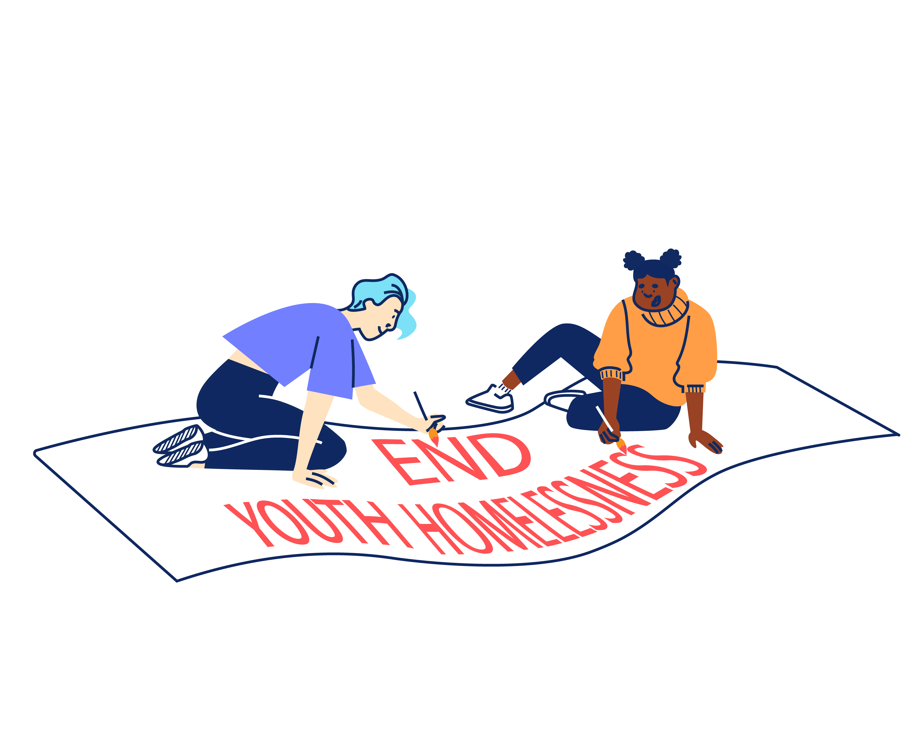

BACK TO OUR BEGINNINGS: ROOTED IN OUR PAST, FOCUSED ON OUR FUTURE – OUR STRATEGY 2025-2030

With rough sleeping at record levels and more young people fleeing violence, there's a pressing need and growing gap for a specialist emergency response that can support young people in crisis and open up housing for thousands more young people in need. ​Rather than trying to provide everything ourselves for all young people until they turn 25, we can focus on being excellent at supporting young people to get the safe homes they deserve as quickly as possible, support with life skills and living independently and helping them create a future without needing our support.
By getting back to our beginnings we will lean on our unique heritage as the only youth-specific day centre and drop-in in London and continue our long and proud history of being here for young people who find themselves homeless in the capital. ​Doing so means making some tough choices about who we cannot support and so our focus will shift to those in more immediate need, prioritising them over those we have already housed and we will be more focused at moving people on successfully. ​
We will support every young Londoner in crisis to access safety, support and stability, then transition them onto independence. We will do this by providing: Successful Services, Productive Partnerships & Confident Campaigning.
Too many young people cannot get the housing help they need.
So we deliver high quality, trauma-informed SERVICES for any young person that needs our support.
We spend 75% of our resources on this.
We spend 15% of our resources on this.
This is complex and difficult work to do.
Because the government under-invests in young people.
Because the services that should help can’t or won’t.
So we need to sustain a WELL-RUN ORGANISATION that invests in staff and celebrates the diversity that makes us a success.
So we CAMPAIGN, saying what others won’t say and doing what others won’t do to ensure that no young person misses out, even the young people we will never meet.
So we work in PARTNERSHIP to optimise our offer and maximise our impact.
We split 10% of our resources across these two areas.


“New Horizon.
It might not be your home.
They might not be your parents.
They might not be your family.
But they want you to win in this world.”

Najma, 21
JOB DESCRIPTION – OUTREACH WORKER (fixed-term)

Reporting to: Head of Services – Rough Sleeping and Services Manager (Outreach)

ROLE OVERVIEW

In addition to the 50+ young people we see every day out our centre, New Horizon’s Outreach service also works with young people on the streets and in the community. The team works pan London to deliver a youth-specific outreach service to young people currently or at risk of rough sleeping. We use our extensive housing expertise to place those young people into accommodation that is appropriate and safe, whilst encouraging them to access the day centre to benefit from the wide range of services we offer.

Please note, the role includes twice weekly street-based outreach shifts, including a requirement for very early mornings (from 5am) and late evenings (until 1am).

ROLE OBJECTIVES

The key objectives of the post are:

- To contribute to the delivery of the NHYC street outreach service, delivering a holistic service to young people who are street homeless, enabling them to move on to independence.
- To build and maintain a network of external partnerships with services supporting those impacted by rough sleeping.
- To enable delivery of a trauma-informed service to young people.
- To support delivery of NHYC’s rough sleeping prevention strategy and best practice youth-specific outreach services.

MAIN TASKS AND RESPONSIBILITIES

Young People Services

Providing comprehensive support through 1-1 and small group work with young people sleeping rough. This will include:

- Working within the Rough Sleeping team to ensure young people receive a high-quality service from the point of registration to move-on.

- Carrying out at least two street-based outreach shifts each week (early morning and late evening required).

- Carrying out housing assessments with young people and referring them into appropriate accommodation.

- Managing a transitional case load of young people and helping them move forward and access appropriate services.

- Working in partnership with the Outreach Team and other external teams, such as commissioned street outreach services, mental health, and substance misuse services.

- Providing expert coaching and guidance to young people and monitoring and evaluating their progress.

- Continued use of feedback and showing a commitment to a service that is sensitive and responsive to young people’s needs, including:
- Completing registrations, outcomes assessments, risk assessments and action plans with young people.
- Ensuring that all relevant work is recorded on the New Horizon database system and Chain database.
- Ensuring risk management and assessment procedures are followed.
- Delivering advocacy and referrals to appropriate services, including making internal referrals

- Contributing to the management and development of the team and day centre, including attending daily handovers, ensuring that Health and Safety issues are addressed at all times, attending Reflective Practice and team meetings.

- Taking a hands-on approach to working with young people

- Participating in the training and supervision of new staff, volunteers, students and locum workers and actively promoting a learning and development environment.

Networking and Liaison

To proactively liaise, communicate and negotiate with internal specialists and external agencies. This will include:

- Seeking out and responding to opportunities with external partners who might offer resources, funding, or individual services relevant to young people’s needs e.g, Local Authorities, Social Services, Community Psychiatric Services, DWP, drugs and alcohol support, and other voluntary agencies.

- Promoting and representing New Horizon Youth Centre at relevant forums and meetings.

Information Management

To produce and maintain accurate and useful information in a range of formats in order to promote effective service delivery and evaluation. This will include:

- Producing written reports to meet the requirements of team managers, service providers and funders.

- Inputting and extracting information from client monitoring systems and other database systems.

- Being self-servicing in day-to-day administration and following team and New Horizon’s administrative procedures.

Reviewing Personal Performance and Development Needs

To be proactive in reviewing and evaluating own performance and identifying and acting upon areas for improvement. This will include:

- Continuously reviewing own working practices in line with feedback and current best practice.

- Taking a proactive approach to supervision and attending clinical supervision, weekly team meetings as well as line management supervision every 4-6 weeks.

- Reviewing and evaluating own performance to identify strengths and areas for development.

- Undertaking development and training opportunities and being responsible for obtaining maximum benefit through review, reflection, and practice.

Other

To contribute positively and constructively to the development of the team, the service, and the Centre. This will include:

- Covering for other members of the team, as necessary.

- Following New Horizon’s policies, procedures, and performance expectations in all functions of the post.

- Undertaking, as required, any other duties compatible with the level and nature of the post and/or reasonably required by the Services Managers, Head of Services, or Leadership Team.

PERSON SPECIFICATION

We are looking for an individual who can demonstrate the following competencies and want to use these to the full in their work.

ESSENTIAL EXPERIENCE, SKILLS AND KNOWLEDGE

- Ability to work effectively with young people facing homelessness to identify personal goals and support mechanisms needed for change. (E)

- The skills, ability and confidence to carry out street outreach shifts at least twice weekly, including late evenings and early morning shifts across London. (E)

- Experience of creating and delivering work both 1-1 and in groups which meet the needs of young people. (E)

- Experience of using IT systems (including knowledge CHAIN and other databases) to support the achievement of personal and collective work goals (E)

- The ability to multitask in a pressured environment. (E)

- Ability to build and maintain effective working relationships with a diverse range of internal stakeholders and external agencies. (E)

- Ability to maintain enthusiasm for a high level of contact with young people on a day-to-day basis and a genuine interest, passion and commitment to help young people to access opportunities leading to independence (E)

- Ability to hold and manage a transitional case load of young people with multiple complex needs, supporting them into accommodation outcomes and linking them in with specialist support services. (E)

- Understanding of the kinds of challenging behaviour that young people might demonstrate and ability to deliver strategies for dealing with such behaviour. (E)

- A high level of knowledge of health and safety issues in a working environment with particular attention to the context of street-based outreach. (E)

- Experience and knowledge around safeguarding policy and procedures for children and young people (E)

- A working knowledge of and commitment to Equity, Diversity and Inclusion as it applies to a supportive service and in the workplace (E)

- Willingness and ability to work outside of normal office hours, AM outreach shifts can start at 5am and evening shifts can finish at 1am (within New Horizon’s flexible working hour’s arrangements) and over the Christmas period (E)

- Willingness to work flexibly in response to changing organisational requirements (E)

- Willingness to travel across London for street outreach shifts and partnership building. (E)

DESIRABLE EXPERIENCE, SKILLS AND KNOWLEDGE

- Thorough and up-to-date working knowledge of:

- Local and National Government policies and procedures in relation to the client group (D)
- Relevant organisations and their role/responsibilities in providing support to vulnerable young people (D)

- Knowledge of the CHAIN database and street-based outreach services. (D)

- Knowledge of housing options for young people sleeping rough. (D)

- Ability to create and maintain external partnerships to support organisational aims and objectives including representation of the organisation at external meetings and events (D)

- Knowledge of working to performance indicators, including monitoring and reporting on service outputs/outcomes, client tracking, analysing performance information, and identifying corrective action (D)

ADDITIONAL INFORMATION

Location:

The post is based at: New Horizon Youth Centre, 68 Chalton Street, London, NW1 1JR and requires travel across London to deliver outreach services in the community.

Contract:

The post is fixed-term for 12 months, subject to successful completion of a probationary period.

Hours of work:

The post holder will be required to work 35 hours per week, Monday-Friday. There is a requirement to carry out at least two street-based outreach shifts per week. Morning shifts may start from 5am and evening shifts may finish at 1am.

Pay:

The starting salary for role is: £32,136.00 (pro-rata).

The salary scale is: AP26 – AP30 (£32,136.00-£35,778.00).

Other benefits:

- 30 days annual leave per year (pro rata), plus bank holidays and some additional time off over Christmas
- Employer contribution of 6% to a group personal pension scheme
- Enhanced Employee Assistance Programme, including 24-hour helpline, access to counselling, contributions towards medical expenses, discounted gym memberships, high street vouchers and more
- Clinical Supervision and Reflective Practice
- Staff Loan Policy, including Cycle to Work scheme
- Generous Training budget and a Diversity Leadership Programme
- Regular Staff Away Days and teambuilding activities

TIMESCALES AND HOW TO APPLY

The timescales for recruitment are as follows:

Closing date and time for applications | 9am on Monday 26th October 2026
Shortlisted candidates will be informed | 28th October 2026
Interviews | Tuesday 3rd November 2026

If you wish to apply for this position, you will need to supply:

- A CV setting out your career history, education or qualifications, and other key responsibilities or achievements (2 sides of A4). Please do not include your name, initials, contact details or references in the CV and the file name.

- A supporting statement (1500 words or up to 2 sides of A4) highlighting your suitability for the role and how you meet the criteria listed on the Person Specification. Please do not include your name, contact details or address.

The supporting statement is an essential part of your application and will be assessed for shortlisting purposes.

- Completed diversity and adjustment questions – Your data will be stored separately from your application and will at no time be connected to you or your application by the shortlisting panel.

To apply, visit our careers site: https://jobs.nhyouthcentre.org.uk

We do not consider incomplete applications.

You will be notified if you have not been shortlisted. However, we are unfortunately unable to provide each individual application with feedback.

If you have any questions or would like to arrange a call to discuss the role, please feel free to email us at recruitment@nhyouthcentre.org.uk or call 0207 388 5560.

nhyouthcentre.org.uk
@nhyouthcentre

Charity number: 276943
Company number: 01393561
Giving potential a home since 1967

