
N
N

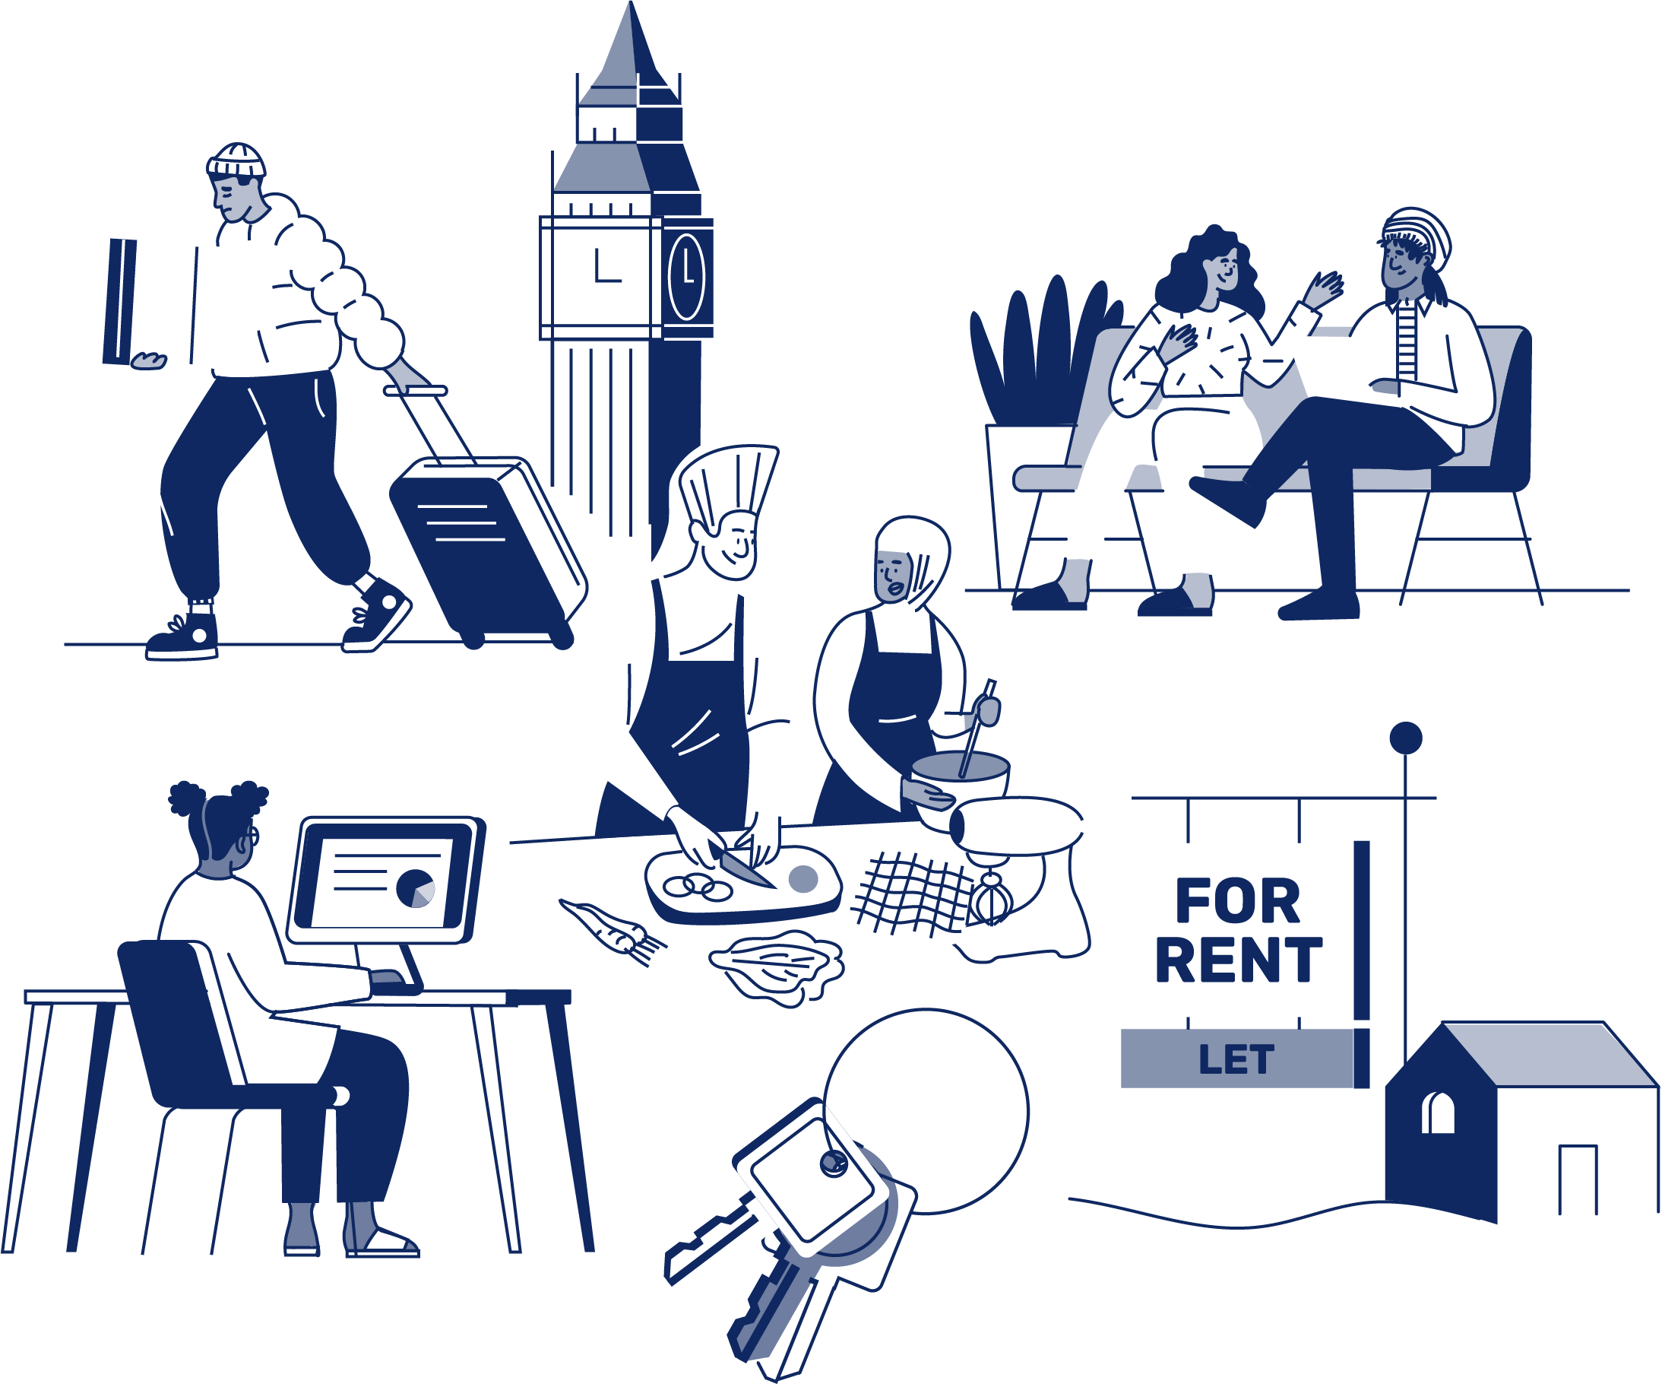
JOB APPLICATION PACK
London Youth Gateway Programme Manager

August 2026
OUR STORY

London is a fantastic city to call home, but a central truth remains in the capital. Every year thousands of young people find themselves unhoused, unsupported and unsafe. That's why New Horizon Youth Centre exists.

Founded in 1967 to address the needs of young people who were homeless and misusing drugs in the West End of London, today New Horizon Youth Centre continues to be a vital support network for 16–24-year-olds with nowhere else to go.

Through the services we provide at our day centre, via outreach and remotely, our multidisciplinary team of over 60 staff support thousands of young people experiencing homelessness in London to find safety, improve their wellbeing, develop skills for life and ultimately find somewhere that they can call home.

“For as long as young people are homeless
and unsafe in London, we will be on a
mission to give their potential a home”

For more info about our impact, please take a look at our latest impact report.



COMMITMENT TO EQUITY, DIVERSITY & INCLUSION

New Horizon Youth Centre is committed to recognising and valuing difference and ensuring fairness and equity; and recognising and seeking to redress inequity and disadvantage wherever possible. We have an ongoing action plan to improve our Equity, Diversity and Inclusion (EDI) practices, which every member of our organisation has a role in contributing to.

As a service provider to young people facing homelessness and who are unsafe, we aim to be an empowering, supportive employer and to offer as much flexibility as possible to help each individual realise their full potential as users of New Horizon Youth Centre and as employees. We believe that this approach is key and central to promoting and developing diversity.

We recognise that true diversity in our community and within the staff group also involves a willingness to act, where necessary, by combating the effects of existing barriers to fair and equal treatment. Within society certain groups are unfairly discriminated against – for example on the grounds of race, gender or gender identity, disability, sexuality, age and class - and are, as a result, disadvantaged in terms of their access to services and employment. We will, where appropriate and where possible, seek to positively redress the effects of this discrimination. Any action we take will be legally compliant and consistent with our approach of making young people and staff feel valued and respected.

We recognise that many people have suffered disadvantage and barriers to progress for all kinds of reasons related to them as an individual and not because of their personal characteristics such as homelessness, employment, economic or domestic circumstances, or involvement with the justice system. For this reason, our commitment to diversity includes being supportive, positive and open minded.

We encourage applications from all backgrounds in respect of ethnicity, disability, gender, sexuality, religion, and socio-economic backgrounds.

During the application process we commit to:
- Reimbursing reasonable childcare and other care costs whilst you are attending interviews.
- Reimbursing reasonable return travel costs for interviews (within London/neighbouring counties).
- Making reasonable adjustments – for example, ensuring we have a sign language interpreter organised in advance if you would like them.
- Offering a guaranteed first stage interview for disabled candidates who meet the minimum requirements for the role.

If there is anything else you are concerned about or think we could provide, please let us know.
OUR WORK IS GUIDED BY THREE VALUES:

We champion young people

We collaborate for impact

We are determined to find a way
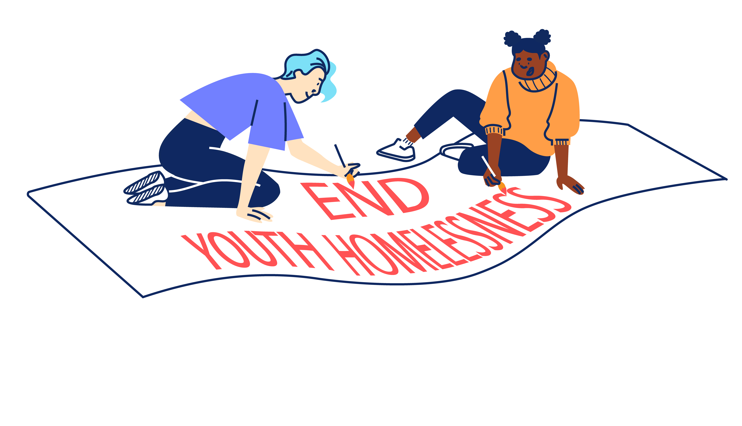

BACK TO OUR BEGINNINGS: ROOTED IN OUR PAST, FOCUSED ON OUR FUTURE – Our Strategy 2025-2030

With rough sleeping at record levels and more young people fleeing violence, there's a pressing need and growing gap for a specialist emergency response that can support young people in crisis and open up housing for thousands more young people in need. ​Rather than trying to provide everything ourselves for all young people until they turn 25, we can focus on being excellent at supporting young people to get the safe homes they deserve as quickly as possible, support with life skills and living independently and helping them create a future without needing our support.
By getting back to our beginnings we will lean on our unique heritage as the only youth-specific day centre and drop-in in London and continue our long and proud history of being here for young people who find themselves homeless in the capital. ​Doing so means making some tough choices about who we cannot support and so our focus will shift to those in more immediate need, prioritising them over those we have already housed and we will be more focused at moving people on successfully. ​
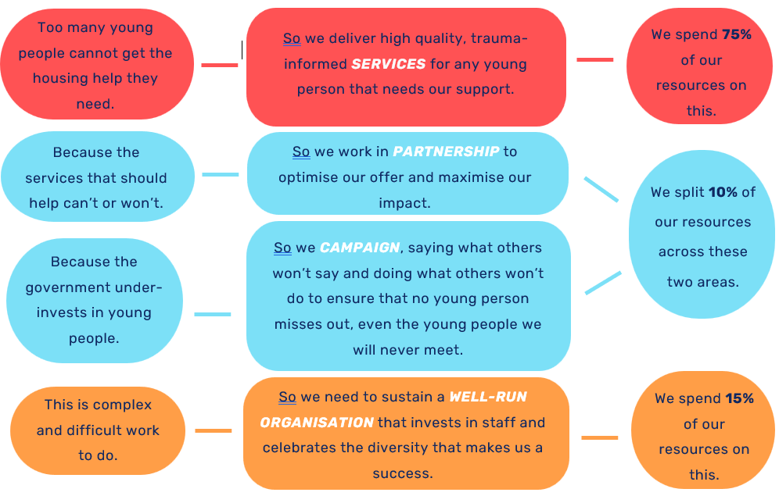
We will support every young Londoner in crisis to access safety, support and stability, then transition them onto independence. We will do this by providing: Successful Services, Productive Partnerships & Confident Campaigning.
JOB DESCRIPTION – London Youth Gateway Programme Manager
Reporting to: Head of Policy, Impact & Partnerships

Role Overview
Every year we support thousands of young people who are facing homelessness or are unsafe in London at our centre, through our outreach work and remotely. We also have a proud history of championing the most vulnerable young people in the capital. We know that no organisation can tackle this alone, so we make sure we are a trusted partner with a strong track record of collaborating across the public, private and beyond profit sectors, known for putting young people first but also not being afraid to ‘put grit in the system’. With collaboration as one of our core values, partnership is a key objective in our strategy. This role plays an essential part in this by supporting our work with statutory and voluntary sector partners, local authorities, and pan-London stakeholders.

You will lead and coordinate our historic pan-London partnership, the London Youth Gateway (LYG) alongside Depaul UK, Centrepoint, Praxis, Akt, Stonewall Housing, Settle, Coram Voice and Greater Change. Our mission is to make sure young Londoners bounce back quickly and safely in times of crisis and to prevent or solve their homelessness for good. You will be playing the pivotal role in helping to shape the partnership in its current grant cycle and beyond, its collaborative processes as well as its connections with each of the London local authorities. This is a brilliant development opportunity and the chance to deliver innovative practice across London and demonstrate your project management skills.

This is a key role in our organisation, and we are looking for someone with demonstrable experience in partnership and stakeholder engagement who knows how to get and keep people on board to meet mutual or differing needs. The ideal candidate will be an effective communicator and influencer, with a strong eye for detail and an absolute commitment to our mission. Other traits that would make you successful in this role include pragmatism, diplomacy, negotiation skills, and skill with managing competing needs of partner organisations to align with overall strategic objective - to prevent and respond to growing youth homelessness in London.

You will be able to facilitate multi-agency meetings and collaboration, hold responsibility for regular reporting to the grant maker to demonstrate the achievements of the programme each quarter, and contribute to our broader policy and influencing work. We have big ambitions for an organisation our size, so we are on the look-out for someone who can work at their own initiative, support our different teams, and is not afraid to get hand-on with administrative tasks, while tuning into partner priorities and sniffing out great opportunities to connect. This role has a lot of ownership and independence and is a brilliant development opportunity for someone who wants to build their skills and profile across the youth and homelessness sectors.

Job Objectives

- Manage and coordinate our London Youth Gateway partnership, enabling strong cross agency collaboration and external profiling.
- Support our engagement work with delivery, local authority and strategic partners across London and nationally.
- Support our wider policy and influencing work through your collaboration with our partners

Main Tasks and Responsibilities

- Partnership Management & Programme Delivery:

- Lead the end-to-end coordination of the London Youth Gateway (LYG) partnership, including planning, design, delivery, and evaluation, ensuring alignment with contractual obligations and high-quality service standards.
- Develop and oversee the annual partnership delivery plan, using SMART objectives to track progress and achieve targets.
- Maintain robust referral and triage processes for young people experiencing homelessness, ensuring scalability and efficiency across the partnership.
- Lead on ongoing mapping and design of LYG 2026-2030 programme; including service improvement, staff training and Central Point of Access referral flows to ensure equitable access.

- Stakeholder Engagement & Collaboration:

- Host quarterly Steering Group meetings (Senior Leadership) and Service Leads meetings (Operational Managers) to drive cohesive planning, risk management, and strategic decision-making.
- Strengthen cross-organisational communication, fostering a culture of best practice sharing and continuous learning.
- Deliver continual pan-London borough engagement activities to enhance LYG’s reputation with statutory, voluntary, and community partners.
- Support New Horizon teams in cultivating relationships with key stakeholders to enhance service promotion, collaboration, and best practice sharing.
- Continuously review and improve the effectiveness and reach of stakeholder engagement initiatives, ensuring maximum impact.
- Maintain LYG website and social media channels to promote the partnership.

- Performance Monitoring & Reporting:

- Work closely with frontline teams to effectively record and demonstrate impact using CRM/Salesforce systems for accurate data collection.
- Work closely with the Data & Impact Manager to ensure young people’s self-reported outcomes are accurately collected across the partnership.
- Produce detailed quarterly and annual reports for funders, highlighting progress against targets, key trends, and insights to inform strategic decision-making.
- Understand how funded outputs and outcomes are achieved, and how to use data to continuously improve quality of service delivery.
- Present partnership findings and quarterly performance scores to NHYC senior leadership and Trustees, as and when required.
- Conduct audit and evaluation of CRM databases as/when required.
- Monitor and report on budget management and performance, ensuring effective financial oversight of the programme.

- Continuous Improvement & Risk Management:
- Identify and escalate risks, challenges, and opportunities to senior leadership.

- Supporting our wider policy and influencing work.
- In collaboration with the wider Campaigns, Impact & Partnership team, identify key policy asks from your work with our partners.
- Promote and represent our work externally in various settings across a complex network, including senior stakeholders from local authorities, statutory agencies, pan-London organisations, homelessness forums, and the voluntary sector.
- Directly and indirectly work with the young people we support to help to amplify their voices, and make sure they feel safe and are being represented fairly and ethically in all our partnership engagement activities.

Other Responsibilities
- Be proactive in reviewing your own performance and identifying and act upon areas for improvement.
- Identify and undertake development opportunities and be responsible for obtaining maximum benefit through review, reflection and practice.
- Contribute constructively to the development of the team, the service and the organisation.
- Follow New Horizon’s policies, procedures and performance expectations in all functions of the post.
- Undertake, as required, any other duties compatible with the level and nature of the post and or that are reasonably required by the Head of Services or Leadership Team.

PERSON SPECIFICATION

We are looking for an individual who can demonstrate the following competencies and want to use these to the full in their work.

E: Essential D: Desirable

Qualifications, Experience and Track Record

- Understanding of front-line service delivery in youth specific services [D]

- Demonstrable stakeholder engagement expertise and experience in the voluntary, statutory and/or local government sectors to reach organisational goals. [E]

- Ability to demonstrate sensitivity to the needs of key stakeholders and partners, and experience in managing relationships to incorporate these. [E]

- Understanding of the priorities and workings of local government, statutory services, and the voluntary sector, and how these can complement each other through effective partnership and best practice sharing. [D]

- Powerful communicator who is comfortable interacting openly and inclusively with different kinds of people in varying settings, including senior stakeholders, policy makers, frontline delivery teams, colleagues, and young people. [E]

- Very strong writing presentation and facilitation skills, with an ability to adapt to different audiences, deliver training and generate conversations between partners. [E]

- Experience of using databases to monitor projects and performance and produce reports for a variety of stakeholders. [E]

- Experience of working with young people and/or knowledge of youth homelessness. [D]

- A genuine interest in our mission and the issues affecting young people. [E]

General

- Alignment with New Horizon’s values, and knowledge of and commitment to improving standards of equity, diversity and inclusion. (E)

- Able to work at own initiative and as part of a team, be hands-on in administrative tasks, and to work closely and proactively with colleagues to support the work of other teams. (E)

- Strongly developed professional, organised and flexible approaches to the work, time management and organisational requirements, and a willingness to work outside of normal hours on occasion. (E)

ADDITIONAL INFORMATION

Location:

The post is based at: New Horizon Youth Centre, 68 Chalton Street, London, NW1 1JR. Some travel across London will be required.

Hours of work:
The role is full-time (35 hours per week), Monday-Friday. Some work over the Christmas period will also be required.

Pay:

The starting salary for the role is £39,634 including London weighting.

The salary scale is AP32 (£39,634) to AP36 (£44,348). New Horizon Youth Centre contributes up to 6% to a group personal pension scheme.

Other benefits:

- 30 days annual leave per year (pro rata), plus bank holidays and some additional time off over Christmas
- Employer contribution of 6% to a group personal pension scheme
- Enhanced Employee Assistance Programme, including 24-hour helpline, access to counselling, contributions towards medical expenses, discounted gym memberships, high street vouchers and more
- Clinical Supervision and Reflective Practice
- Staff Loan Policy, including Cycle to Work scheme
- Generous Training budget and a Diversity Leadership Programme
- Regular Staff Away Days and teambuilding activities

TIMESCALES AND HOW TO APPLY

The timescales for recruitment are as follows:

Closing date and time for applications | 9am, Monday 21st September
Shortlisted candidates will be informed | 24th September
Interviews | 29th September or 1st October

If you wish to apply for this position, you will need to supply:

- A CV setting out your career history, education or qualifications, and other key responsibilities or achievements (2 sides of A4). Please do not include your name, initials, contact details or references in the CV and the file name.

- A supporting statement (1500 words or up to 2 sides of A4) highlighting your suitability for the role and how you meet the criteria listed on the Person Specification. Please do not include your name, contact details or address.

The supporting statement is an essential part of your application and will be assessed for shortlisting purposes.

- Completed diversity and adjustment questions – Your data will be stored separately from your application and will at no time be connected to you or your application by the shortlisting panel.

To apply, visit our careers site: https://jobs.nhyouthcentre.org.uk

We do not consider incomplete applications.

You will be notified if you have not been shortlisted. However, we are unfortunately unable to provide each individual application with feedback.

If you have any questions or would like to arrange a call to discuss the role, please feel free to email us at recruitment@nhyouthcentre.org.uk or call 0207 388 5560.

nhyouthcentre.org.uk
@nhyouthcentre

Charity number: 276943
Company number: 01393561
Giving potential a home since 1967

