
N
N


JOB APPLICATION PACK
Head of Services – Rough Sleeping

March 2026
OUR STORY

London is a fantastic city to call home, but a central truth remains in the capital. Every year thousands of young people find themselves unhoused, unsupported and unsafe.

That's why New Horizon Youth Centre exists.

Founded in 1967 by Lord Longford to address the needs of young people who were homeless and misusing drugs in the West End of London, today New Horizon Youth Centre continues to be a vital support network for 16–24-year-olds with nowhere else to go.

Through the services we provide at our day centre, via outreach and remotely, our multidisciplinary team of over 70 staff support thousands of young people experiencing homelessness in London to find safety, improve their wellbeing, develop skills for life and ultimately find somewhere that they can call home.

“For as long as young people are homeless
and unsafe in London, we will be on a
mission to give their potential a home”

For more info about our impact, please take a look at our latest impact report.


COMMITMENT TO EQUITY, DIVERSITY & INCLUSION

New Horizon Youth Centre is committed to recognising and valuing difference and ensuring fairness and equity; and recognising and seeking to redress inequity and disadvantage wherever possible. We have an ongoing action plan to improve our Equity, Diversity and Inclusion (EDI) practices, which every member of our organisation has a role in contributing to.

As a service provider to young people facing homelessness and who are unsafe, we aim to be an empowering, supportive employer and to offer as much flexibility as possible to help each individual realise their full potential as users of New Horizon Youth Centre and as employees. We believe that this approach is key and central to promoting and developing diversity.

We recognise that true diversity in our community and within the staff group also involves a willingness to act, where necessary, by combating the effects of existing barriers to fair and equal treatment. Within society certain groups are unfairly discriminated against – for example on the grounds of race, gender or gender identity, disability, sexuality, age and class - and are, as a result, disadvantaged in terms of their access to services and employment. We will, where appropriate and where possible, seek to positively redress the effects of this discrimination. Any action we take will be legally compliant and consistent with our approach of making young people and staff feel valued and respected.

We recognise that many people have suffered disadvantage and barriers to progress for all kinds of reasons related to them as an individual and not because of their personal characteristics such as homelessness, employment, economic or domestic circumstances, or involvement with the justice system. For this reason, our commitment to diversity includes being supportive, positive and open minded.

We encourage applications from all backgrounds in respect of ethnicity, disability, gender, sexuality, religion, and socio-economic backgrounds.

During the application process we commit to:
- Reimbursing reasonable childcare and other care costs whilst you are attending interviews.
- Reimbursing reasonable return travel costs for interviews (within London/neighbouring counties).
- Making reasonable adjustments – for example, ensuring we have a sign language interpreter organised in advance if you would like them.
- Offering a guaranteed first stage interview for disabled candidates who meet the minimum requirements for the role.

If there is anything else you are concerned about or think we could provide, please let us know.

OUR WORK IS GUIDED BY THREE VALUES:

We champion young people

We collaborate for impact

We are determined to find a way
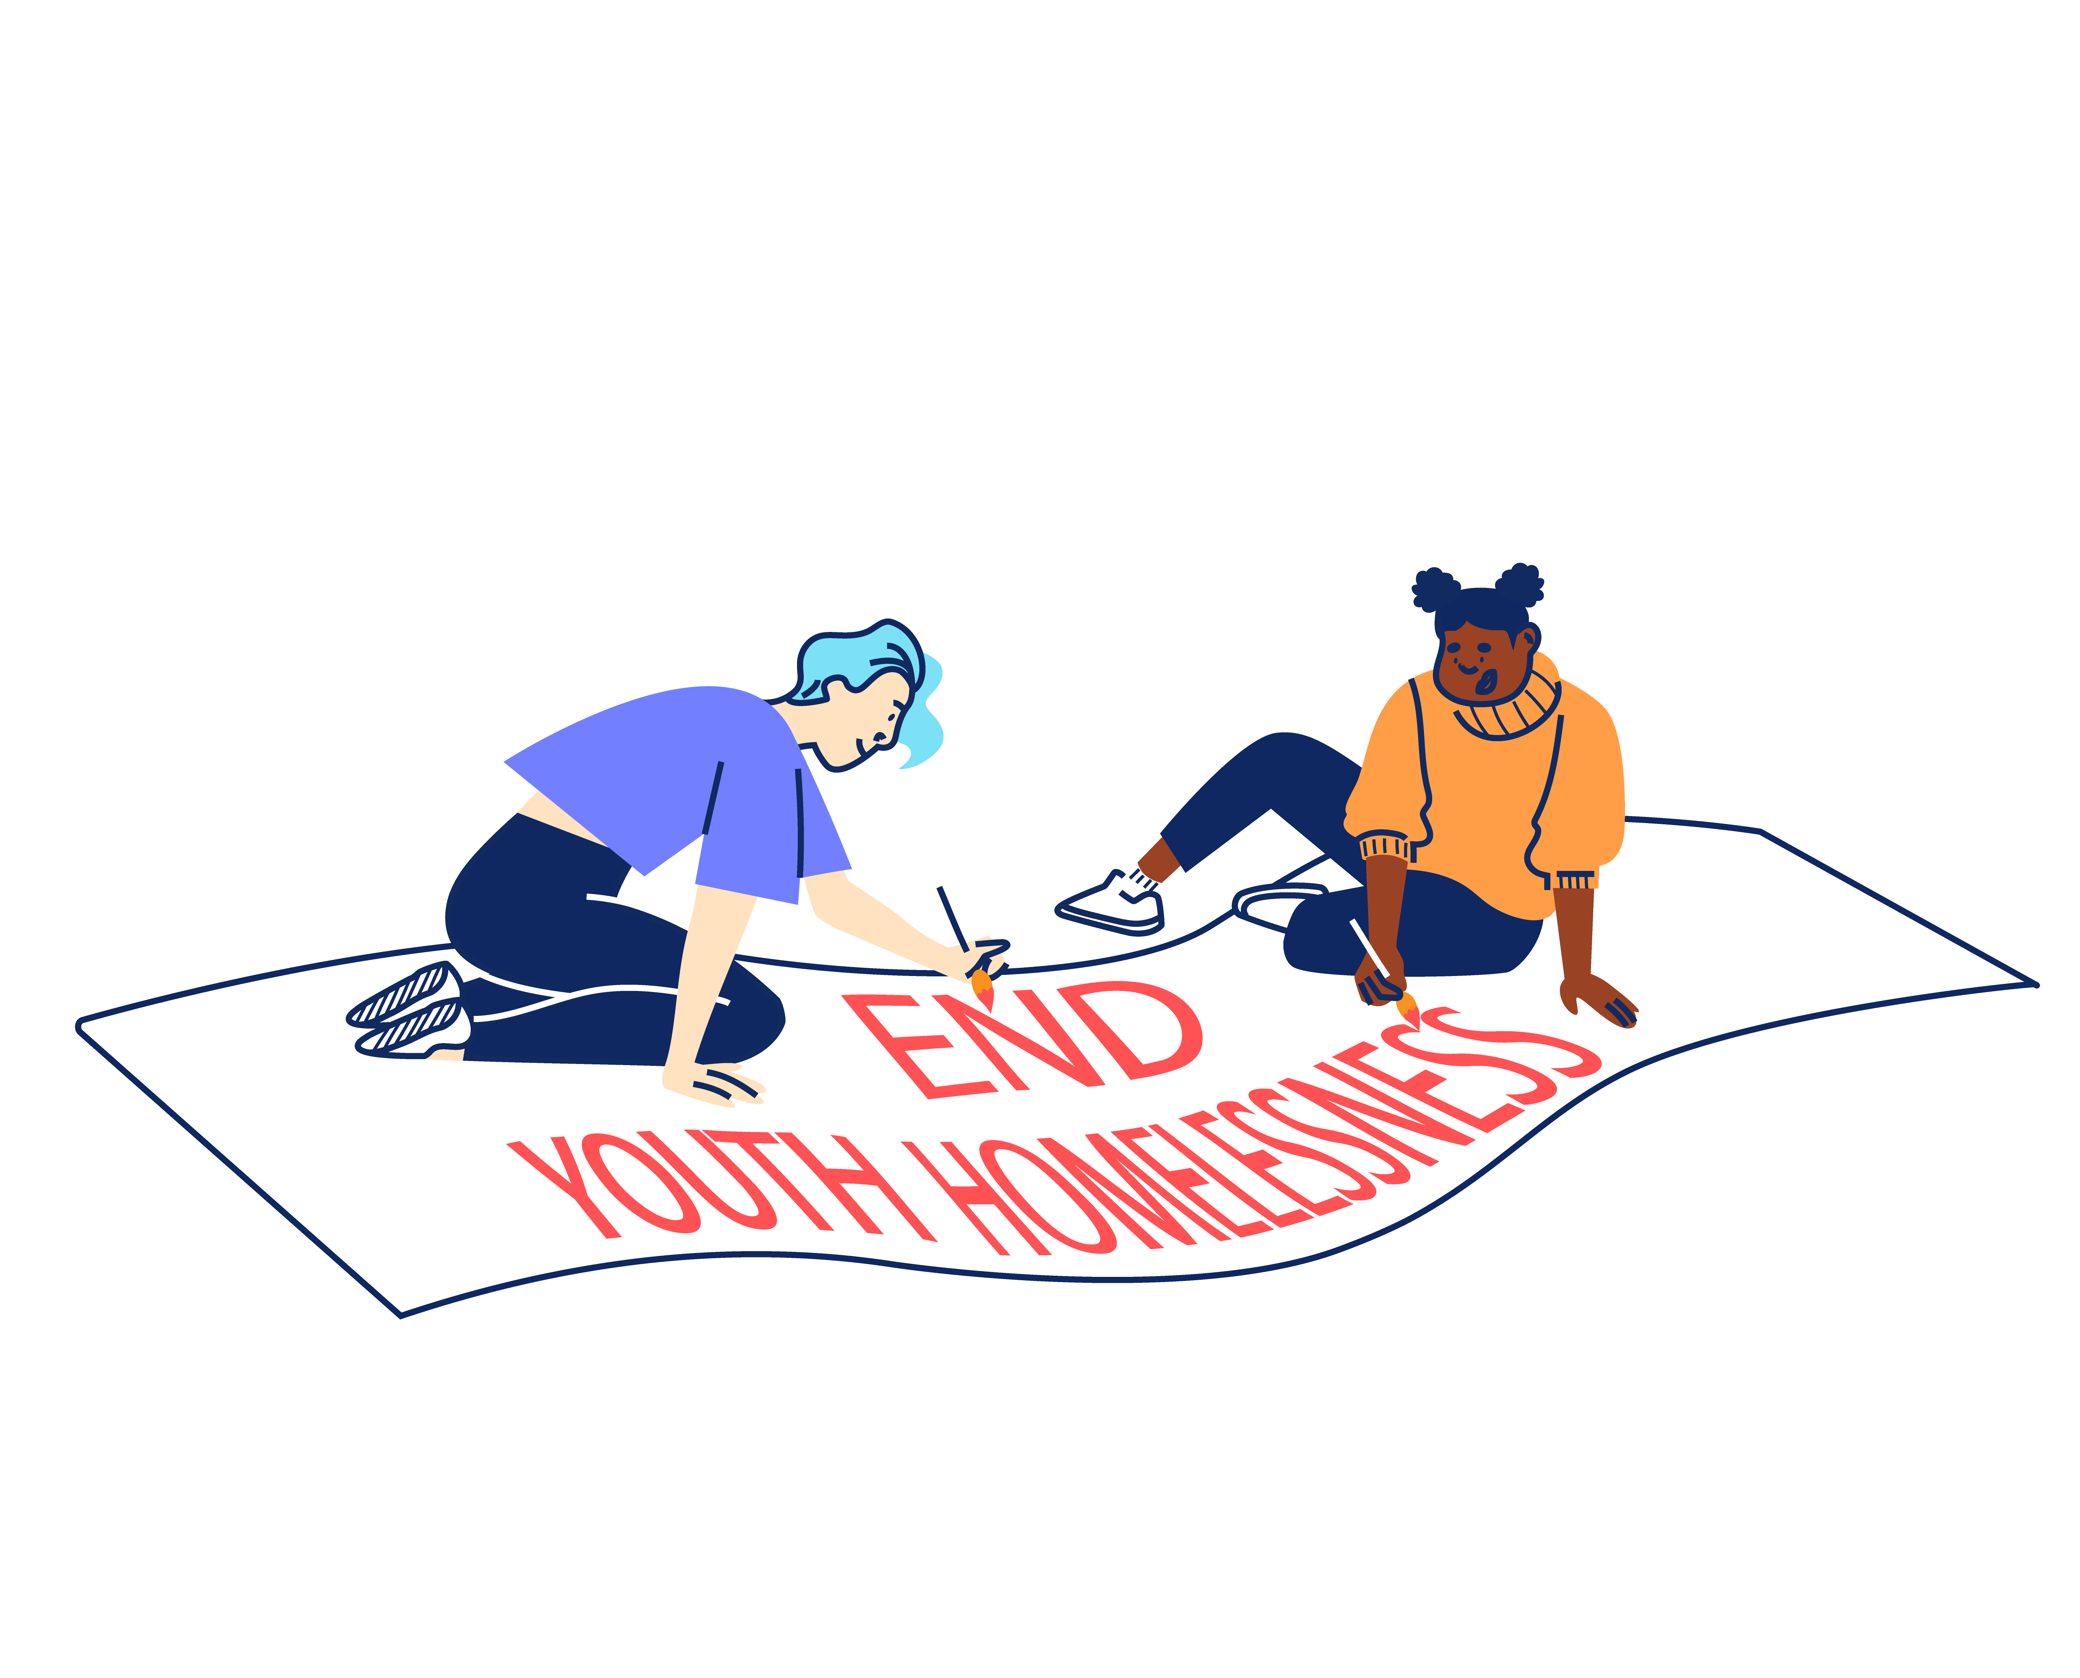

BACK TO OUR BEGINNINGS: ROOTED IN OUR PAST, FOCUSED ON OUR FUTURE – OUR STRATEGY 2025-2030

With rough sleeping at record levels and more young people fleeing violence, there's a pressing need and growing gap for a specialist emergency response that can support young people in crisis and open up housing for thousands more young people in need. ​Rather than trying to provide everything ourselves for all young people until they turn 25, we can focus on being excellent at supporting young people to get the safe homes they deserve as quickly as possible, support with life skills and living independently and helping them create a future without needing our support.
By getting back to our beginnings we will lean on our unique heritage as the only youth-specific day centre and drop-in in London and continue our long and proud history of being here for young people who find themselves homeless in the capital. ​Doing so means making some tough choices about who we cannot support and so our focus will shift to those in more immediate need, prioritising them over those we have already housed and we will be more focused at moving people on successfully. ​
We will support every young Londoner in crisis to access safety, support and stability, then transition them onto independence. We will do this by providing: Successful Services, Productive Partnerships & Confident Campaigning.
Too many young people cannot get the housing help they need.
So we deliver high quality, trauma-informed SERVICES for any young person that needs our support.
We spend 75% of our resources on this.
We spend 15% of our resources on this.
This is complex and difficult work to do.
Because the government under-invests in young people.
Because the services that should help can’t or won’t.
So we need to sustain a WELL-RUN ORGANISATION that invests in staff and celebrates the diversity that makes us a success.
So we CAMPAIGN, saying what others won’t say and doing what others won’t do to ensure that no young person misses out, even the young people we will never meet.
So we work in PARTNERSHIP to optimise our offer and maximise our impact.
We split 10% of our resources across these two areas.


“New Horizon.
It might not be your home.
They might not be your parents.
They might not be your family.
But they want you to win in this world.”

Najma, 21
JOB DESCRIPTION
HEAD OF SERVICES – ROUGH SLEEPING

Reporting to: Director of Services

MAIN TASKS AND RESPONSIBILITIES

- Young People’s Services

To lead on high quality referral, outreach and emergency accommodation services for young people at risk of rough sleeping. This will include:

  - Leading our youth-specific street outreach function, ensuring the team delivers effective and targeted sessions throughout the week, and responds flexibly and pro-actively to emerging needs, with continuous improvements informed by sector trends.
  - Leading on the effective delivery of the Youth Hub emergency accommodation project in partnership with Depaul UK and the GLA.
  - Ensuring effective referral routes and trauma-informed triage processes for new young people accessing NHYC.
  - Leading on our Central Point of Access function for the London Youth Gateway partnership.
  - Working with the Head of Safeguarding and Designated Safeguarding Officers to ensure services are safe for young people, staff, external partners, and other relevant stakeholders.
  - Overseeing thorough and timely risk assessments of services.
  - Ensuring that the inclusion and participation of young people in service delivery is maintained and promoted.
  - Contributing to the safe running of the day centre including coordinating daily work planning and staff rotas.
- Staff Management
To work with the Director of Services and the leadership team to lead and develop a staff team that makes a full and positive contribution to the achievement of NHYC’s mission. This will include:

  - Participating in recruitment and selection of new staff, volunteers, students and locum workers.
  - Leading, managing and motivating team members including staff, volunteers, students and locum workers by means of:
- Developing and implementing planned programmes of induction.
- Setting and monitoring annual individual performance objectives and development plans.
- Holding regular recorded supervisions, annual appraisals and team meetings.
- Managing the workload of the team to ensure an appropriate work-life balance.
- Actively promoting a learning and development environment.
- Dealing with issues concerning staff conduct and performance in line with policies and procedures.
- Ensuring appropriate training and supervision for all team members when assisting with delivery of services.

- Sharing best practice
To proactively share best practice with internal and external stakeholders to maximise the impact of the work of NHYC. This will include:

  - Developing and maintaining effective partnerships with services who might offer resources or funding relevant to young people’s needs. Formulating Service Level Agreements where appropriate.
  - Collaborating around the continuous improvement and development of systems and projects that will benefit the organisation and wider sector.
  - Promoting and representing NHYC externally at relevant forums, meetings and events.
  - Contributing to applications for new project funds or other resources.

- Information Management

To produce and maintain accurate and relevant information in a range of formats to drive learning and continuous service improvements. This will include:

  - Using the InForm (Salesforce) database for recording and reporting purposes, ensuring the team maintain all case files in line with organisation procedures.

  - Producing written reports in a variety of formats to meet the requirements of the Director of Services, service providers and funders.

  - Being fully and compliant with NHYC GDPR policies. Working with the Leadership team on relevant compliance monitoring and action planning.

- Reviewing Personal Performance and Development Needs

To be proactive in reviewing and evaluating own performance and identifying and acting upon areas for improvement. This will include:

  - Evaluating own performance in line with feedback received to identify strengths and areas for development. Identifying own learning and development opportunities.

  - Undertaking development and training opportunities and engaging regularly in clinical supervision and reflective practice.

- Other

To contribute positively and constructively to the development of the team, the service and NHYC. This will include:

  - Acting on behalf of the Director of Services on day-to-day matters and contributing to the overall leadership and management of the organisation as requested.

  - Covering for team members as necessary.

  - Implementing NHYCs Policies and Procedures in all functions of the post.

  - Undertaking, as required, any other duties compatible with the level and nature of the post and/or reasonably required by the Director of Services, Chief Operating Officer or Chief Executive.

  - Attending all Leadership and Management team meetings, participating constructively in operational planning and strategic work.

PERSON SPECIFICATION

Qualifications, Experience and Track Record

E: Essential
D: Desirable

- Experience of managing a diverse range of quality youth services and projects. (E)

- Experience of managing outreach services and/or emergency accommodation projects. (D)

- Ability to work effectively with young people facing homelessness to identify personal goals and support mechanisms for change including for those young people experiencing multiple complex needs. (E)

- Experience of leading a multi-disciplinary team, and a proven track record of dealing positively with a range of performance and HR matters. (E)

- Ability to create and maintain internal and external partnerships and networks to achieve organisational aims and objectives, including co-delivery of projects or services. (E)

- Experience of using IT systems (including client databases) to support the achievement of personal and collective work goals. (E)

Specialist Knowledge and Role Requirements
- Ability to maintain enthusiasm for a high level of contact with young people on a day-to-day basis and a genuine interest in helping young people to move towards independent living. (E)
- Ability to develop and manage risk assessments and procedures across multi-disciplinary teams, including in higher-risk settings. (E)

- Understanding of the types of behaviour that young people who are facing homelessness might demonstrate and ability to deliver de-escalation strategies for behaviour support and management. (E)
- Thorough and up-to-date working knowledge of:
- Local, pan-London and National Government policies and procedures in relation to the client group. (E)
- Relevant organisations and their role and responsibilities in providing housing support to vulnerable young people. (E)
- Knowledge of working to key performance indicators, including monitoring and reporting on service impact, analysing performance information, and identifying continuous improvements. (E)
- A high level of knowledge of managing risk safely in the working environment. (E)
- A thorough working knowledge around safeguarding policy and procedures for children and young people. (E)

- A working knowledge of and commitment to Equity, Diversity and Inclusion as it applies to a supportive service and in the workplace. (E)

- Enthusiasm for evolving services and projects in response to demands from the organisation and wider sector, including a proactive attitude and willingness to pilot new initiatives. (E)

Additional Job Requirements
- Willingness and ability to work outside of normal hours on occasion (within NHYC policies). This includes working over the Christmas period where required. (E)
- Willingness to travel across London for the purposes of the role. (E)

- Willingness to work flexibly in response to changing organisational requirements. (E)
ADDITIONAL INFORMATION

Location:

The post is based at: New Horizon Youth Centre, 68 Chalton Street, London, NW1 1JR.

Contract:

The contract is ongoing, subject to successful completion of a probationary period.

Hours of work:

The post holder will be required to work 35 hours per week, Monday-Friday.

Pay:

The starting salary for role is AP37: £46,800 (pro-rata).

The salary scale is: AP37 (£46,800) to AP41 (£52,000).

Other benefits:

- 30 days annual leave per year (pro rata), plus bank holidays and some additional time off over Christmas
- Employer contribution of 6% to a group personal pension scheme
- Enhanced Employee Assistance Programme, including 24-hour helpline, access to counselling, contributions towards medical expenses, discounted gym memberships, high street vouchers and more
- Clinical Supervision and Reflective Practice
- Staff Loan Policy, including Cycle to Work scheme
- Generous Training budget and a Diversity Leadership Programme
- Regular Staff Away Days and teambuilding activities

TIMESCALES AND HOW TO APPLY

The timescales for recruitment are as follows:

Closing date and time for applications | 9am, Monday 20th April 2026
Shortlisted candidates will be informed | 23rd April 2026
Interviews | Thursday 30th April 2026

If you wish to apply for this position, you will need to supply:

- A CV setting out your career history, education or qualifications, and other key responsibilities or achievements (up to 2 sides of A4). Please do not include your name, initials, contact details or references in the CV or file name.

- A supporting statement (up to 1500 words or 2 sides of A4) highlighting your suitability for the role and how you meet the criteria listed on the Person Specification. Please do not include your name, contact details or address.

The supporting statement is an essential part of your application and will be assessed for shortlisting purposes.

- Completed diversity and adjustment questions – Your data will be stored separately from your application and will at no time be connected to you or your application by the shortlisting panel.

To apply, visit our careers site: https://jobs.nhyouthcentre.org.uk

We do not consider incomplete applications.

You will be notified if you have not been shortlisted. However, we are unfortunately unable to provide each individual application with feedback.

If you have any questions or would like to arrange a call to discuss the role, please feel free to email us at recruitment@nhyouthcentre.org.uk or call 0207 388 5560.

nhyouthcentre.org.uk
@nhyouthcentre

Charity number: 276943
Company number: 01393561
Giving potential a home since 1967

