
N
N

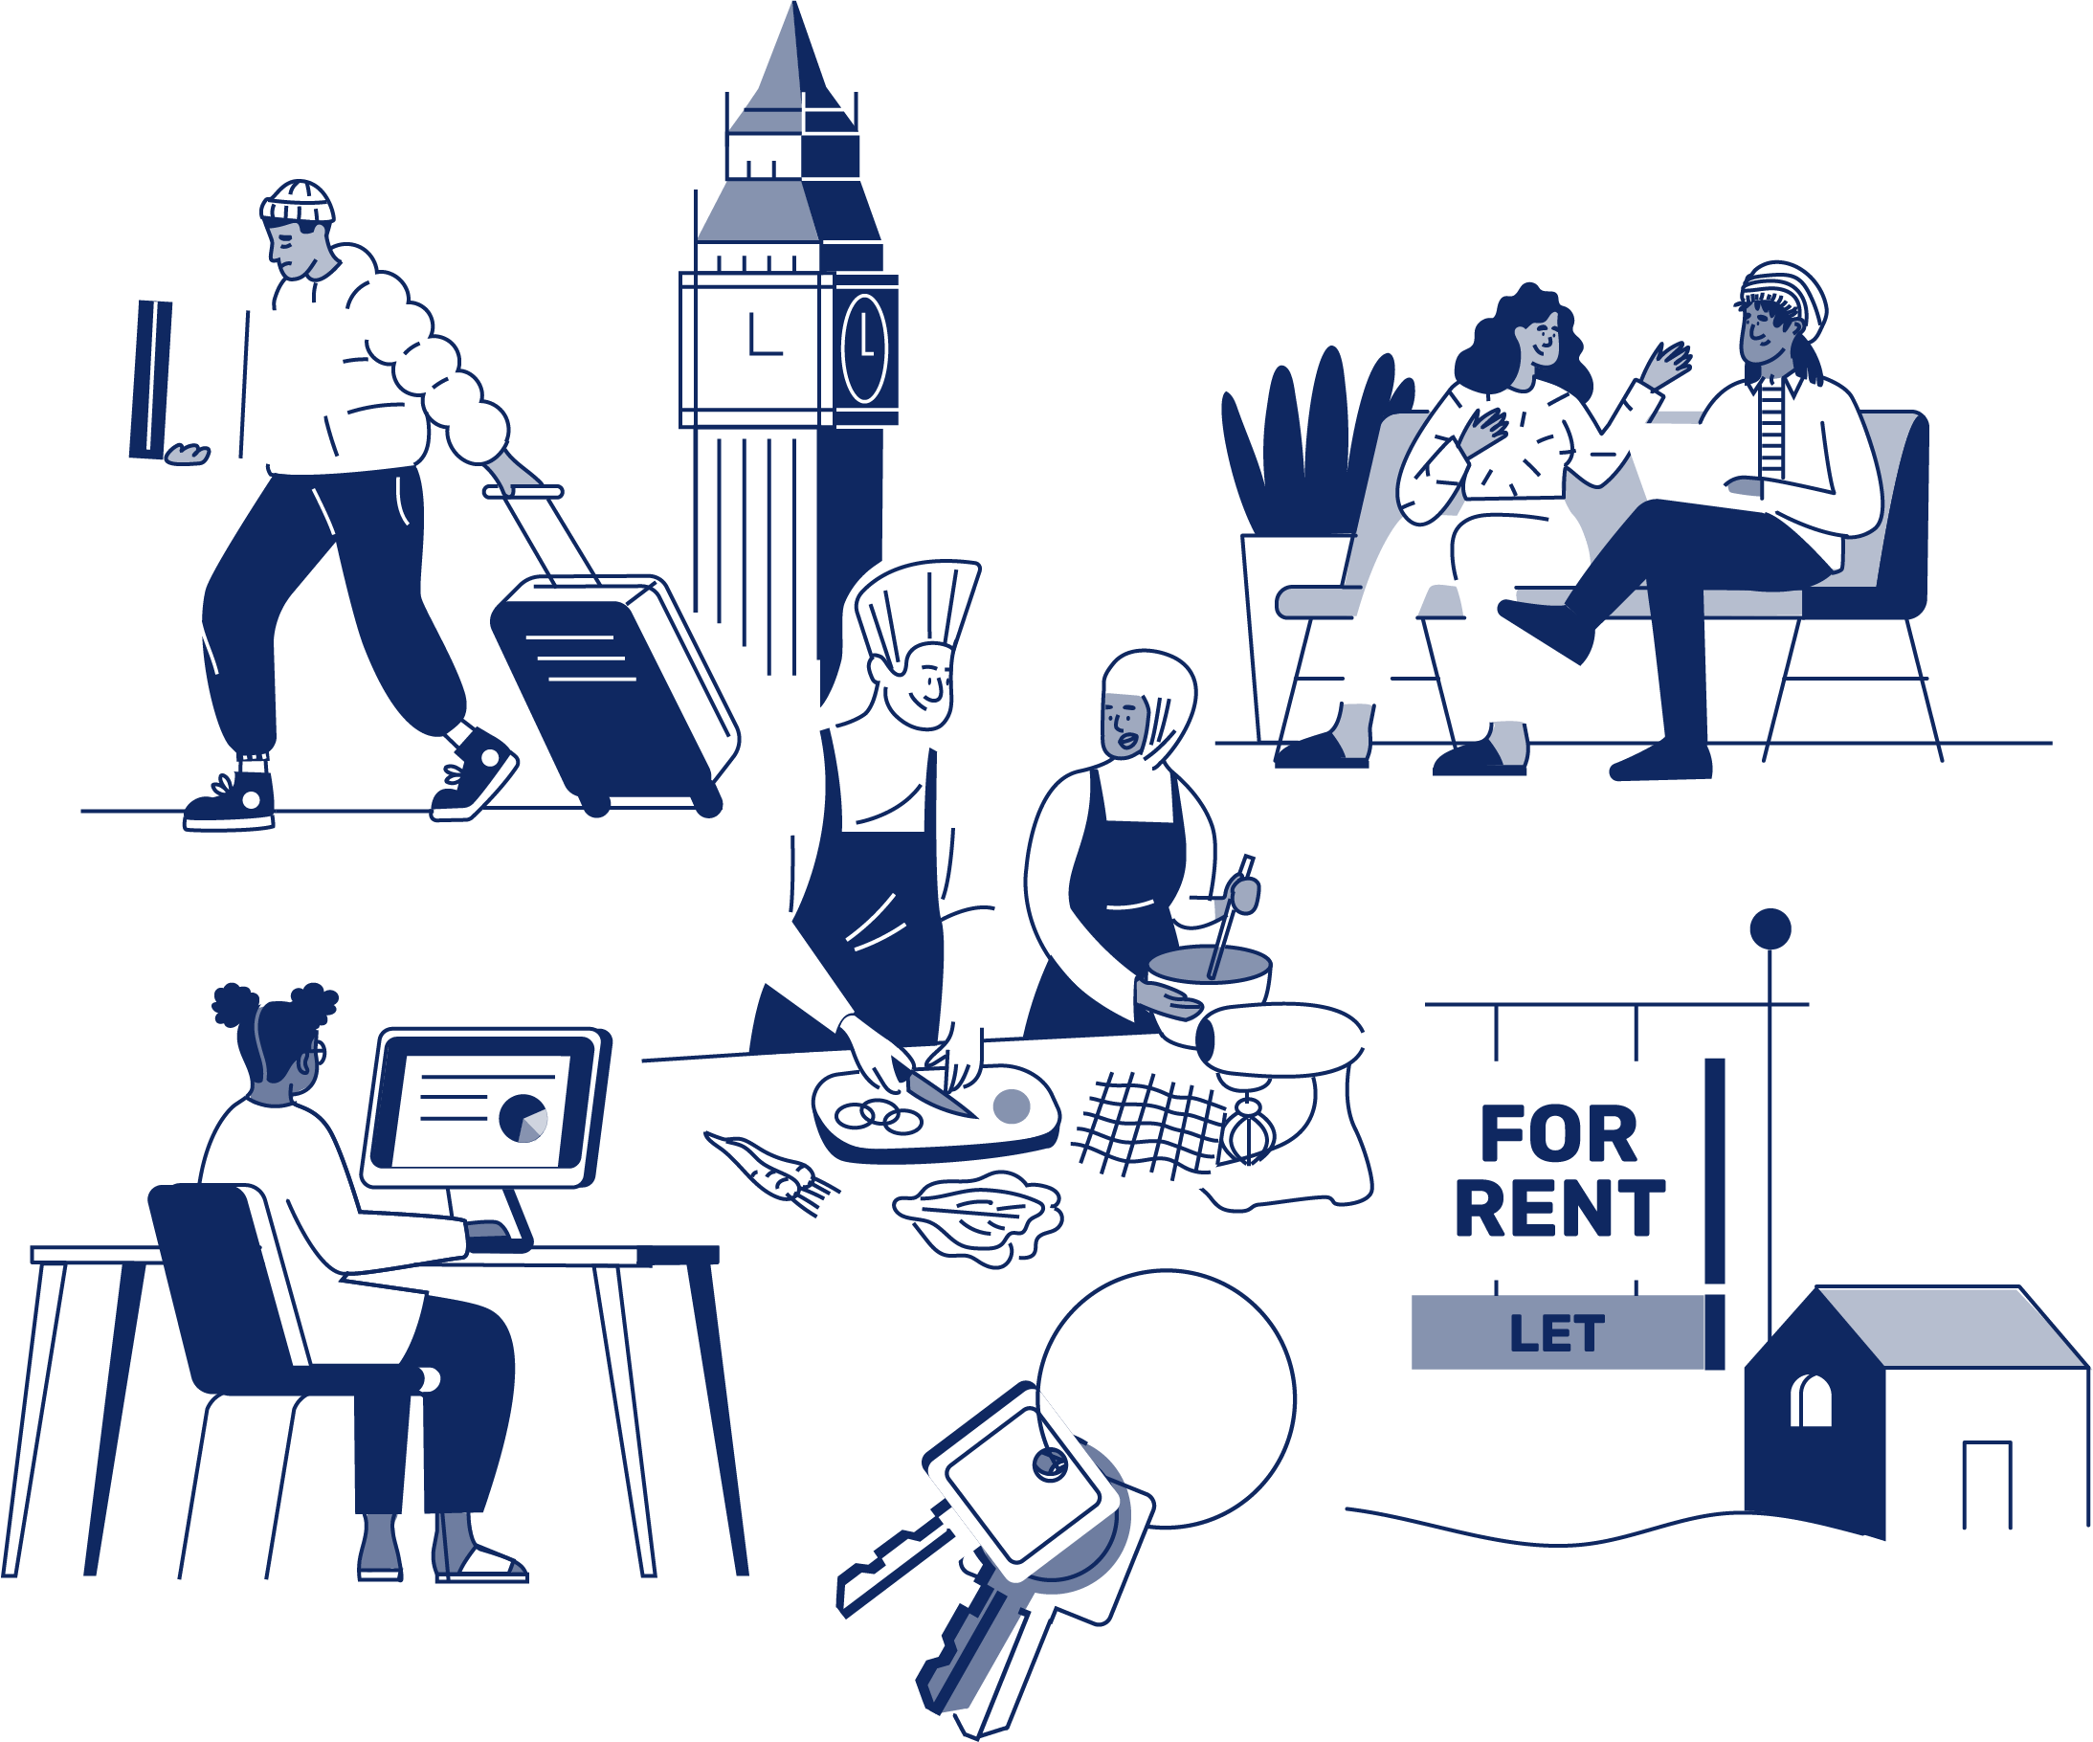
JOB APPLICATION PACK
Counsellor
(part-time)

March 2026
OUR STORY

London is a fantastic city to call home, but a central truth remains in the capital. Every year thousands of young people find themselves unhoused, unsupported and unsafe.

That's why New Horizon Youth Centre exists.

Founded in 1967 by Lord Longford to address the needs of young people who were homeless and misusing drugs in the West End of London, today New Horizon Youth Centre continues to be a vital support network for 16–24-year-olds with nowhere else to go.

Through the services we provide at our day centre, via outreach and remotely, our multidisciplinary team of over 70 staff support thousands of young people experiencing homelessness in London to find safety, improve their wellbeing, develop skills for life and ultimately find somewhere that they can call home.

“For as long as young people are homeless
and unsafe in London, we will be on a
mission to give their potential a home”

For more info about our impact, please take a look at our latest impact report.


COMMITMENT TO EQUITY, DIVERSITY & INCLUSION

New Horizon Youth Centre is committed to recognising and valuing difference and ensuring fairness and equity; and recognising and seeking to redress inequity and disadvantage wherever possible. We have an ongoing action plan to improve our Equity, Diversity and Inclusion (EDI) practices, which every member of our organisation has a role in contributing to.

As a service provider to young people facing homelessness and who are unsafe, we aim to be an empowering, supportive employer and to offer as much flexibility as possible to help each individual realise their full potential as users of New Horizon Youth Centre and as employees. We believe that this approach is key and central to promoting and developing diversity.

We recognise that true diversity in our community and within the staff group also involves a willingness to act, where necessary, by combating the effects of existing barriers to fair and equal treatment. Within society certain groups are unfairly discriminated against – for example on the grounds of race, gender or gender identity, disability, sexuality, age and class - and are, as a result, disadvantaged in terms of their access to services and employment. We will, where appropriate and where possible, seek to positively redress the effects of this discrimination. Any action we take will be legally compliant and consistent with our approach of making young people and staff feel valued and respected.

We recognise that many people have suffered disadvantage and barriers to progress for all kinds of reasons related to them as an individual and not because of their personal characteristics such as homelessness, employment, economic or domestic circumstances, or involvement with the justice system. For this reason, our commitment to diversity includes being supportive, positive and open minded.

We encourage applications from all backgrounds in respect of ethnicity, disability, gender, sexuality, religion, and socio-economic backgrounds.

New Horizon Youth Centre is deeply committed to inclusive working practices, so during the application process we commit to:
- Reimbursing reasonable childcare or other care costs whilst you are attending interviews.
- Reimbursing reasonable return travel costs for interviews (within London/neighbouring counties)
- Making any reasonable adjustments – for example ensuring we have a sign language interpreter organised in advance if you would like them.
- Offering a guaranteed first stage interview for disabled candidates who meet the minimum requirements for the role.

If there is anything else you are concerned about or think we could provide, please let us know.

OUR WORK IS GUIDED BY THREE VALUES:

We champion young people

We collaborate for impact

We are determined to find a way
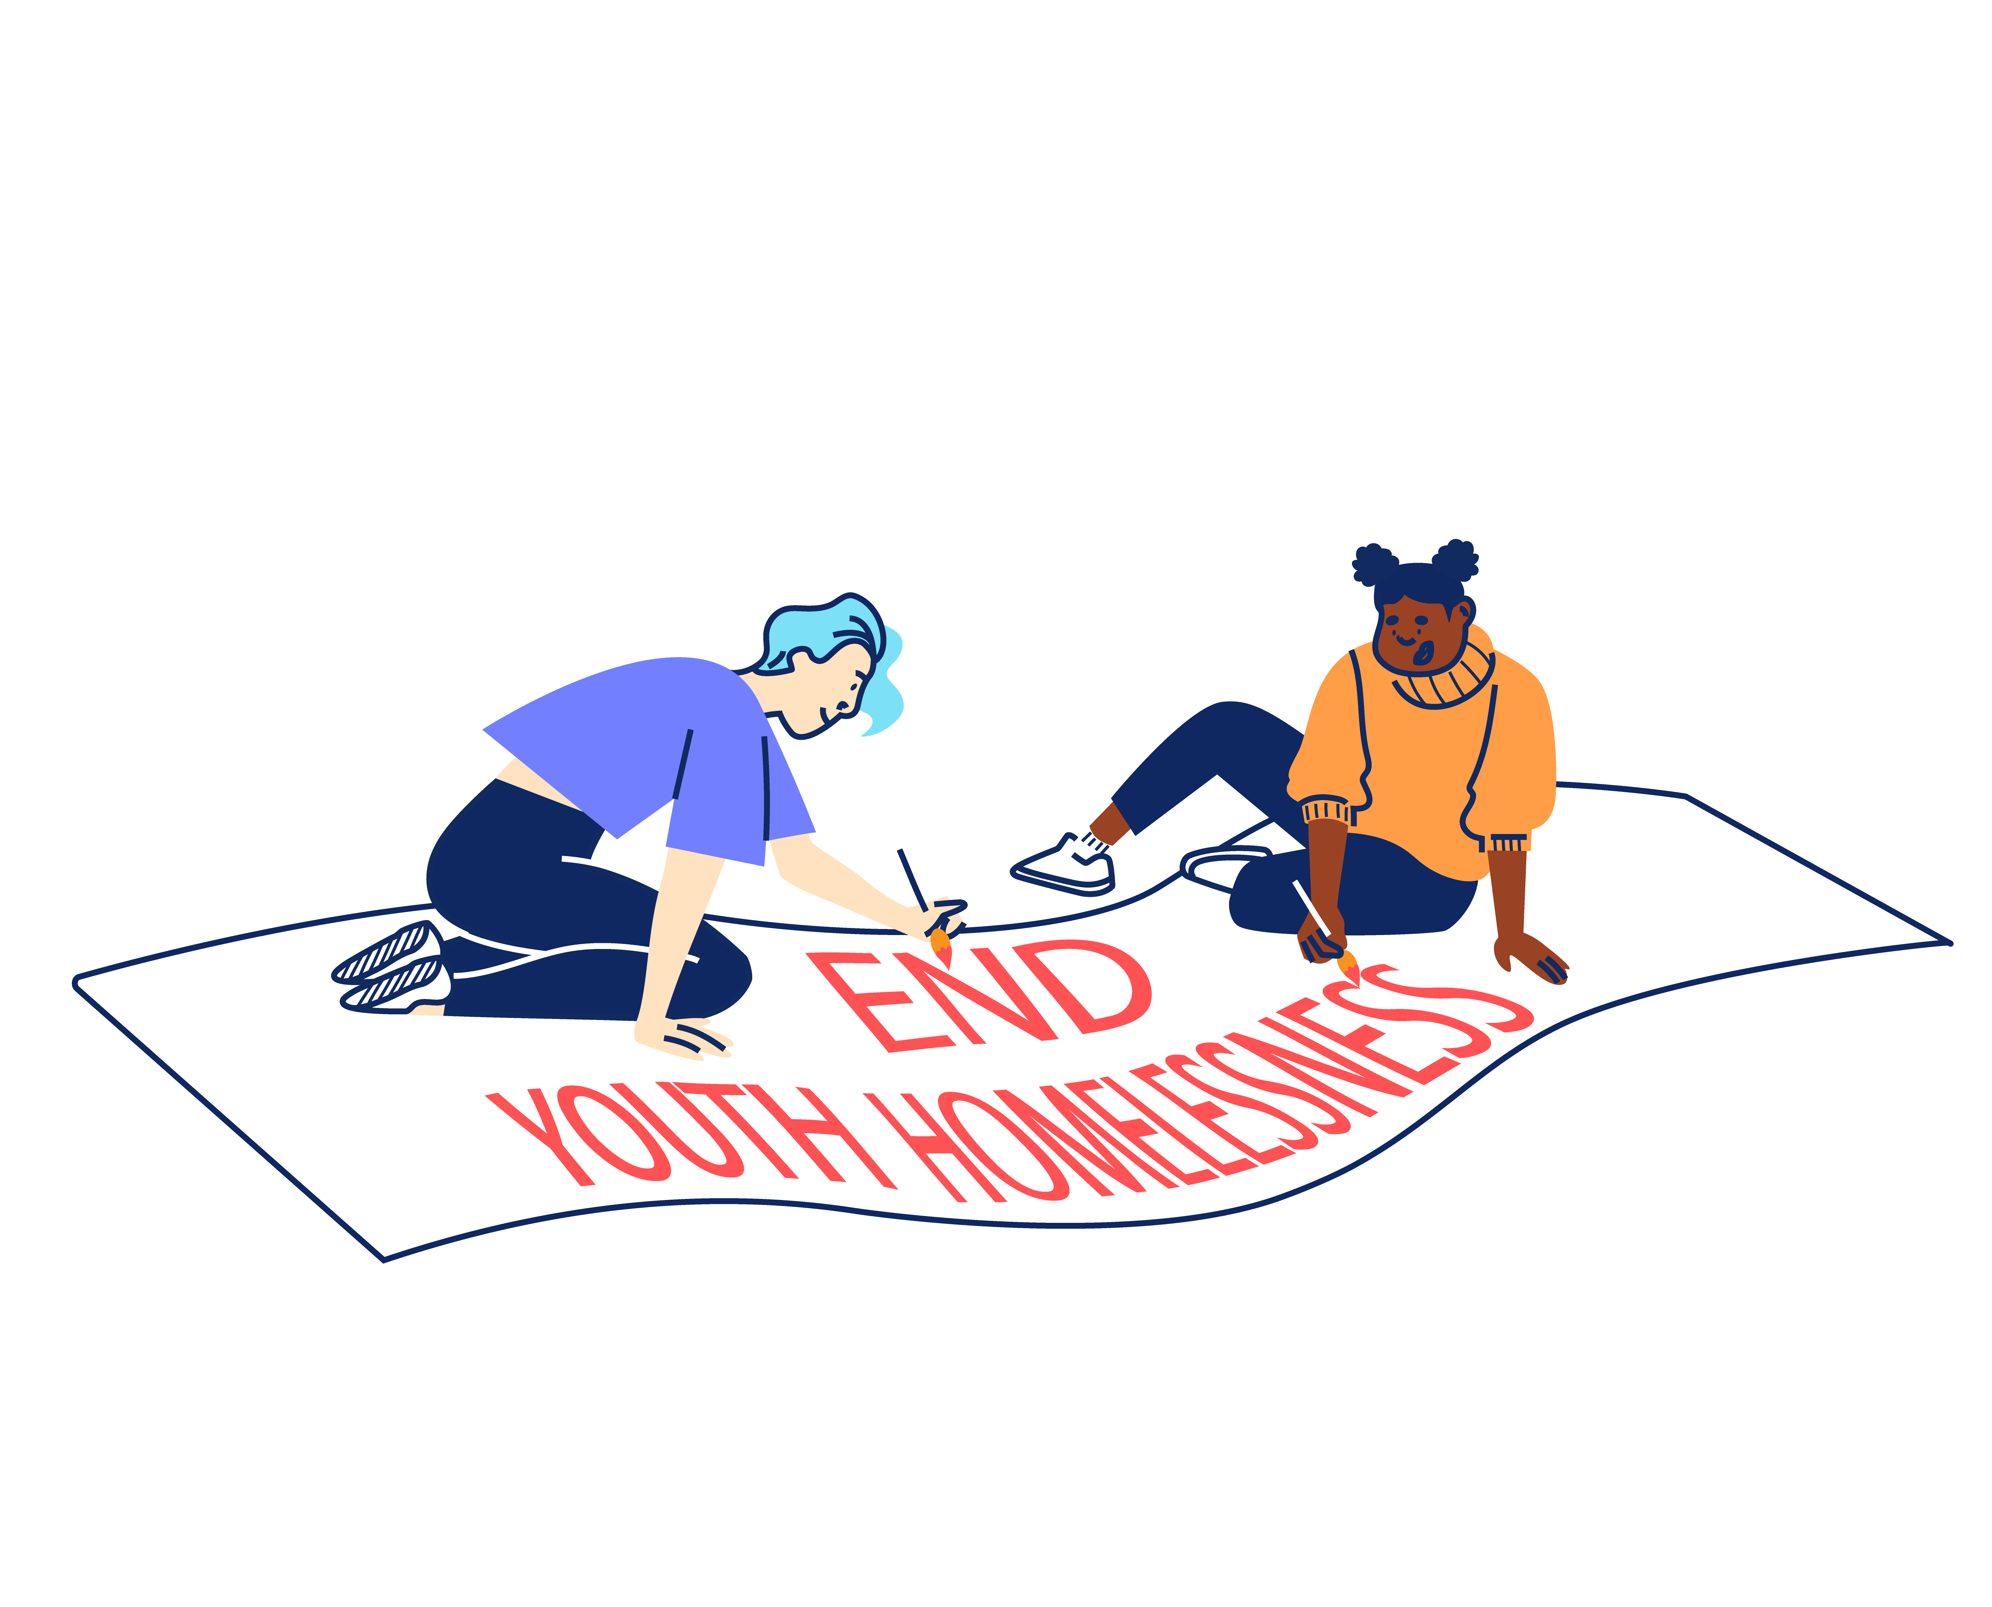

BACK TO OUR BEGINNINGS: ROOTED IN OUR PAST, FOCUSED ON OUR FUTURE – OUR STRATEGY 2025-2030

With rough sleeping at record levels and more young people fleeing violence, there's a pressing need and growing gap for a specialist emergency response that can support young people in crisis and open up housing for thousands more young people in need. ​Rather than trying to provide everything ourselves for all young people until they turn 25, we can focus on being excellent at supporting young people to get the safe homes they deserve as quickly as possible, support with life skills and living independently and helping them create a future without needing our support.
By getting back to our beginnings we will lean on our unique heritage as the only youth-specific day centre and drop-in in London and continue our long and proud history of being here for young people who find themselves homeless in the capital. ​Doing so means making some tough choices about who we cannot support and so our focus will shift to those in more immediate need, prioritising them over those we have already housed and we will be more focused at moving people on successfully. ​
We will support every young Londoner in crisis to access safety, support and stability, then transition them onto independence. We will do this by providing: Successful Services, Productive Partnerships & Confident Campaigning.
Too many young people cannot get the housing help they need.
So we deliver high quality, trauma-informed SERVICES for any young person that needs our support.
We spend 75% of our resources on this.
We spend 15% of our resources on this.
This is complex and difficult work to do.
Because the government under-invests in young people.
Because the services that should help can’t or won’t.
So we need to sustain a WELL-RUN ORGANISATION that invests in staff and celebrates the diversity that makes us a success.
So we CAMPAIGN, saying what others won’t say and doing what others won’t do to ensure that no young person misses out, even the young people we will never meet.
So we work in PARTNERSHIP to optimise our offer and maximise our impact.
We split 10% of our resources across these two areas.


“New Horizon.
It might not be your home.
They might not be your parents.
They might not be your family.
But they want you to win in this world.”

Najma, 21

JOB DESCRIPTION - COUNSELLOR
Reporting to: Head of Health Services

ABOUT YOU
Many of the young people you will work with have experienced significant trauma, including displacement, persecution, torture, human trafficking, and modern slavery. Working as part of a multidisciplinary team, you will support emotional wellbeing and resilience, help young people navigate and engage with wider support services, and contribute to a safe, inclusive, and culturally responsive therapeutic environment.

You will be passionate about providing culturally competent therapy with a strong understanding of the mental health needs of marginalised communities, particularly refugees and people seeking asylum. You will have fluency in one or more languages commonly spoken by refugee communities, which is essential to this role.

You will be confident working with complex trauma, comfortable in a dynamic, community-based environment, and committed to creating accessible and affirming therapeutic spaces for young people who may have experienced significant barriers to support. This includes delivering one to one counselling, group therapy, and therapeutic workshops within a busy day centre setting.

MAIN TASKS AND RESPONSIBILITIES

To provide high-quality, trauma-informed therapeutic support to young people experiencing, or at risk of, homelessness, with a particular focus on refugees and people seeking asylum. This will include:

- Delivering one to one counselling and group-based therapeutic interventions in a fast-paced, drop-in day centre setting.

- Co-designing and facilitating therapeutic groups and workshops tailored to the needs of refugee and asylum-seeking young people

- Conducting initial clinical assessments and contribute to ongoing care planning

- Working collaboratively with teams across disciplines to ensure holistic, joined-up support for young people

- Applying a strong trauma-informed, anti-oppressive, and culturally sensitive approach to all aspects of the role

- Assessing and responding appropriately to risk, including safeguarding, self-harm and suicide risk, in line with organisational policies and ethical framework.

- Adapting therapeutic approaches to a drop-in model, including brief interventions and fluctuating engagement

- Engaging in regular clinical supervision and reflective practice to ensure safe, ethical practice

- Maintaining accurate and timely clinical records in line with professional and organisational standards

- Contributing to the ongoing development and improvement of the service, by monitoring outcomes and service impact

OTHER

To contribute positively and constructively to the development of the team, the service and the Centre. This will include:

- Covering for other members of the team as necessary.

- Following NHYC’s policies, procedures and performance expectations in all functions of the post.

- Undertaking, as required, any other duties compatible with the level and nature of the post and/or reasonably required by the Service Manager, Head of Services, or Leadership Team.

PERSON SPECIFICATION

We are looking for an individual who can demonstrate the following competencies and want to use these to the full in their work.

E: Essential
D: Desirable

Qualifications and Registration

- A recognised Counselling qualification at Level 4 or above (person-centred or closely aligned modality). (E)

- Registered and/or accredited with a professional counselling body (e.g. BACP or equivalent). (E)

Language & Communication

- Fluency in English and at least one language commonly spoken by refugee communities (E)

- Ability to deliver counselling in a culturally sensitive and accessible way to clients from diverse backgrounds. (E)

Experience & Skills

- Demonstrable post-qualification counselling experience in a comparable professional setting, with a strong focus on trauma. (E)

- Proven ability to build and sustain effective therapeutic relationships with young people facing multiple and intersecting challenges. (E)

- Effectiveness working within a high-pressure, frontline setting. (D)

- Personal insight or lived experience that enhances understanding of the challenges faced by refugee, asylum-seeking, or young people experiencing homelessness. (D)

Safeguarding, Ethics & Professional Practice

- Strong working knowledge of the BACP Ethical Framework (or equivalent). (E)

- Excellent understanding of complex trauma and the ability to work safely with risk. (E)

- Excellent knowledge of safeguarding policies and procedures for children and vulnerable adults. (E)

- Ability to meet reporting requirements and maintain clear, accurate, and timely clinical records

Collaborative Working & Organisational Awareness

- Ability to work collaboratively within a multidisciplinary team and with external partners to support holistic care for young people. (E)

- A clear commitment to Equity, Diversity and Inclusion in both service delivery and the workplace. (E)

- Willingness to work flexibly, including occasional work outside standard hours in line with organisational need. (E)

ADDITIONAL INFORMATION

Location:

The post is based at: New Horizon Youth Centre, 68 Chalton Street, London, NW1 1JR.

Contract:

The contract is ongoing, subject to successful completion of a probationary period.

Hours of work:

The role is part-time. The post holder will be required to work 21 hours across three 3 days per week. The exact working pattern will be determined following interview. Some work over the Christmas period will be required.

Pay:

The starting salary for role is: £31,200.00 (pro-rata).

The salary scale is: AP26 (£31,200) to AP30 (£34,736).

Other benefits:

- 30 days annual leave per year (pro rata), plus bank holidays and some additional time off over Christmas
- Employer contribution of 6% to a group personal pension scheme
- Enhanced Employee Assistance Programme, including 24-hour helpline, access to counselling, contributions towards medical expenses, discounted gym memberships, high street vouchers and more
- Clinical Supervision and Reflective Practice
- Staff Loan Policy, including Cycle to Work scheme
- Generous Training budget and a Diversity Leadership Programme
- Regular Staff Away Days and teambuilding activities

TIMESCALES AND HOW TO APPLY

The timescales for recruitment are as follows:

Closing date and time for applications | 9am, Friday 27th March 2026
Shortlisted candidates will be informed | 1st April 2026
Interviews | w/c 6th April 2026

If you wish to apply for this position, you will need to supply:

- A CV setting out your career history, education or qualifications, and other key responsibilities or achievements (2 sides of A4). Please do not include your name, initials, contact details or references in the CV and the file name.

- A supporting statement (1500 words or up to 2 sides of A4) highlighting your suitability for the role and how you meet the criteria listed on the Person Specification. Please do not include your name, contact details or address.

The supporting statement is an essential part of your application and will be assessed for shortlisting purposes.

- Completed diversity and adjustment questions – Your data will be stored separately from your application and will at no time be connected to you or your application by the shortlisting panel.

To apply, visit our careers site: https://jobs.nhyouthcentre.org.uk

We do not consider incomplete applications.

You will be notified if you have not been shortlisted. However, we are unfortunately unable to provide each individual application with feedback.

If you have any questions or would like to arrange a call to discuss the role, please feel free to email us at recruitment@nhyouthcentre.org.uk or call 0207 388 5560.

nhyouthcentre.org.uk
@nhyouthcentre

Charity number: 276943
Company number: 01393561
Giving potential a home since 1967

