
N
N

JOB APPLICATION PACK
Services Manager (Housing)

October 2025
Dear applicant,

Life is not linear. Nobody knows that better than the young people who come to New Horizon Youth Centre. While the thousands of stories they tell us every year are as different as they can be, one thing unites them: their current experiences of homelessness do not define them or where they will end up. Indeed, as one of the young members of our Women’s Space told us, sometimes you have got to go through the darkness to get to the light.

During the last few years COVID, cost-of-living and housing crises have created challenges for us all, but young people have felt it particularly acutely. Youth homelessness is currently at unprecedented levels. In 2023, over 20,000 young people in London approached their council because they were, or were about to be, homeless.

To meet these rising levels of need, we are expanding our staff team, services and partnerships. By joining us, you will be part of ensuring New Horizon consistently and powerfully does what it does best: championing young people, collaborating for impact and being determined to find a way to holistically support every young person that comes through our doors.

Whilst making sure that basic needs are met and young people are safe, housed and able to focus on their future, it is also critical that we guarantee that young people, especially those experiencing homelessness who have been systemically denied a voice, are present in the creation of systems that will change and impact their lives for the better.

We are not afraid of being bold and thinking big in response to today’s challenges; it requires us to grow our staff team, our collaborations, our funding and our campaigning to end youth homelessness. Staff wellbeing is a crucial part to this journey, along with ensuring that young people are with us every step of the way.

We know that far too many young people find themselves unhoused, unsupported and unsafe. Now is the time to right this wrong and ensure that every young Londoners’ potential has a home.

We hope that you’ll join us.


Phil Kerry, Chief Executive

OUR STORY

London is a fantastic city to call home, but a central truth remains in the capital. Every year thousands of young people find themselves unhoused, unsupported and unsafe.

That's why New Horizon Youth Centre exists.

Founded in 1967 by Lord Longford to address the needs of young people who were homeless and misusing drugs in the West End of London, today New Horizon Youth Centre continues to be a vital support network for 16–24-year-olds with nowhere else to go.

Through the services we provide at our day centre, via outreach and remotely, our multidisciplinary team of over 60 staff support thousands of young people experiencing homelessness in London to find safety, improve their wellbeing, develop skills for life and ultimately find somewhere that they can call home.

“For as long as young people are homeless
and unsafe in London, we will be on a
mission to give their potential a home”

For more info about our impact, please take a look at our latest impact report.


COMMITMENT TO EQUITY, DIVERSITY & INCLUSION

New Horizon Youth Centre is committed to recognising and valuing difference and ensuring fairness and equity; and recognising and seeking to redress inequity and disadvantage wherever possible. We have an ongoing action plan to improve our Equity, Diversity and Inclusion (EDI) practices, which every member of our organisation has a role in contributing to.

As a service provider to young people facing homelessness and who are unsafe, we aim to be an empowering, supportive employer and to offer as much flexibility as possible to help each individual realise their full potential as users of New Horizon Youth Centre and as employees. We believe that this approach is key and central to promoting and developing diversity.

We recognise that true diversity in our community and within the staff group also involves a willingness to act, where necessary, by combating the effects of existing barriers to fair and equal treatment. Within society certain groups are unfairly discriminated against – for example on the grounds of race, gender or gender identity, disability, sexuality, age and class - and are, as a result, disadvantaged in terms of their access to services and employment. We will, where appropriate and where possible, seek to positively redress the effects of this discrimination. Any action we take will be legally compliant and consistent with our approach of making young people and staff feel valued and respected.

We recognise that many people have suffered disadvantage and barriers to progress for all kinds of reasons related to them as an individual and not because of their personal characteristics such as homelessness, employment, economic or domestic circumstances, or involvement with the justice system. For this reason, our commitment to diversity includes being supportive, positive and open minded.

We encourage applications from all backgrounds in respect of ethnicity, disability, gender, sexuality, religion, and socio-economic backgrounds.

New Horizon Youth Centre is deeply committed to inclusive working practices, so during the application process we commit to:
- Reimbursing any childcare and other care costs whilst you are attending interviews.
- Reimbursing your travel costs to the office and back for interviews.
- Making any reasonable adjustments – for example ensuring we have a sign language interpreter organised in advance if you would like them.
- Offering a guaranteed first stage interview for disabled candidates who meet the minimum requirements for the role.

If there is anything else you are concerned about or think we could provide, please let us know.
OUR WORK IS GUIDED BY THREE VALUES:

We champion young people

We collaborate for impact

We are determined to find a way
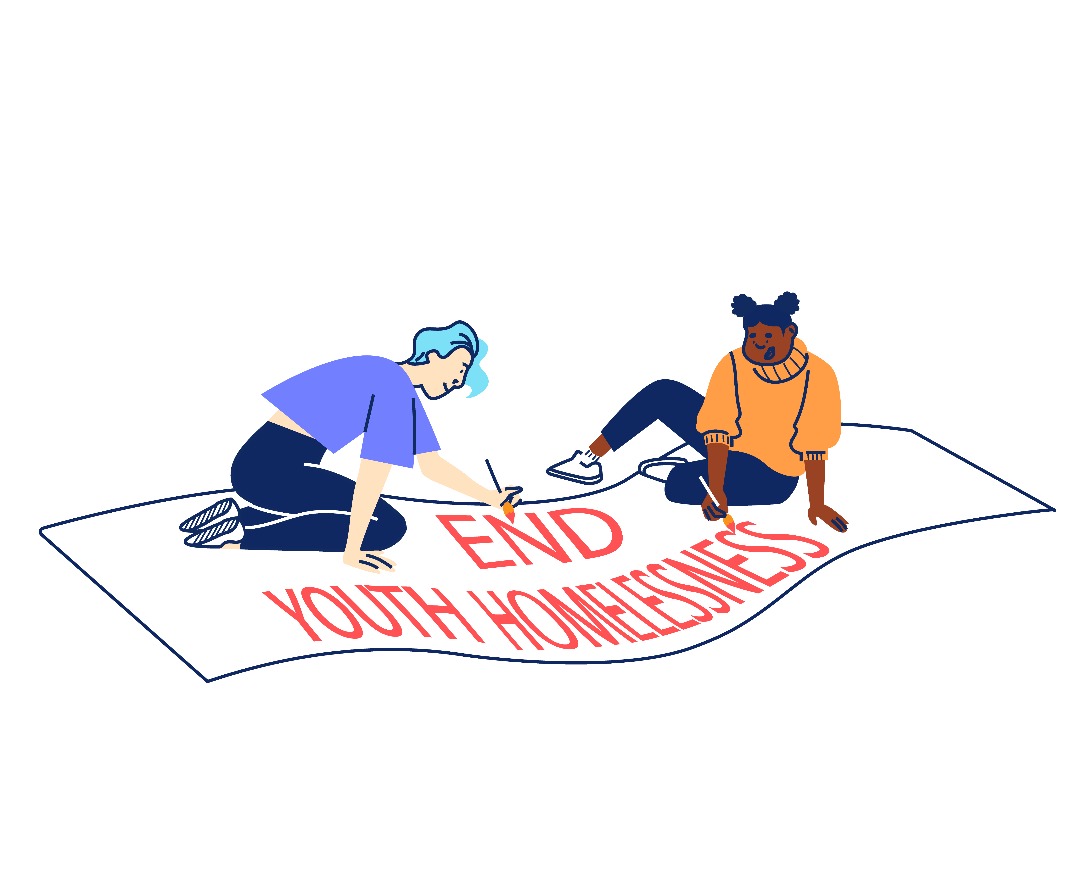

JOB DESCRIPTION – SERVICES MANAGER (HOUSING)

Reporting to: Head of Services - Housing

JOB OBJECTIVES

The Services Manager (Housing) will primarily focus on the managing New Horizon's Housing Advice service, delivered both from the day centre and remotely. They will work alongside another Services Manager (Housing), whose focus is primarily on our Accommodation Projects.

The key objectives of the post are:

- To support the Head of Services in the daily running of New Horizon Youth Centre’s (NHYC) Housing services, including Advice and Accommodation Projects, ensuring they respond holistically to young people with multiple complex needs.

- To support the management and development of a team of Housing Advice and Support workers.

- To maintain and build a network of partnerships with relevant external stakeholders to improve young people’s housing outcomes.

MAIN TASKS AND RESPONSIBILITIES

- Staff Management
To work with the Head of Services to lead, supervise and develop team members, and to ensure that the Housing team makes a full and positive contribution to the achievement of New Horizon Youth Centre’s mission. This will include:
  - Participating in recruitment, selection and induction of new staff, locums, students and volunteers.

  - Leading, managing and motivating team members by means of:
  - Drawing up and carrying out planned programmes of induction.
  - Setting and monitoring individual performance objectives and targets.
  - Holding regular, recorded supervisions, annual appraisals and team meetings
  - Coaching and training staff, volunteers, students and locum workers and actively promoting a learning and development environment.
  - Managing the workload of the team and preparing rotas to ensure that adequate cover is provided at all times.

  - Dealing with problems concerning staff conduct, performance and attendance in line with policies and procedures.

- Young People’s Services
To work with the Head of Services on managing the Housing Advice service and partnerships that will ensure the provision of broader high-quality services to young people. This will include:
  - Supporting the Head of Services in all aspects of the development and delivery of the service, ensuring young people receive a high-quality service from the point of registration to move-on.

  - Development and management of the service to meet the standards required by clients, external assessors and funders.

  - To maintain and build a network of partnerships with relevant external stakeholders to improve young people’s housing outcomes.

  - Continued use of feedback and showing a commitment to a service that is sensitive and responsive to clients’ needs.

  - Processing and responding promptly and objectively to complaints from clients and other agencies.

  - Contributing to the running of the day centre including acting as Duty Manager, coordinating daily work planning, managing Health and Safety and addressing any safeguarding issues as a priority.

  - Assisting with developing satellite services within the service, ensuring that Service Level Agreements are established, reviewed and monitored.

  - Taking a hands-on approach to dealing with complex or difficult cases.

  - Contributing to applications for new project funds or other resources.

- Sharing best practice
To proactively share best practice with internal and external stakeholders in order to maximise the impact of the work of NHYC. This will include:
  - Developing effective working relationships with specialists and agencies who might offer resources, funding, or individual services relevant to young people’s needs e.g. Local Authorities, Social Services, the DWP, health services, and other voluntary sector agencies. Formulating Service Level Agreements where appropriate.

  - Working with the Head of Services to research and pilot new systems that will benefit the service and assist in best practice sharing throughout the whole organisation.

  - Promoting and representing NHYC at relevant external forums, meetings and events.

- Information Management
To produce and maintain accurate and useful information in a range of formats in order to promote effective service delivery and evaluation. This will include:
  - Inputting and extracting information from the CRM and other accounting systems. Utilising computer software for the production of correspondence and reports. Ensuring relevant project monitoring and evaluation is completed.

  - Producing written reports in a variety of formats to meet the requirements of senior managers, funders and service providers.

  - Being self-servicing in day-to-day administration, including time management.

  - Ensuring the service is fully compliant with NHYC GDPR policies.

- Reviewing Personal Performance and Development Needs
To be proactive in reviewing and evaluating own performance and identifying and acting upon areas for improvement. This will include:
  - Reviewing and evaluating own performance in line with feedback to identify strengths and areas for development. Identifying own learning and development needs and opportunities.

  - Undertaking development and training opportunities and being responsible for obtaining maximum benefit through review, reflection and practice.

- Other
To contribute positively and constructively to the development of the teams, service and NHYC. This will include:
  - Acting on behalf of the Head of Services on day to day matters in their absence and contributing to the overall management of the team as requested.

  - Covering for other members of the team as necessary.

  - Following NHYC’s policies, procedures and performance expectations in all functions of the post.

  - Undertaking as required any other duties compatible with the level and nature of the post and/or reasonably required by the Head of Services or Leadership Team.

PERSON SPECIFICATION

We are looking for an individual who can demonstrate the following competencies and want to use these to the full in their work.

(E) – Essential
(D) – Desirable

QUALIFICATIONS, EXPERIENCE AND TRACK RECORD

- Experience of managing a service within a housing or day centre setting, including specialist work and resolving difficult situations with clients. (E)

- Ability to support and coach staff teams to help young vulnerable people to identify personal goals and support mechanisms for change, including those young people with multiple complex needs. (E)

- Experience of line management, including coordinating the work of a number of individuals to achieve effective outcomes. (D)

- Ability to create and maintain effective external partnerships to achieve organisational aims and objectives, including effectively communicating information at external meetings and events. (E)

- Experience of using IT systems (including knowledge of databases to support the achievement of personal and collective work goals. (E)

- The ability to multitask in a fast-paced environment. (E)

KNOWLEDGE AND SKILLS

- Knowledge of effective line management principles and the ability to motivate others to deliver high quality services. (E)

- Ability to maintain enthusiasm for a high level of contact with young people on a day-to-day basis and a genuine passion for supporting young people to move towards independent living. (E)

- Ability to managing diverse behaviour in a psychologically informed manner. (E)

- Thorough and up-to-date knowledge of:
- Local and National Government policies and procedures in relation to the client group (D)
- Relevant organisations and their role/responsibilities in providing support to young people (D)

- Knowledge of working to performance indicators, including monitoring and reporting on service outputs/outcomes, analysing performance information, and identifying corrective action. (E)

- An understanding of and a commitment to Equity, Diversity and Inclusion as it applies to a supportive service and in the workplace (E)

- A high level of knowledge of health and safety issues in a working environment. (E)

- Experience and knowledge around safeguarding policy and procedures for children and vulnerable adults. (E)

ADDITIONAL INFORMATION

Contract
The contract is ongoing, subject to successful completion of a six-month probationary period.

Location: This post is based at New Horizon Youth Centre, 68 Chalton Street, London, NW1 1JR.

Hours of work: The post holder will be required to work 35 hours per week. Some work over the Christmas period will be required.

Pay: The starting salary for this role is £37,024.

The salary scale is AP32 (£37,024) – AP36 (£41,600).

New Horizon Youth Centre contributes up to 6% to a group personal pension scheme.

Other benefits:

- 30 days annual leave per year (pro rata), plus bank holidays and some additional time off over Christmas
- Employer contribution of 6% to a group personal pension scheme
- Enhanced Employee Assistance Programme, including 24-hour helpline, access to counselling, contributions towards medical expenses, discounted gym memberships, high street vouchers and more
- Clinical Supervision and Reflective Practice
- Staff Loan Policy, including Cycle to Work scheme
- Generous Training budget and a Diversity Leadership Programme
- Regular Staff Away Days and teambuilding activities

TIMESCALES AND HOW TO APPLY

The timescales for recruitment are as follows:

Closing date and time for applications | 9am, Monday 3rd November 2025
Shortlisted candidates will be informed | Friday 7th November 2025
Interviews | Friday 14th November 2025

If you wish to apply for this position, please supply the following in a word document format.

- A CV setting out your career history, education or qualifications, and other key responsibilities or achievements.

- A supporting statement (up to 2 sides of A4) highlighting your suitability for the role and how you meet the criteria listed on the Person Specification. Please address the points in Person Specification only. Please note that the supporting statement is an important part of your application and will be assessed as part of your full application.

- Completed diversity and adjustment questions – Your data will be stored separately from your application and will at no time be connected to you or your application by the shortlisting panel.

To apply, visit our careers site: https://jobs.nhyouthcentre.org.uk

We do not consider incomplete applications.

You will be notified if you have not been shortlisted. However, we are unfortunately unable to provide each individual application with feedback.

If you have any questions or would like to arrange a call to discuss the role, please feel free to email us at recruitment@nhyouthcentre.org.uk or call 0207 388 5560.

nhyouthcentre.org.uk
@nhyouthcentre

Charity number: 276943
Company number: 01393561
Giving potential a home since 1967

