
N
N

JOB APPLICATION PACK
Data and Impact Manager

October 2025
Dear applicant,

Life is not linear. Nobody knows that better than the young people who come to New Horizon Youth Centre. While the thousands of stories they tell us every year are as different as they can be, one thing unites them: their current experiences of homelessness do not define them or where they will end up. Indeed, as one of the young members of our Women’s Space told us, sometimes you have got to go through the darkness to get to the light.

During the last few years COVID, cost-of-living and housing crises have created challenges for us all, but young people have felt it particularly acutely. Youth homelessness is currently at unprecedented levels. In 2023, over 20,000 young people in London approached their council because they were, or were about to be, homeless.

To meet these rising levels of need, we are expanding our staff team, services and partnerships. By joining us, you will be part of ensuring New Horizon consistently and powerfully does what it does best: championing young people, collaborating for impact and being determined to find a way to holistically support every young person that comes through our doors.

Whilst making sure that basic needs are met and young people are safe, housed and able to focus on their future, it is also critical that we guarantee that young people, especially those experiencing homelessness who have been systemically denied a voice, are present in the creation of systems that will change and impact their lives for the better.

We are not afraid of being bold and thinking big in response to today’s challenges; it requires us to grow our staff team, our collaborations, our funding and our campaigning to end youth homelessness. Staff wellbeing is a crucial part to this journey, along with ensuring that young people are with us every step of the way.

We know that far too many young people find themselves unhoused, unsupported and unsafe. Now is the time to right this wrong and ensure that every young Londoners’ potential has a home.

We hope that you’ll join us.


Phil Kerry, Chief Executive

OUR STORY

London is a fantastic city to call home, but a central truth remains in the capital. Every year thousands of young people find themselves unhoused, unsupported and unsafe.

That's why New Horizon Youth Centre exists.

Founded in 1967 by Lord Longford to address the needs of young people who were homeless and misusing drugs in the West End of London, today New Horizon Youth Centre continues to be a vital support network for 16–24-year-olds with nowhere else to go.

Through the services we provide at our day centre, via outreach and remotely, our multidisciplinary team of over 60 staff support thousands of young people experiencing homelessness in London to find safety, improve their wellbeing, develop skills for life and ultimately find somewhere that they can call home.

“For as long as young people are homeless
and unsafe in London, we will be on a
mission to give their potential a home”

For more info about our impact, please take a look at our latest impact report.



COMMITMENT TO EQUITY, DIVERSITY & INCLUSION

New Horizon Youth Centre is committed to recognising and valuing difference and ensuring fairness and equity; and recognising and seeking to redress inequity and disadvantage wherever possible. We have an ongoing action plan to improve our Equity, Diversity and Inclusion (EDI) practices, which every member of our organisation has a role in contributing to.

As a service provider to young people facing homelessness and who are unsafe, we aim to be an empowering, supportive employer and to offer as much flexibility as possible to help each individual realise their full potential as users of New Horizon Youth Centre and as employees. We believe that this approach is key and central to promoting and developing diversity.

We recognise that true diversity in our community and within the staff group also involves a willingness to act, where necessary, by combating the effects of existing barriers to fair and equal treatment. Within society certain groups are unfairly discriminated against – for example on the grounds of race, gender or gender identity, disability, sexuality, age and class - and are, as a result, disadvantaged in terms of their access to services and employment. We will, where appropriate and where possible, seek to positively redress the effects of this discrimination. Any action we take will be legally compliant and consistent with our approach of making young people and staff feel valued and respected.

We recognise that many people have suffered disadvantage and barriers to progress for all kinds of reasons related to them as an individual and not because of their personal characteristics such as homelessness, employment, economic or domestic circumstances, or involvement with the justice system. For this reason, our commitment to diversity includes being supportive, positive and open minded.

We encourage applications from all backgrounds in respect of ethnicity, disability, gender, sexuality, religion, and socio-economic backgrounds.

New Horizon Youth Centre is deeply committed to inclusive working practices, so during the application process we commit to:
- Reimbursing any childcare and other care costs whilst you are attending interviews.
- Reimbursing your travel costs to the office and back for interviews.
- Making any reasonable adjustments – for example ensuring we have a sign language interpreter organised in advance if you would like them.
- Offering a guaranteed first stage interview for disabled candidates who meet the minimum requirements for the role.

If there is anything else you are concerned about or think we could provide, please let us know.
OUR WORK IS GUIDED BY THREE VALUES:

We champion young people

We collaborate for impact

We are determined to find a way

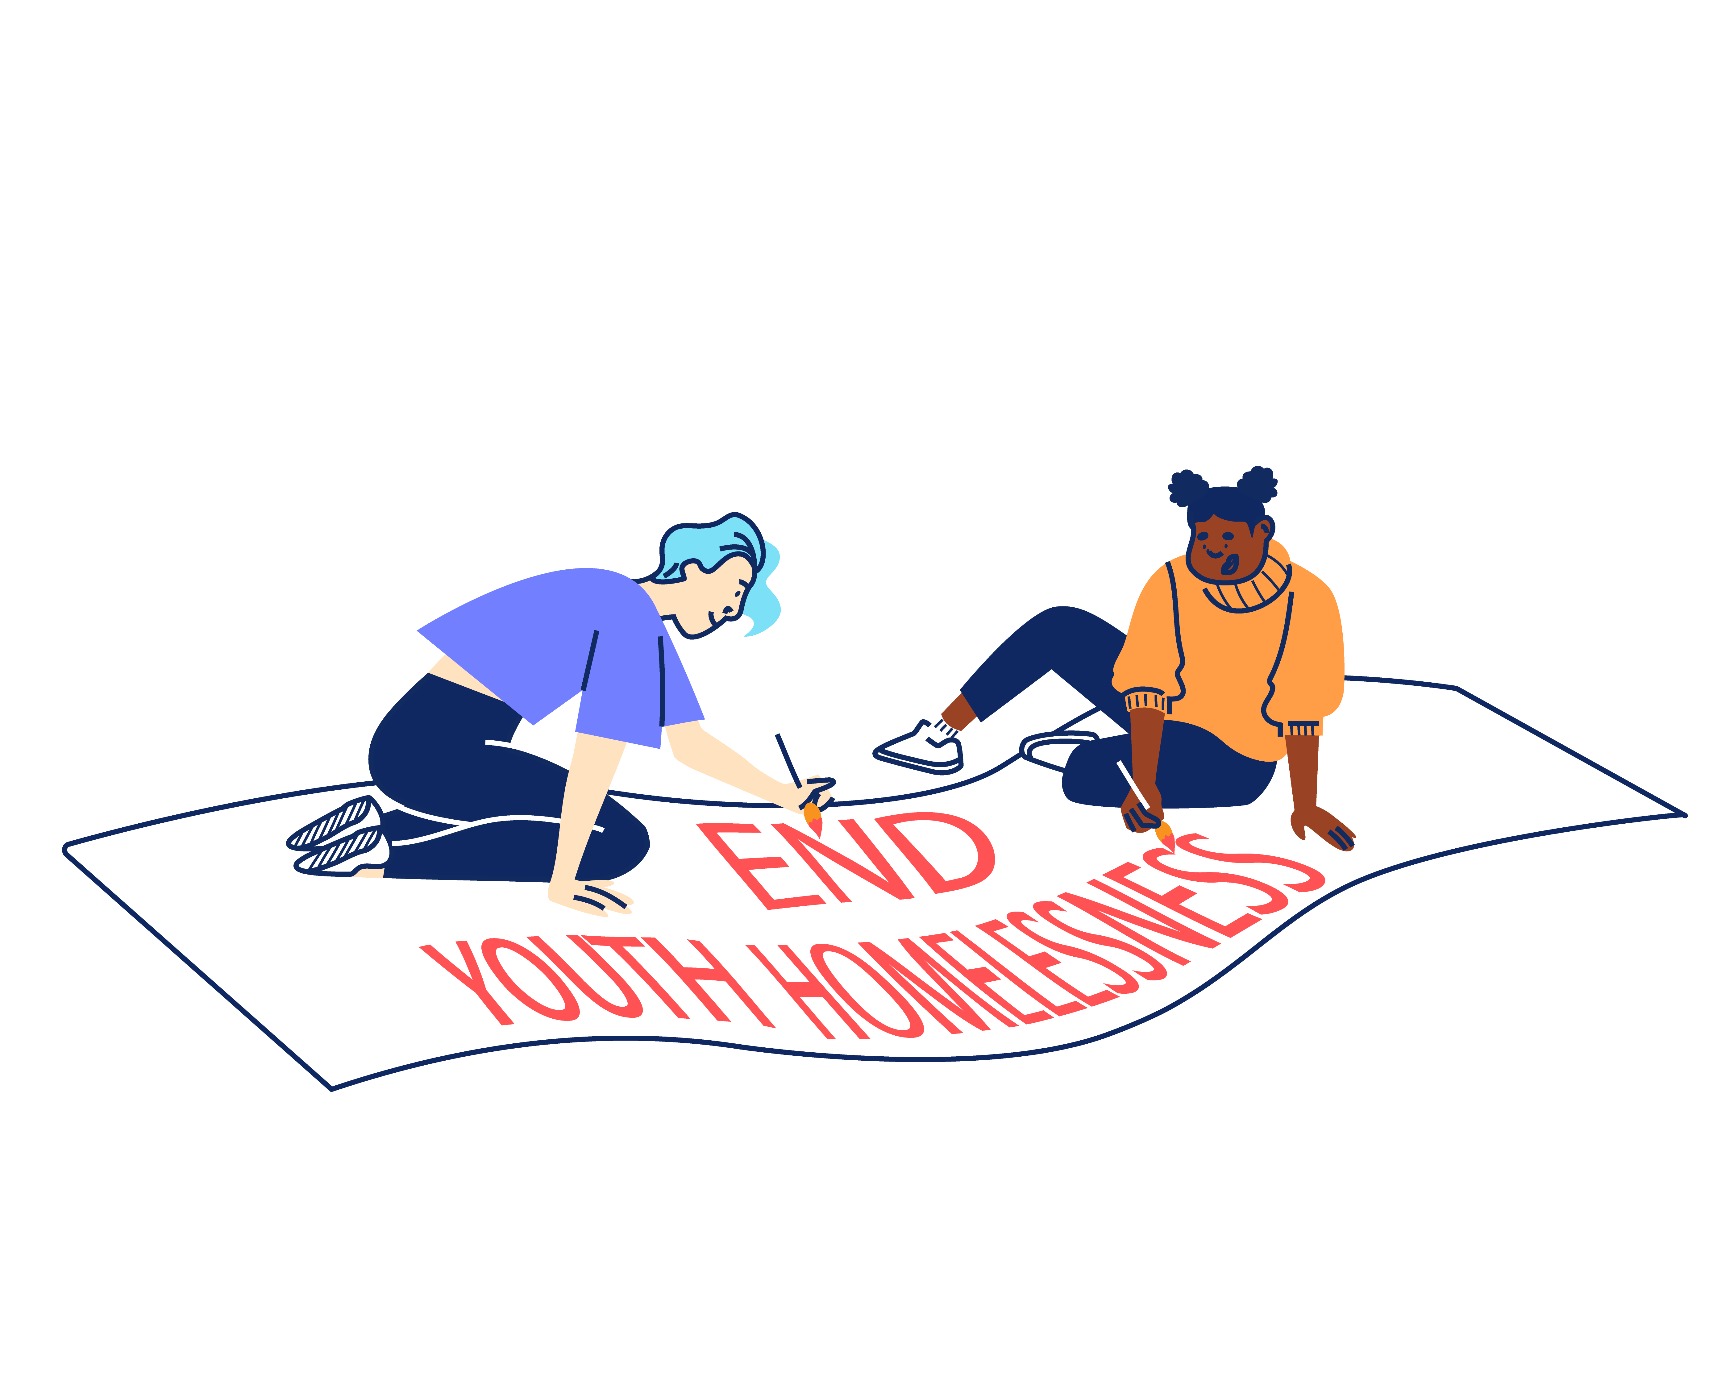

“New Horizon.
It might not be your home.
They might not be your parents.
They might not be your family.
But they want you to win in this world.”

Najma, 21
JOB DESCRIPTION – Data and Impact Manager

Reporting to: Head of Policy, Impact & Partnerships

This exciting role sits in our Campaigns, Impact & Partnerships team, who are one of NHYC’s main drivers of systems change and partnerships. Our Data and Impact Manager works dynamically across the organisation to support frontline teams in recording and sharing the impact of our work. We’re looking for someone curious, patient and with a strong eye for detail. This role oversees our data and outcomes tools, making sure we’re accurately recording and evidencing the change we create. The role holder will work across an array of digital tools to provide data and narrative about our work for our teams, funders and the wider public.
It's a great opportunity to join the team as we take on another expansion and a new range of partnerships, this role is perfect for someone looking to take a step up in project and data management, training & information sharing. They’ll also have the opportunity to lead on landmark pieces of work, experience our frontline offer and stretch themselves by informing the development of our next organisational strategy. They’ll sit within a supportive and talented team who also work across our campaigns, impact and partnerships work but will have autonomy and independence over their role and objectives.

KEY OBJECTIVES

- To develop and manage our monitoring, evaluation and learning processes, including overseeing the use of outcomes measurement tools, so that we can better demonstrate our impact internally and externally.
- To manage development of our CRM system (Salesforce) so that staff can more efficiently record casework and outcomes data.
- To coordinate evaluation, research and learning across the organisation, partnerships and contracted commissions.
- To leverage our learning and evidence to change practice and policy for young people experiencing homelessness and disadvantage in London and nationally.

MAIN TASKS AND RESPONSIBILITIES

Monitoring and impact
- Supporting the Leadership Team with planning and evidence-based decision making, service development, fundraising, commissioning research and evaluations and policy activities.

- Routinely collating and analysing data across the organisation and monitoring service performance against KPIs, for funder reports and bids.

- Interpreting and visualising key findings and ensuring these are accessible across the organisation, including sharing regular updates through our staff away days and all-staff meetings.

- Training colleagues on implementing our evaluation framework and measurement tools in their regular service delivery, and supporting teams across the organisation to ensure that data collection is of a high quality.

- Providing expertise to teams in the development and implementation of outcomes and impact measurement, report preparation, research design and methods, and project evaluation.

- Testing and updating our organisational Theory of Change, taking learnings from internal and external evaluations to better understand attribution in outcomes (‘what works’) and mechanisms for change (‘how does it work’)

- Leading the development of a more robust learning culture in the organisation.

Data management
- Overseeing ongoing development of our CRM system (Salesforce), working with external consultants to build upgrades and managing relevant financial budgets.

- Working with colleagues across services to monitor referral rates and outcomes. Ensuring assessments and demographic monitoring tools are kept up to date.

- Supporting colleagues continuously in their use of the CRM, including training new starters and leading regular, organisation-wide ‘refresher’ training on recording data effectively and using reports.

- Managing the CRM day-to-day to ensure staff can use it effectively for frontline work, and troubleshooting technical issues that arise.

Learning
- Developing and conducting evaluation and research, using quantitative and qualitative methods.

- Coordinating and commissioning project evaluations alongside other teams and working with external consultants to deliver high quality evaluation work.

- Drafting reports and other publications based on our learning and research to help share best practice, shape the debate, and improve opportunities and funding for young people.

- Organising and delivering best practice and learning events with colleagues, partners, stakeholders, and young people.

Other
- Involving young people in our impact, evaluation and learning work wherever possible and appropriate.

- Complying with GDPR legislation in relation to data collection, impact measurement and evaluation activities.

- Contributing to the daily running of our frontline services where appropriate.

PERSON SPECIFICATION

We are looking for an individual who can demonstrate the following competencies and want to use these to the full in their work. We recognize some candidates may feel they need everything listed below to apply to the role, but as long as you are willing to learn on the job, we welcome you as an applicant. As a rough guide, we’d hope you can meet 60% of the essential criteria, we don't expect anyone to be able to cover 100% of the requirements. If you’re not sure, we still recommend doing an application!

(E) – Essential
(D) - Desirable

QUALIFICATIONS, EXPERIENCE AND TRACK RECORD
- Relevant experience in previous monitoring, evaluation and impact roles. (E)

- Experience of developing and managing data processes and impact measurement frameworks. (E)

- Experience of carrying out quantitative and qualitative research, and using insights from this to inform service development, learning and policy. (E)

- Demonstrable and hands-on knowledge of a wide range of quantitative and qualitative research and evaluation methods and tools. (E)

- Experience of using and developing CRM systems and coaching colleagues in their use. (E)

- A working knowledge of and commitment to equity, diversity and inclusion. (E)

- Working knowledge of In-Form or Salesforce use and development. Salesforce Admin qualification is not essential, but there should be a willingness to learn how to build and customise the Salesforce platform (D)

- Experience of working in the voluntary, community or not-for-profit sectors (D)

- Experience of managing external evaluation consultants and contractors, including overseeing financial budgets. (D)

KNOWLEDGE AND SKILLS
- A genuine interest in our mission and the issues affecting young people. (E)

- Strong data analysis skills, including familiarity using Excel to conduct descriptive and statistical analysis (E)

- Strong communication, influencing and relationship management skills with an ability to communicate with people at all levels and build effective working relationships across all teams. (E)

- Excellent writing skills and able to produce fluent, concise and clear content and reports for colleagues, donors and funders, local and national stakeholders; excellent ability to translate complex concepts and ideas into clear, accessible communication. (E)

- Able to engage, coach and upskill colleagues, and support capacity building within an organisation. (D)

- A keen attention to detail with the ability to manage a busy workload and competing priorities under pressure. (E)

- Able to work at own initiative and as part of a team, and to work closely and proactively with internal and external stakeholders to deliver results. (E)

OTHER

- A willingness to work flexibly in response to changing organisational requirements (E)

- A willingness to work outside normal hours on occasions and support our frontline services (E)

ADDITIONAL INFORMATION

Contract
The contract is ongoing, subject to successful completion of a probationary period.

Location
The post is based at: New Horizon Youth Centre, 68 Chalton Street, London, NW1 1JR. Some travel across London will be required.

Hours of work
The role is full-time (35 hours per week), Monday-Friday. Some work over the Christmas period and occasional evenings will be required.

Pay
The starting salary for the role is £37,024.00 including London weighting.

The salary scale is: AP32 (£37,024.00) to AP36 (£41,600.00).

Other benefits:
- 30 days annual leave per year, plus bank holidays and some additional time off over Christmas
- Employer contribution of 6% to a group personal pension scheme
- Enhanced Employee Assistance Programme, including 24-hour helpline, access to counselling, contributions towards medical expenses, discounted gym memberships, high street vouchers and more
- Clinical Supervision and Reflective Practice
- Staff Loan Policy, including Cycle to Work scheme
- Generous Training budget and a Diversity Leadership Programme
- Regular Staff Away Days and teambuilding activities

TIMESCALES AND HOW TO APPLY

The timescales for recruitment are as follows:

Closing date and time for applications | 09:00 Monday 27th October
Shortlisted candidates will be informed | Friday 31st October
Interviews | 5-6th November

If you wish to apply for this position, you will need to supply:

- A CV setting out your career history, education or qualifications, and other key responsibilities or achievements (2 sides of A4). Please do not include your name, initials, contact details or references in the CV and the file name.

- A supporting statement (1500 words or up to 2 sides of A4) highlighting your suitability for the role and how you meet the criteria listed on the Person Specification. Please do not include your name, contact details or address.

The supporting statement is an essential part of your application and will be assessed for shortlisting purposes.

- Completed diversity and adjustment questions – Your data will be stored separately from your application and will at no time be connected to you or your application by the shortlisting panel.

To apply, visit our careers site: https://jobs.nhyouthcentre.org.uk

We do not consider incomplete applications.

You will be notified if you have not been shortlisted. However, we are unfortunately unable to provide each individual application with feedback.

If you have any questions or would like to arrange a call to discuss the role, please feel free to email us at recruitment@nhyouthcentre.org.uk or call 0207 388 5560.

nhyouthcentre.org.uk
@nhyouthcentre

Charity number: 276943
Company number: 01393561
Giving potential a home since 1967

