
N
N

JOB APPLICATION PACK
Services Manager (Day Centre)

July 2025

Dear applicant,

Life is not linear. Nobody knows that better than the young people who come to New Horizon Youth Centre. While the thousands of stories they tell us every year are as different as they can be, one thing unites them: their current experiences of homelessness do not define them or where they will end up. Indeed, as one of the young members of our Women’s Space told us, sometimes you have got to go through the darkness to get to the light.

During the last few years COVID, cost-of-living and housing crises have created challenges for us all, but young people have felt it particularly acutely. Youth homelessness is currently at unprecedented levels. In 2023, over 20,000 young people in London approached their council because they were, or were about to be, homeless.

To meet these rising levels of need, we are expanding our staff team, services and partnerships. By joining us, you will be part of ensuring New Horizon consistently and powerfully does what it does best: championing young people, collaborating for impact and being determined to find a way to holistically support every young person that comes through our doors.

Whilst making sure that basic needs are met and young people are safe, housed and able to focus on their future, it is also critical that we guarantee that young people, especially those experiencing homelessness who have been systemically denied a voice, are present in the creation of systems that will change and impact their lives for the better.

We are not afraid of being bold and thinking big in response to today’s challenges; it requires us to grow our staff team, our collaborations, our funding and our campaigning to end youth homelessness. Staff wellbeing is a crucial part to this journey, along with ensuring that young people are with us every step of the way.

We know that far too many young people find themselves unhoused, unsupported and unsafe. Now is the time to right this wrong and ensure that every young Londoners’ potential has a home.

We hope that you’ll join us.


Phil Kerry, Chief Executive

OUR STORY

London is a fantastic city to call home, but a central truth remains in the capital. Every year thousands of young people find themselves unhoused, unsupported and unsafe.

That's why New Horizon Youth Centre exists.

Founded in 1967 by Lord Longford to address the needs of young people who were homeless and misusing drugs in the West End of London, today New Horizon Youth Centre continues to be a vital support network for 16–24-year-olds with nowhere else to go.

Through the services we provide at our day centre, via outreach and remotely, our multidisciplinary team of over 60 staff support thousands of young people experiencing homelessness in London to find safety, improve their wellbeing, develop skills for life and ultimately find somewhere that they can call home.

“For as long as young people are homeless
and unsafe in London, we will be on a
mission to give their potential a home”

For more info about our impact, please take a look at our latest impact report.


COMMITMENT TO EQUITY, DIVERSITY & INCLUSION

New Horizon Youth Centre is committed to recognising and valuing difference and ensuring fairness and equity; and recognising and seeking to redress inequity and disadvantage wherever possible. We have an ongoing action plan to improve our Equity, Diversity and Inclusion (EDI) practices, which every member of our organisation has a role in contributing to.

As a service provider to young people facing homelessness and who are unsafe, we aim to be an empowering, supportive employer and to offer as much flexibility as possible to help each individual realise their full potential as users of New Horizon Youth Centre and as employees. We believe that this approach is key and central to promoting and developing diversity.

We recognise that true diversity in our community and within the staff group also involves a willingness to act, where necessary, by combating the effects of existing barriers to fair and equal treatment. Within society certain groups are unfairly discriminated against – for example on the grounds of race, gender or gender identity, disability, sexuality, age and class - and are, as a result, disadvantaged in terms of their access to services and employment. We will, where appropriate and where possible, seek to positively redress the effects of this discrimination. Any action we take will be legally compliant and consistent with our approach of making young people and staff feel valued and respected.

We recognise that many people have suffered disadvantage and barriers to progress for all kinds of reasons related to them as an individual and not because of their personal characteristics such as homelessness, employment, economic or domestic circumstances, or involvement with the justice system. For this reason, our commitment to diversity includes being supportive, positive and open minded.

We encourage applications from all backgrounds in respect of ethnicity, disability, gender, sexuality, religion, and socio-economic backgrounds.

New Horizon Youth Centre is deeply committed to inclusive working practices, so during the application process we commit to:
- Reimbursing any childcare and other care costs whilst you are attending interviews.
- Reimbursing your travel costs to the office and back for interviews.
- Making any reasonable adjustments – for example ensuring we have a sign language interpreter organised in advance if you would like them.
- Offering a guaranteed first stage interview for disabled candidates who meet the minimum requirements for the role.

If there is anything else you are concerned about or think we could provide, please let us know.
OUR WORK IS GUIDED BY THREE VALUES:

We champion young people

We collaborate for impact

We are determined to find a way
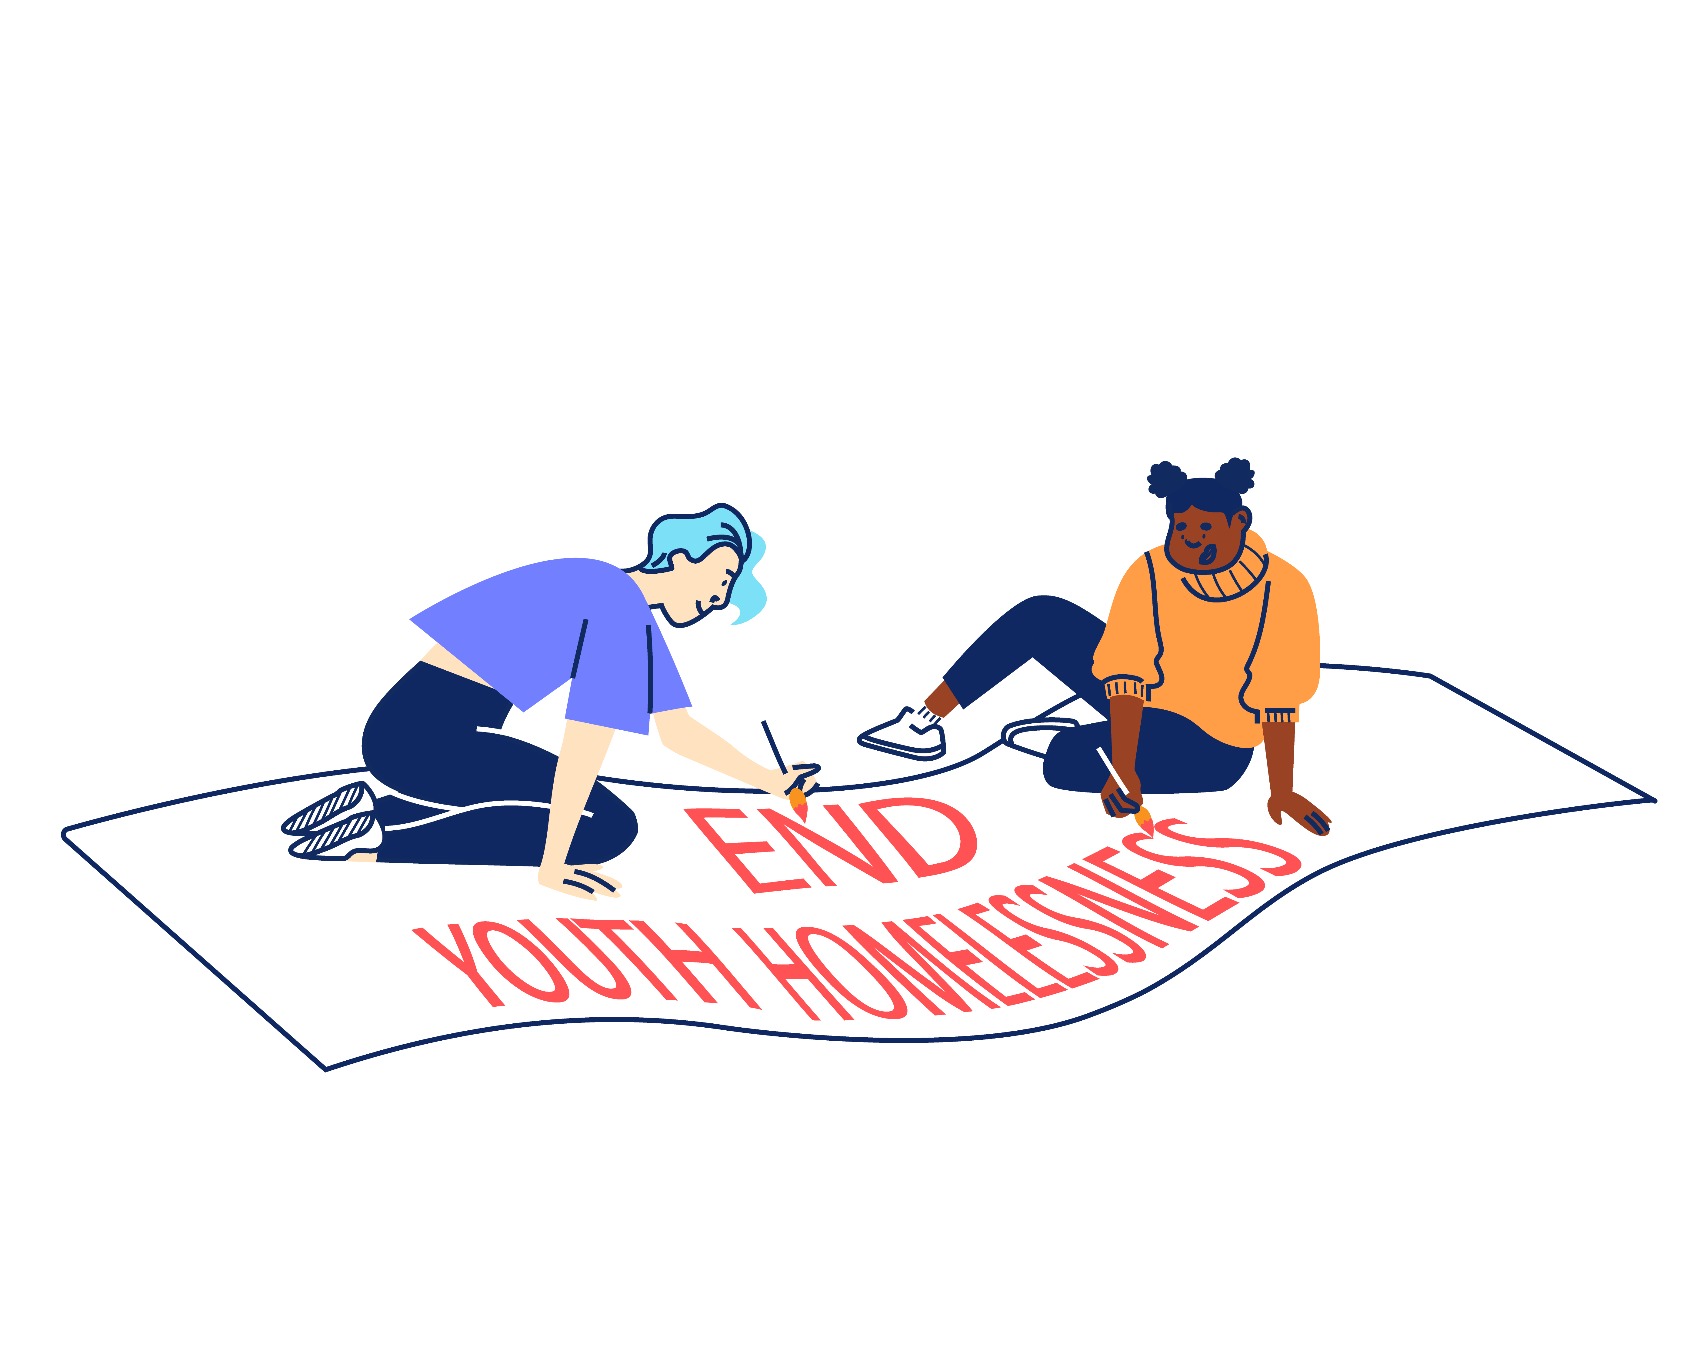


STRATEGIC OBJECTIVES:

Through 2022 – 2025 New Horizon Youth Centre will focus on:

- Delivering high quality, trauma-informed services for any young person that needs our support
- Refocusing our services around four key outcomes areas (Housing, Safety,
Life-skills, and Health) to help us specialise further and grow our impact.
- Redefining the welcomes into our services so that we can build trust and
ensure young people get the support they want and move on.
- Creating a brand-new health offer and optimising the scale of our housing offer
to address these continued areas of significant need.

2. Working with and through others to optimise our offer and maximise our impact.
- Continuing to invest in the London Youth Gateway youth homelessness partnership, scaling its reach and finding more ways to collaborate.
- Revitalising our centre as a hub that provides both drop-in and specialist services via our team and a network of committed partners that share our values.
- More deliberately sharing best practice with partners and statutory agencies
so that more professionals are equipped with the skills and knowledge to help.

3. Saying what others won’t say and do what other won’t do to ensure that no single young person misses out, even the young people we will never meet.
- Prioritising services where needs exist without solutions, working with others
to innovate and bring these issues to public attention.
- Redoubling our policy work and building our evidence to put ‘grit in the system’ and ensure that the issues affecting young people are understood and acted upon.
- Working with young people to reframe the narrative around youth homelessness, ensuring that they have the right platform to campaign for change.

And importantly will continue to focus on:

4. Sustaining a well-run organisation that invests in staff and celebrates the diversity that makes us a success
- Making good on our commitment to be anti-racist, embedding diversity across
our work and practice.
- Renewing our staff care and investing in our technology and facilities so
that the team have the practical and emotional support they need to thrive.
- Setting ambitious goals for our fundraising so that we have the resources
and financial security to be ruthless in the pursuit of our mission.


“New Horizon.
It might not be your home.
They might not be your parents.
They might not be your family.
But they want you to win in this world.”

Najma, 21
JOB DESCRIPTION – SERVICES MANAGER (DAY CENTRE)

Reporting to: Head of Services – Youth Work

INTRODUCTION

New Horizon Youth Centre runs a busy day centre from Monday to Friday. Open from 10.30am – 4pm every day to young people, we provide basic needs to young people experiencing homelessness, such as breakfast and lunch, clothes, toiletries, showers, laundry facilities and Wi-Fi.

The Services Manager (Day Centre) is part of the NHYC Youth Work Team. The Youth Work Team deliver our day centre service as well as planning and delivering a range of Youth Work opportunities for young people experiencing or at risk of homelessness.

This role is primarily focused on delivering our frontline daycentre service each week. You will spend around 2-3 days per week as our Duty Manager in the day centre. You’ll also be responsible for coordinating our staffing rota, line management of the team, overseeing our Locums, Students and Volunteers programme, supporting with donations and day centre stock, delivering regular staff training, and ensuring the day-to-day running of the service. You will also have direct oversight of our Chef and daily lunch service.

JOB OBJECTIVES

The key objectives of the post are:

- To support the Head of Services in the running of the day centre, delivering a holistic, trauma-informed service to young people who are unsafe and/or facing homelessness, enabling them to move on to independence.

- To lead on the day-to-day coordination of the day centre including managing staffing, coordinating donations and health and safety.

- To work effectively and collaboratively with operational managers and wider teams across the organisation to deliver of a weekly drop-in service.

- To support the management and development of a multidisciplinary team of youth and life skills workers, volunteers, students, and locums.

MAIN TASKS AND RESPONSIBILITIES

- Staff Management

To work with the Head of Services to lead and develop a staff team that makes a full and positive contribution to the achievement of NHYC’s mission. This will include:

  - Participating in recruitment and selection of new staff, volunteers, students and locum workers.
  - Leading, managing and motivating team members including staff, volunteers, students and locum workers by means of:
- Developing and implementing planned programmes of induction
- Holding regular recorded supervisions, annual appraisals and team meetings.
- Managing the workload of the team to ensure an appropriate work-life balance
- Actively promoting a learning and development environment.

  - Dealing with problems concerning staff conduct, performance and attendance in line with policies and procedures.

- Young People’s Services

To work with the Head of Services on ensuring the provision of a high-quality life skills programme to young people accessing the day centre service. This will include:

  - Supporting the Head of Services in all aspects of the development and delivery of the service, ensuring young people receive a high-quality service from the point of registration to move-on.
  - Leading the day-to-day operational management of the day centre including:
- Providing regular duty management cover in the day centre, as well as ad hoc cover when required by the service.
- Attending morning and afternoon handover.
- Supporting frontline staff to problem solve and troubleshoot queries throughout the day.
- Ensuring appropriate staffing levels and drawing up monthly rotas.

  - Liaising with internal team, external partners and funders regarding donations and requirements for the day centre.
  - Managing daily Health and Safety issues as they arise and addressing any safeguarding issues as a priority. Liaising with Designated Safeguarding Officers.
  - Maintaining a welcoming and fully equipped day centre for young people. Liaising with the Admin team and on any building management matters.
  - Coordinating youth work and lifeskills activities in the day centre alongside other managers to meet the standards required by young people, partners and funders.
  - Continued use of feedback and showing a commitment to a service that is sensitive and responsive to young people’s needs.
  - Taking a hands-on approach to dealing with complex or difficult cases.

- Sharing Best Practice

To proactively share best practice with internal and external stakeholders to maximise the impact of the work of NHYC. This will include:

  - Developing and maintaining effective working relationships with services who might offer resources or funding relevant to young people’s needs. Formulating Service Level Agreements where appropriate.
  - Promoting and representing NHYC at relevant external forums, meetings, and events.

- Information Management

To produce and maintain accurate and useful information in a range of formats to promote effective service delivery and evaluation. This will include:

  - Recording all contacts with young people appropriately. Maintaining all relevant files and keeping recording systems.
  - Inputting and extracting information from the CRM and other accounting systems. Utilising computer software to produce correspondence and reports. Ensuring relevant project monitoring and evaluation is completed.
  - Being proactive in own day-to-day administration, including time management, paperwork, and emails.
  - Being fully and compliant with NHYC Data Protection and Safeguarding policies.

- Reviewing Personal Performance and Development Needs

To be proactive in reviewing and evaluating own performance and identifying and acting upon areas for improvement. This will include:

  - Reviewing and evaluating own performance to identify strengths and areas for development.
  - Undertaking development and training opportunities and engaging regularly in clinical supervision and reflective practice.

- Other

To contribute positively and constructively to the development of the teams, service and NHYC. This will include:

  - Willingness to undertake duties in relation to the smooth running of the day centre and life skills service, including covering for other members of the team where necessary.
  - Following NHYC’s policies, procedures, and performance expectations in all functions of the post.
  - Undertaking as required any other duties compatible with the level and nature of the post and/or reasonably required by the Head of Services, Director of Operations or CEO.

PERSON SPECIFICATION

Essential Skills, Knowledge, and Experience

Here are the essential skills and experiences which we’re looking for in a Service Manager – Day Centre.

- Experience managing or coordinating a similar frontline service, such as with a day centre, homelessness/housing provision or youth service with vulnerable client groups.

- Ability to maintain enthusiasm for a high level of contact with young people on a day-to-day basis and a genuine passion in helping young people to make positive changes in their lives.

- Experience of managing diverse behaviour in a psychologically informed manner.

- Ability to create and maintain effective external partnerships to achieve organisational aims, including effectively communicating information or presenting at external meetings and events.

- The ability to multitask, make decisions, and manage multiple priorities effectively in a pressured, fast-paced environment.

- Experience managing and implementing health and safety procedures within a service, including completing risk assessments.

- A thorough understanding of safeguarding policies including raising concerns, reporting information, and implementing procedures.

- Confidence using IT systems such as Microsoft Office and databases to support the achievement of personal and collective team goals.

- An understanding of and a commitment to Equity, Diversity and Inclusion as it applies to a supportive service and in the workplace.

- Experience working to performance indicators, including monitoring and reporting on service outputs/outcomes, client tracking, analysing performance information, and identifying corrective action.

Desirable Skills, Knowledge, and Experience

We’d love to hear from you if you also have these desirable skills and experiences, but don’t worry if you don’t. These are the extras we’d really like!

- Experience of line management , including recruitment, training and supervision of staff and management of performance issues.

- A thorough understanding of the issues, barriers, and challenges which young people experiencing homelessness might be facing, especially at the point of accessing help and support.

- Up-to date working knowledge of Local and National Government policies relating to employment, education, benefits, housing, healthcare, sexual health, and young people.

Additional Job Requirements

- Willingness and ability to work outside of normal office hours on occasion (within New Horizon’s flexible working hour’s arrangements) and over the Christmas period.

- Willingness to work flexibly in response to changing organisational requirements.

- Willingness to work from different sites including our day centre in Camden.

ADDITIONAL INFORMATION

Contract
The contract is ongoing, subject to successful completion of a probationary period.

Location
The post is based at: New Horizon Youth Centre, 68 Chalton Street, London, NW1 1JR. Some travel across London may be required.

Hours of work
The role is full-time, working a total of 35 hours per week (9:30-5:00, Monday-Friday).

Salary
The starting salary for the role is £37,024.00 (pro rata). The salary scale is: AP37 (£37,024) to AP41 (£41,600). New Horizon Youth Centre contributes up to 6% to a group personal pension scheme.

Other benefits:

- 30 days annual leave per year (pro rata), plus bank holidays and some additional time off over Christmas
- Employer contribution of 6% to a group personal pension scheme
- Enhanced Employee Assistance Programme, including 24-hour helpline, access to counselling, contributions towards medical expenses, discounted gym memberships, high street vouchers and more
- Clinical Supervision and Reflective Practice
- Staff Loan Policy, including Cycle to Work scheme
- Generous Training budget and a Diversity Leadership Programme
- Regular Staff Away Days and teambuilding activities

TIMESCALES AND HOW TO APPLY

The timescales for recruitment are as follows:

Closing date and time for applications | 9am, Thursday 24th July 2025
Shortlisted candidates will be informed | Friday 25th July 2025
Interviews | Wednesday 30th July 2025

If you wish to apply for this position, you will need to supply:

- A CV setting out your career history, education or qualifications, and other key responsibilities or achievements (2 sides of A4). Please do not include your name, initials, contact details or references in the CV and the file name.

- A supporting statement (1500 words or up to 2 sides of A4) highlighting your suitability for the role and how you meet the criteria listed on the Person Specification. Please do not include your name, contact details or address.

The supporting statement is an essential part of your application and will be assessed for shortlisting purposes.

- Completed diversity and adjustment questions – Your data will be stored separately from your application and will at no time be connected to you or your application by the shortlisting panel.

To apply, visit our careers site: https://jobs.nhyouthcentre.org.uk

We do not consider incomplete applications.

You will be notified if you have not been shortlisted. However, we are unfortunately unable to provide each individual application with feedback.

If you have any questions or would like to arrange a call to discuss the role, please feel free to email us at recruitment@nhyouthcentre.org.uk or call 0207 388 5560.

nhyouthcentre.org.uk
@nhyouthcentre

Charity number: 276943
Company number: 01393561
Giving potential a home since 1967

