
N
N

JOB APPLICATION PACK
Assessment and Resettlement Worker (RS002)

Insert month & year
Dear applicant,

Life is not linear. Nobody knows that better than the young people who come to New Horizon Youth Centre. While the thousands of stories they tell us every year are as different as they can be, one thing unites them: their current experiences of homelessness do not define them or where they will end up. Indeed, as one of the young members of our Women’s Space told us, sometimes you have got to go through the darkness to get to the light.

During the last few years COVID, cost-of-living and housing crises have created challenges for us all, but young people have felt it particularly acutely. Youth homelessness is currently at unprecedented levels. In 2023, over 20,000 young people in London approached their council because they were, or were about to be, homeless.

To meet these rising levels of need, we are expanding our staff team, services and partnerships. By joining us, you will be part of ensuring New Horizon consistently and powerfully does what it does best: championing young people, collaborating for impact and being determined to find a way to holistically support every young person that comes through our doors.

Whilst making sure that basic needs are met and young people are safe, housed and able to focus on their future, it is also critical that we guarantee that young people, especially those experiencing homelessness who have been systemically denied a voice, are present in the creation of systems that will change and impact their lives for the better.

We are not afraid of being bold and thinking big in response to today’s challenges; it requires us to grow our staff team, our collaborations, our funding and our campaigning to end youth homelessness. Staff wellbeing is a crucial part to this journey, along with ensuring that young people are with us every step of the way.

We know that far too many young people find themselves unhoused, unsupported and unsafe. Now is the time to right this wrong and ensure that every young Londoners’ potential has a home.

We hope that you’ll join us.


Phil Kerry, Chief Executive

OUR STORY

London is a fantastic city to call home, but a central truth remains in the capital. Every year thousands of young people find themselves unhoused, unsupported and unsafe.

That's why New Horizon Youth Centre exists.

Founded in 1967 by Lord Longford to address the needs of young people who were homeless and misusing drugs in the West End of London, today New Horizon Youth Centre continues to be a vital support network for 16–24-year-olds with nowhere else to go.

Through the services we provide at our day centre, via outreach and remotely, our multidisciplinary team of over 60 staff support thousands of young people experiencing homelessness in London to find safety, improve their wellbeing, develop skills for life and ultimately find somewhere that they can call home.

“For as long as young people are homeless
and unsafe in London, we will be on a
mission to give their potential a home”

For more info about our impact, please take a look at our latest impact report.


COMMITMENT TO EQUITY, DIVERSITY & INCLUSION

New Horizon Youth Centre is committed to recognising and valuing difference and ensuring fairness and equity; and recognising and seeking to redress inequity and disadvantage wherever possible. We have an ongoing action plan to improve our Equity, Diversity and Inclusion (EDI) practices, which every member of our organisation has a role in contributing to.

As a service provider to young people facing homelessness and who are unsafe, we aim to be an empowering, supportive employer and to offer as much flexibility as possible to help each individual realise their full potential as users of New Horizon Youth Centre and as employees. We believe that this approach is key and central to promoting and developing diversity.

We recognise that true diversity in our community and within the staff group also involves a willingness to act, where necessary, by combating the effects of existing barriers to fair and equal treatment. Within society certain groups are unfairly discriminated against – for example on the grounds of race, gender or gender identity, disability, sexuality, age and class - and are, as a result, disadvantaged in terms of their access to services and employment. We will, where appropriate and where possible, seek to positively redress the effects of this discrimination. Any action we take will be legally compliant and consistent with our approach of making young people and staff feel valued and respected.

We recognise that many people have suffered disadvantage and barriers to progress for all kinds of reasons related to them as an individual and not because of their personal characteristics such as homelessness, employment, economic or domestic circumstances, or involvement with the justice system. For this reason, our commitment to diversity includes being supportive, positive and open minded.

We encourage applications from all backgrounds in respect of ethnicity, disability, gender, sexuality, religion, and socio-economic backgrounds.

New Horizon Youth Centre is deeply committed to inclusive working practices, so during the application process we commit to:
- Reimbursing any childcare and other care costs whilst you are attending interviews.
- Reimbursing your travel costs to the office and back for interviews.
- Making any reasonable adjustments – for example ensuring we have a sign language interpreter organised in advance if you would like them.
- Offering a guaranteed first stage interview for disabled candidates who meet the minimum requirements for the role.

If there is anything else you are concerned about or think we could provide, please let us know.
OUR WORK IS GUIDED BY THREE VALUES:

We champion young people

We collaborate for impact

We are determined to find a way
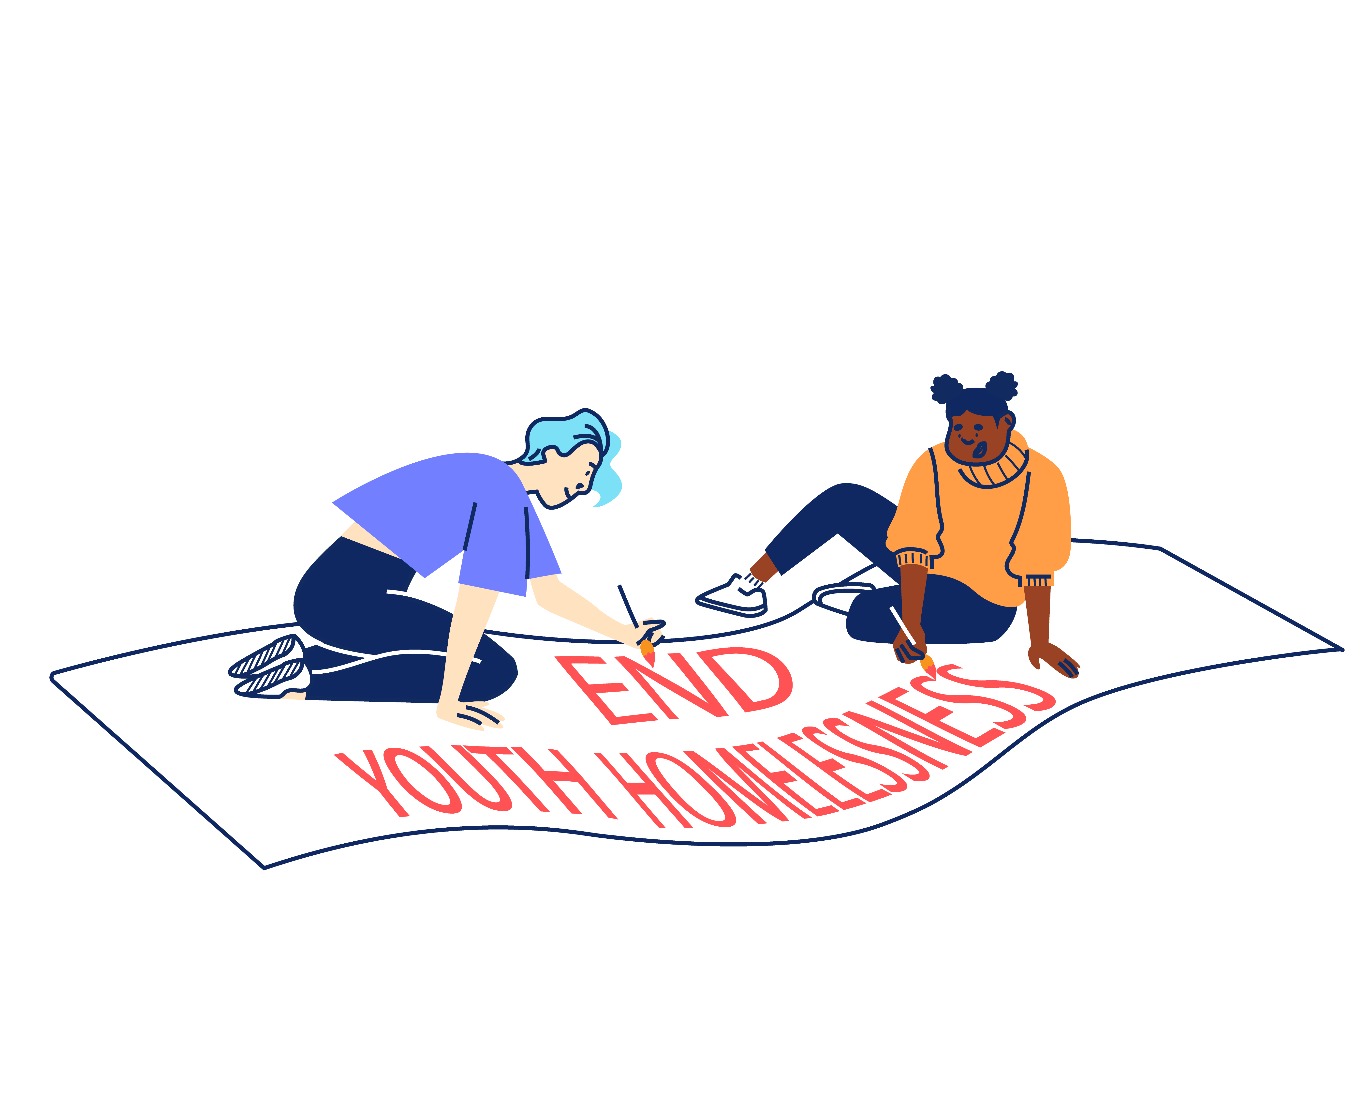


STRATEGIC OBJECTIVES:

Through 2022 – 2025 New Horizon Youth Centre will focus on:

- Delivering high quality, trauma-informed services for any young person that needs our support
- Refocusing our services around four key outcomes areas (Housing, Safety,
Life-skills, and Health) to help us specialise further and grow our impact.
- Redefining the welcomes into our services so that we can build trust and
ensure young people get the support they want and move on.
- Creating a brand-new health offer and optimising the scale of our housing offer
to address these continued areas of significant need.

2. Working with and through others to optimise our offer and maximise our impact.
- Continuing to invest in the London Youth Gateway youth homelessness partnership, scaling its reach and finding more ways to collaborate.
- Revitalising our centre as a hub that provides both drop-in and specialist services via our team and a network of committed partners that share our values.
- More deliberately sharing best practice with partners and statutory agencies
so that more professionals are equipped with the skills and knowledge to help.

3. Saying what others won’t say and do what other won’t do to ensure that no single young person misses out, even the young people we will never meet.
- Prioritising services where needs exist without solutions, working with others
to innovate and bring these issues to public attention.
- Redoubling our policy work and building our evidence to put ‘grit in the system’ and ensure that the issues affecting young people are understood and acted upon.
- Working with young people to reframe the narrative around youth homelessness, ensuring that they have the right platform to campaign for change.

And importantly will continue to focus on:

4. Sustaining a well-run organisation that invests in staff and celebrates the diversity that makes us a success
- Making good on our commitment to be anti-racist, embedding diversity across
our work and practice.
- Renewing our staff care and investing in our technology and facilities so
that the team have the practical and emotional support they need to thrive.
- Setting ambitious goals for our fundraising so that we have the resources
and financial security to be ruthless in the pursuit of our mission


“New Horizon.
It might not be your home.
They might not be your parents.
They might not be your family.
But they want you to win in this world.”

Najma, 21
JOB DESCRIPTION – ASSESSMENT AND RESETTLEMENT WORKER

Reporting to: Head of Services (Rough Sleeping) and Services Manager (Youth Hub)

This position is a one-year fixed term contract with the potential for extension based on performance and organizational needs.

The key objectives of the post are:

- To deliver an effective advice, assessment and resettlement service to young people accessing the Youth Hub emergency accommodation project, enabling young people to move on into safe and appropriate long-term housing and independence.

- To work effectively with all external partners, as well as collaborating effectively with relevant internal stakeholders.

- To increase accommodation options for young people, both through NHYC’s own projects and with external partners.

MAIN TASKS AND RESPONSIBILITIES

Advice and Move on Services

Delivering advice, accommodation and other move on services to young people with multiple needs who access the Youth Hub project. This will include:

- Working to ensure young people receive a high-quality service from the point of registration to move-on. Taking a hands-on approach to dealing with complex or difficult cases.

- Carrying out thorough needs assessments with young people accessing the Youth Hub in order to refer young people into appropriate move-on accommodation and to external specialist services.

- Providing young people with expert advice and guidance on Accommodation, Welfare Benefits, Housing Benefit and Tenancy rights, Legal Services, and Employment, Education & Training. Monitoring and evaluating young people’s progress.

- Taking a lead on managing the engagement of other relevant external partners, able to provide accommodation and other move on opportunities to young people.

- Referring young people to other internal New Horizon Youth Centre teams in order to support their progression, including Health, Youth Work and Jobs, Education and Training.

- Referring young people to a wide range of specialist external advice services including around advocacy, substance misuse, mental health, immigration, counselling, financial/debt advice, and legal services.

- Continued use of feedback and showing a commitment to a service that is sensitive and responsive to clients’ needs, involving:

- Completing registrations, needs assessments and move on plans with clients
- Ensuring risk management and assessment procedures are followed
- Providing advocacy and making referrals to appropriate services

- Attending regular briefings, team meetings, reflective practice and clinical supervision, both with NHYC and project partners. Ensuring that Health and Safety or safeguarding issues are addressed at all times.

Sharing Best Practice

To proactively share best practice with internal and external stakeholders in order to maximise the impact of the work of NHYC. This will include:

- Identifying and acting to maximise NHYC’s profile by seeking out and responding to opportunities with specialists and agencies who might offer resources, funding, or individual services relevant to client needs.

- Contributing to research and innovation projects that ensure NHYC remains a leading organisation within the sector.

- Promoting and representing NHYC at relevant forums, meetings and events.

Information Management

To produce and maintain accurate and useful information in a range of formats in order to promote effective service delivery and evaluation. This will include:

- Recording all contacts with clients appropriately and maintaining all relevant files and recording systems.

- Producing written reports in a variety of formats to meet the requirements of NHYC, external service providers and funders, e.g., project reviews and assessment reports.

- Inputting and extracting information from client monitoring systems and other accounting and database systems. Utilising other relevant software for the production of reports.

- Being self-servicing in day-to-day administration, and following team and NHYC’s administrative procedures.

Reviewing Personal Performance and Development Needs

To be proactive in reviewing and evaluating own performance and identifying and acting upon areas for improvement. This will include:

- Reviewing and evaluating own performance to identify strengths and areas for development. Identifying own learning/development needs and opportunities.

- Undertaking development and training opportunities and being responsible for obtaining maximum benefit through review, reflection and practice.

- Taking a proactive approach to supervision including regular line management supervision, team meetings, team reflective practice and clinical supervision.

Other

To contribute positively and constructively to the development of the team, the service and wider organisation. This will include:

- Covering for other members of the team as necessary, including at our main day centre in Camden.

- Following NHYC’s policies, procedures and performance expectations in all functions of the post.

- Undertaking, as required, any other duties compatible with the level and nature of the post and/or reasonably required by the Services Manager, Head of Services, Director of Operations or CEO.

PERSON SPECIFICATION

We are looking for an individual who can demonstrate the following competencies to a high level and want to use these to the full in their work.

E: Essential
D: Desirable

QUALIFICATIONS, EXPERIENCE AND TRACK RECORD

- Ability to work effectively with young people facing homelessness to identify personal goals and support mechanisms for change including for those young people with multiple complex issues. (E)

- Experience of delivering specialist housing advice services within a youth and community or other relevant sector. (E)

- Experience of managing a case list of multiple clients with complex needs and barriers. (E)

- Proven track record of progressing vulnerable people into stable accommodation outcomes. (E)

- Experience of working in partnership with both internal and external stakeholders in order to deliver specific projects or achieve organisational aims and objectives. (E)

- Experience of using IT systems (including knowledge of databases) to support the achievement of personal and collective work goals. (E)

- The ability to multitask in a pressured environment. (E)

- Experience of working in a hostel/foyer or similar residential setting. (D)

SPECIALIST KNOWLEDGE AND ROLE REQUIREMENTS

- Ability to maintain enthusiasm for a high level of contact with clients on a day-to-day basis, and a genuine interest in helping vulnerable people/young people to make changes in their life to move towards independent living. (E)

- Understanding of the kinds of challenging behaviour that clients might demonstrate and ability to deliver strategies for dealing with such behaviour. (E)

- Thorough and up-to-date working knowledge of:
- Local and National Government policies and procedures in relation to the client group. (D)
- Relevant local and national organisations and their role/responsibilities in providing support to vulnerable young people. (D)
- The benefits system and how this impacts young people. (D)
- A working knowledge of accommodation options and referral pathways relevant to the client group. (E)

- Knowledge of working to performance indicators, including monitoring and reporting on service outputs/outcomes, client tracking, analysing performance information, and identifying corrective action. (E)

- A high level of knowledge of health and safety issues in a working environment. (E)

- Experience and knowledge around safeguarding policy and procedures for children and vulnerable adults. (E)

- A working knowledge of and commitment to Equity, Diversity and Inclusion as it applies to a supportive service and in the workplace. (E)

ADDITIONAL REQUIREMENTS

- Willingness and ability to work outside of normal office hours on occasion (within New Horizon’s flexible working hour’s arrangements) and over the Christmas period. (D)

- Willingness to work flexibly in response to changing organisational requirements. (E)

- Willingness to travel to different sites in London, including our day centre in Camden. (E)

ADDITIONAL INFORMATION

Location:

The post is based at the Youth Hub in Islington. The address will be shared at interview stage. Some travel across London will be required, including to our main day centre in Camden.

Contract type and hours of work:

The role is fixed term for 12 months.

The role is full-time, working 35 hours per week, Monday to Friday (9:30-5:00). Some work over the Christmas period will also be required.

Pay:

The starting salary for the role is £31,200. The salary scale is: AP26 (£31,200) to AP30 (£34,736). New Horizon Youth Centre contributes up to 6% to a group personal pension scheme.

Other benefits:

- 30 days annual leave per year (pro rata), plus bank holidays and some additional time off over Christmas
- Employer contribution of 6% to a group personal pension scheme
- Enhanced Employee Assistance Programme, including 24-hour helpline, access to counselling, contributions towards medical expenses, discounted gym memberships, high street vouchers and more
- Clinical Supervision and Reflective Practice
- Staff Loan Policy, including Cycle to Work scheme
- Generous Training budget and a Diversity Leadership Programme
- Regular Staff Away Days and teambuilding activities

TIMESCALES AND HOW TO APPLY

The timescales for recruitment are as follows:

Closing date and time for applications | 9am, Monday 7th April 2025
Shortlisted candidates will be informed | Thursday 10th April
Interviews | w/c 14th April

If you wish to apply for this position, you will need to supply:

- A detailed CV setting out your career history, education or qualifications, and other key responsibilities or achievements. Please do not include your name, initials, contact details or references in the CV and the file name.

- A cover letter (supporting statement) (1500 words or up to 2 sides of A4) highlighting your suitability for the role and how you meet the criteria listed on the Person Specification. Please do not include your name, contact details or address.

The supporting statement is an important part of your application and will be assessed as part of your full application.

- Completed diversity and adjustment questions – Your data will be stored separately from your application and will at no time be connected to you or your application by the shortlisting panel.

To apply, visit our careers site: https://jobs.nhyouthcentre.org.uk

We do not consider incomplete applications.

You will be notified if you have not been shortlisted. However, we are unfortunately unable to provide each individual application with feedback.

If you have any questions or would like to arrange a call to discuss the role, please feel free to email us at recruitment@nhyouthcentre.org.uk or call 0207 388 5560.

nhyouthcentre.org.uk
@nhyouthcentre

Charity number: 276943
Company number: 01393561
Giving potential a home since 1967

