
N
N

JOB APPLICATION PACK
Caseworker (YJ005)
12-month, fixed-term contract

October 2024
Dear applicant,

Life is not linear. Nobody knows that better than the young people who come to New Horizon Youth Centre. While the thousands of stories they tell us every year are as different as they can be, one thing unites them: their current experiences of homelessness do not define them or where they will end up. Indeed, as one of the young members of our Women’s Space told us, sometimes you have got to go through the darkness to get to the light.

During the last few years COVID, cost-of-living and housing crises have created challenges for us all, but young people have felt it particularly acutely. Youth homelessness is currently at unprecedented levels. In 2023, over 20,000 young people in London approached their council because they were, or were about to be, homeless.

To meet these rising levels of need, we are expanding our staff team, services and partnerships. By joining us, you will be part of ensuring New Horizon consistently and powerfully does what it does best: championing young people, collaborating for impact and being determined to find a way to holistically support every young person that comes through our doors.

Whilst making sure that basic needs are met and young people are safe, housed and able to focus on their future, it is also critical that we guarantee that young people, especially those experiencing homelessness who have been systemically denied a voice, are present in the creation of systems that will change and impact their lives for the better.

We are not afraid of being bold and thinking big in response to today’s challenges; it requires us to grow our staff team, our collaborations, our funding and our campaigning to end youth homelessness. Staff wellbeing is a crucial part to this journey, along with ensuring that young people are with us every step of the way.

We know that far too many young people find themselves unhoused, unsupported and unsafe. Now is the time to right this wrong and ensure that every young Londoners’ potential has a home.

We hope that you’ll join us.


Phil Kerry, Chief Executive

OUR STORY

London is a fantastic city to call home, but a central truth remains in the capital. Every year thousands of young people find themselves unhoused, unsupported and unsafe.

That's why New Horizon Youth Centre exists.

Founded in 1967 by Lord Longford to address the needs of young people who were homeless and misusing drugs in the West End of London, today New Horizon Youth Centre continues to be a vital support network for 16–24-year-olds with nowhere else to go.

Through the services we provide at our day centre, via outreach and remotely, our multidisciplinary team of over 60 staff support thousands of young people experiencing homelessness in London to find safety, improve their wellbeing, develop skills for life and ultimately find somewhere that they can call home.

“For as long as young people are homeless
and unsafe in London, we will be on a
mission to give their potential a home”

For more info about our impact, please take a look at our latest impact report.


COMMITMENT TO EQUITY, DIVERSITY & INCLUSION

New Horizon Youth Centre is committed to recognising and valuing difference and ensuring fairness and equity; and recognising and seeking to redress inequity and disadvantage wherever possible. We have an ongoing action plan to improve our Equity, Diversity and Inclusion (EDI) practices, which every member of our organisation has a role in contributing to.

As a service provider to young people facing homelessness and who are unsafe, we aim to be an empowering, supportive employer and to offer as much flexibility as possible to help each individual realise their full potential as users of New Horizon Youth Centre and as employees. We believe that this approach is key and central to promoting and developing diversity.

We recognise that true diversity in our community and within the staff group also involves a willingness to act, where necessary, by combating the effects of existing barriers to fair and equal treatment. Within society certain groups are unfairly discriminated against – for example on the grounds of race, gender or gender identity, disability, sexuality, age and class - and are, as a result, disadvantaged in terms of their access to services and employment. We will, where appropriate and where possible, seek to positively redress the effects of this discrimination. Any action we take will be legally compliant and consistent with our approach of making young people and staff feel valued and respected.

We recognise that many people have suffered disadvantage and barriers to progress for all kinds of reasons related to them as an individual and not because of their personal characteristics such as homelessness, employment, economic or domestic circumstances, or involvement with the justice system. For this reason, our commitment to diversity includes being supportive, positive and open minded.

We encourage applications from all backgrounds in respect of ethnicity, disability, gender, sexuality, religion, and socio-economic backgrounds.

New Horizon Youth Centre is deeply committed to inclusive working practices, so during the application process we commit to:
- Reimbursing any childcare and other care costs whilst you are attending interviews.
- Reimbursing your travel costs to the office and back for interviews.
- Making any reasonable adjustments – for example ensuring we have a sign language interpreter organised in advance if you would like them.
- Offering a guaranteed first stage interview for disabled candidates who meet the minimum requirements for the role.

If there is anything else you are concerned about or think we could provide, please let us know.
OUR WORK IS GUIDED BY THREE VALUES:

We champion young people

We collaborate for impact

We are determined to find a way
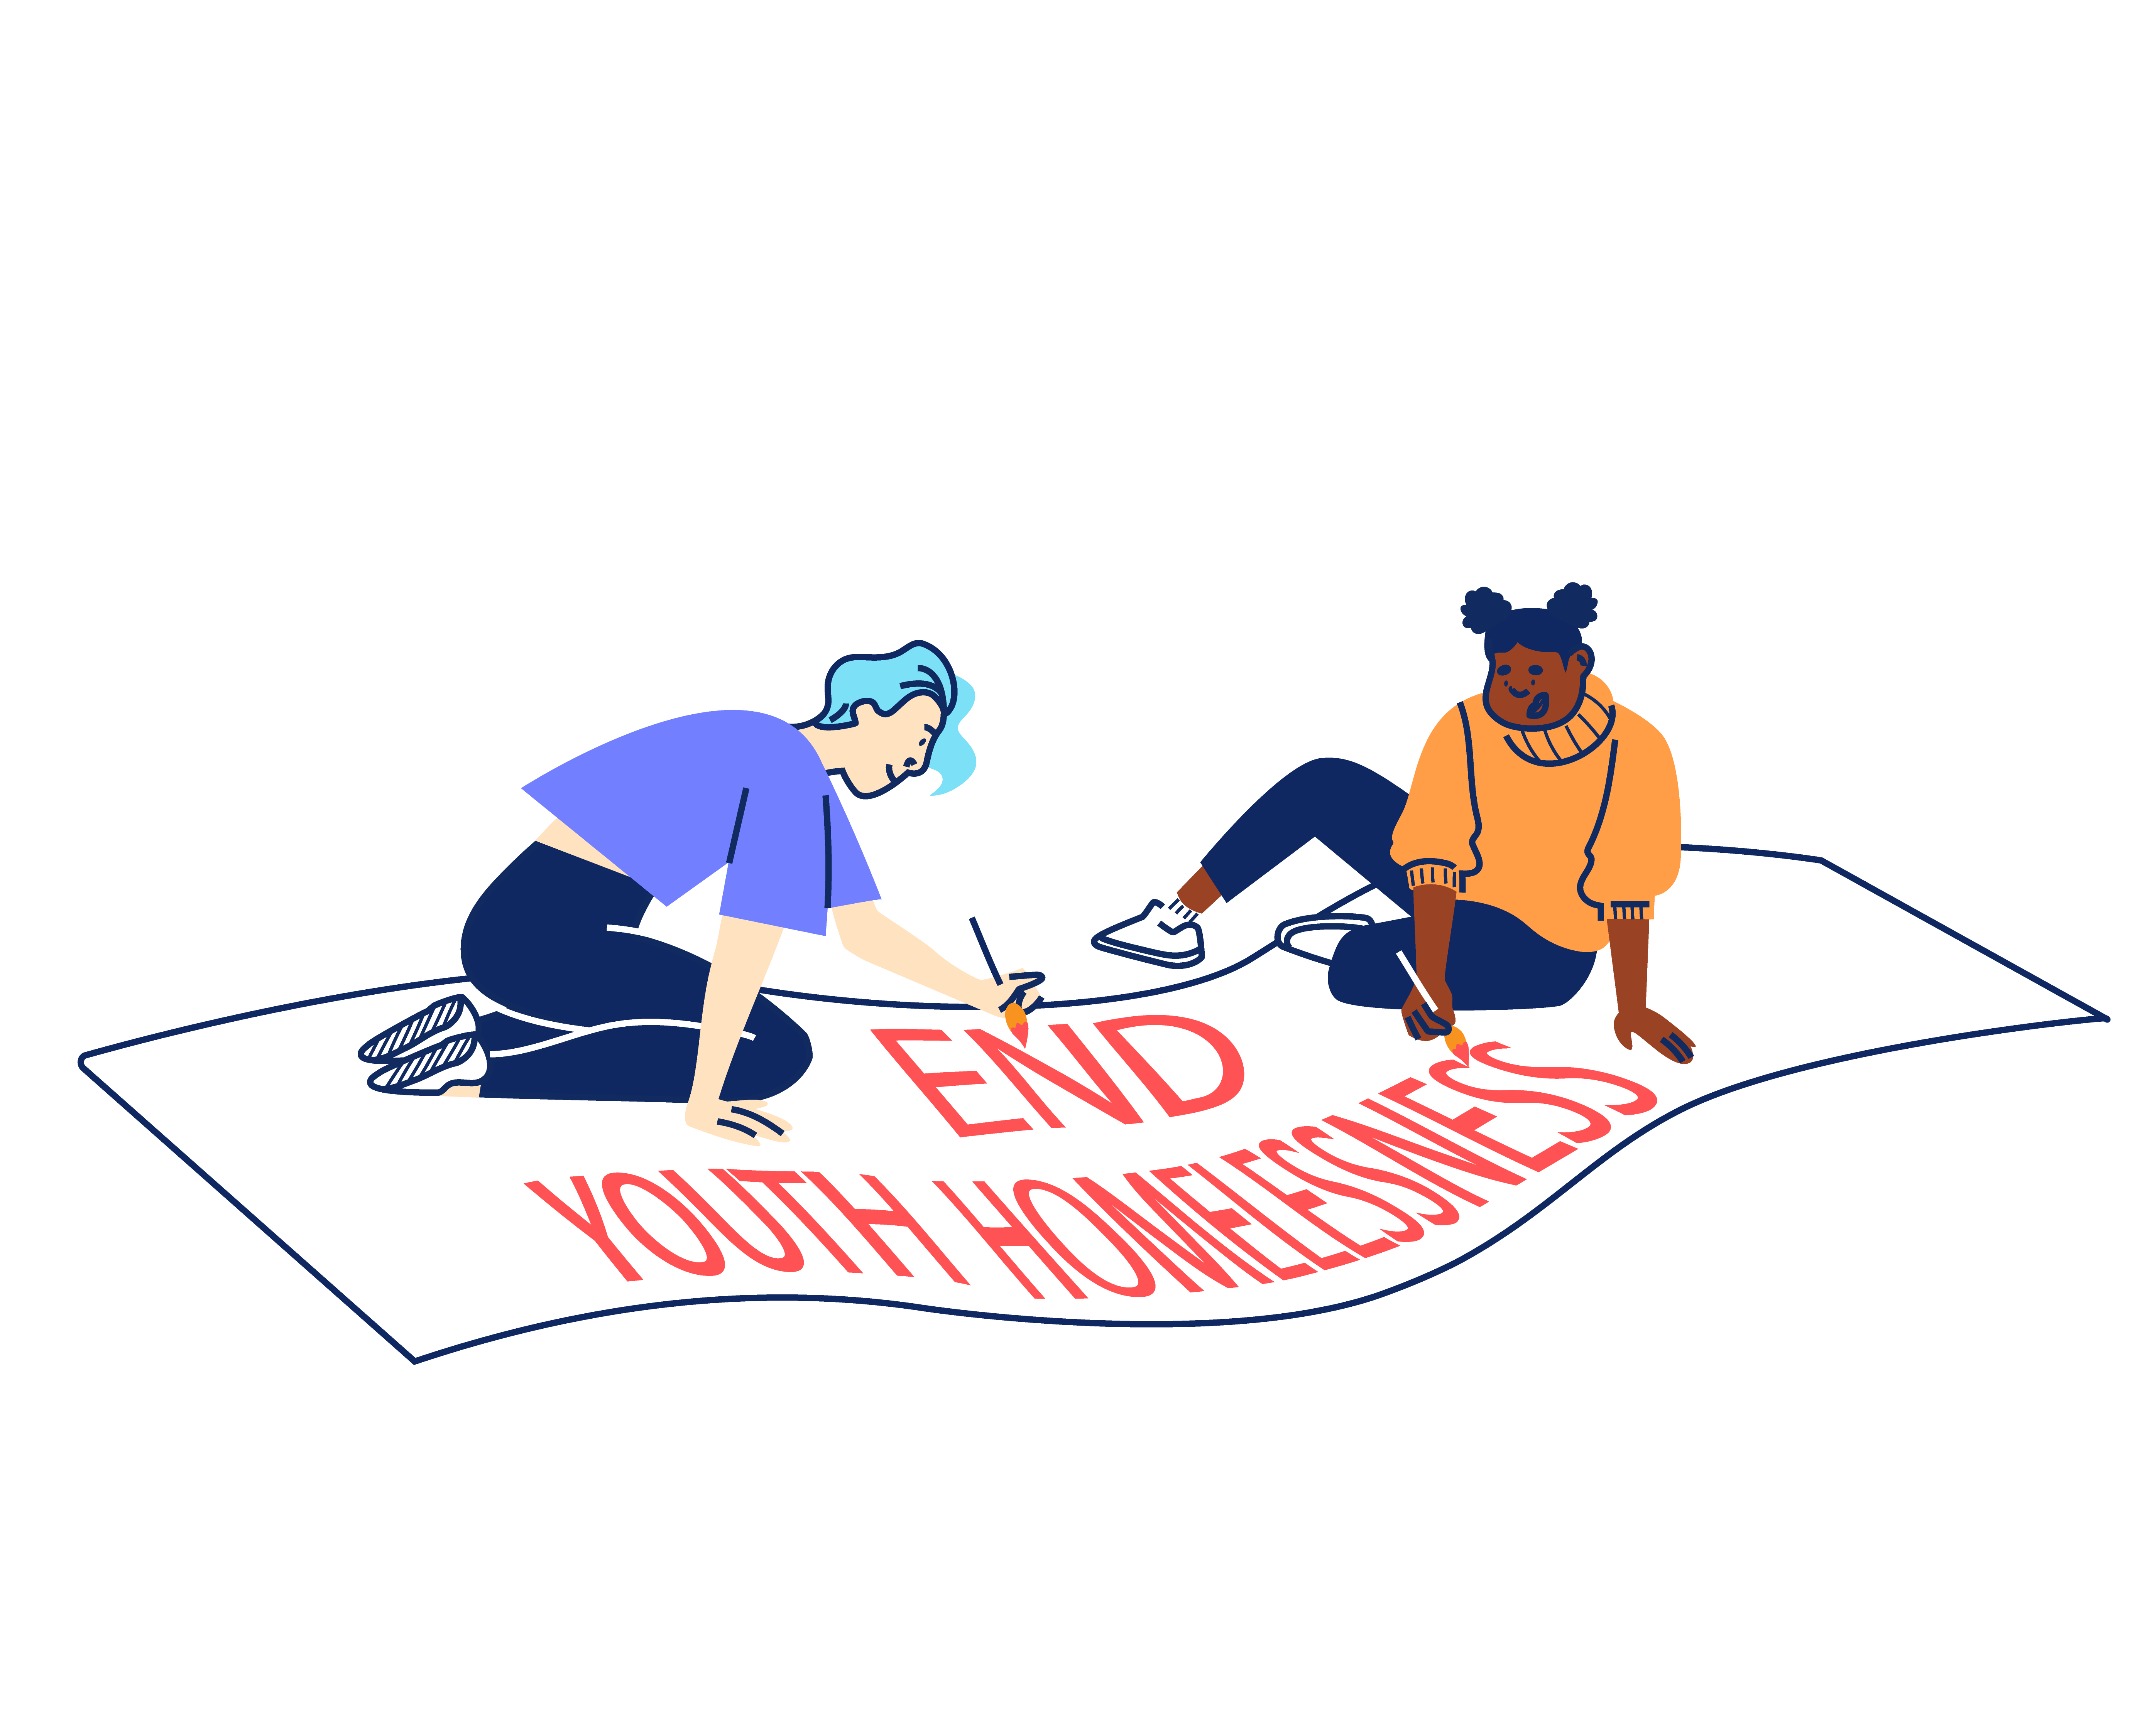


STRATEGIC OBJECTIVES:

Through 2022 – 2025 New Horizon Youth Centre will focus on:

- Delivering high quality, trauma-informed services for any young person that needs our support
- Refocusing our services around four key outcomes areas (Housing, Safety,
Life-skills, and Health) to help us specialise further and grow our impact.
- Redefining the welcomes into our services so that we can build trust and
ensure young people get the support they want and move on.
- Creating a brand-new health offer and optimising the scale of our housing offer
to address these continued areas of significant need.

2. Working with and through others to optimise our offer and maximise our impact.
- Continuing to invest in the London Youth Gateway youth homelessness partnership, scaling its reach and finding more ways to collaborate.
- Revitalising our centre as a hub that provides both drop-in and specialist services via our team and a network of committed partners that share our values.
- More deliberately sharing best practice with partners and statutory agencies
so that more professionals are equipped with the skills and knowledge to help.

3. Saying what others won’t say and do what other won’t do to ensure that no single young person misses out, even the young people we will never meet.
- Prioritising services where needs exist without solutions, working with others
to innovate and bring these issues to public attention.
- Redoubling our policy work and building our evidence to put ‘grit in the system’ and ensure that the issues affecting young people are understood and acted upon.
- Working with young people to reframe the narrative around youth homelessness, ensuring that they have the right platform to campaign for change.

And importantly will continue to focus on:

4. Sustaining a well-run organisation that invests in staff and celebrates the diversity that makes us a success
- Making good on our commitment to be anti-racist, embedding diversity across
our work and practice.
- Renewing our staff care and investing in our technology and facilities so
that the team have the practical and emotional support they need to thrive.
- Setting ambitious goals for our fundraising so that we have the resources
and financial security to be ruthless in the pursuit of our mission.


“New Horizon.
It might not be your home.
They might not be your parents.
They might not be your family.
But they want you to win in this world.”

Najma, 21
JOB DESCRIPTION – Caseworker

Reporting to: Head of Services and Services Manager (Youth Justice)

MAIN TASKS AND RESPONSIBILITIES

Young people’s services
Developing and delivering a holistic service to young people involved with the criminal justice system or impacted by violence.

- Working within the Youth Justice team to ensure young people receive a high-quality service from the point of initial contact to move-on.

- Holding and managing a caseload of young people and helping individuals achieve their goals as well as working with them to live a life away from the criminal justice system.

- Working towards enabling young people to move-on into safe and suitable accommodation.

- Referring young people to the Jobs, Education and Training team to support progression into appropriate opportunities.

- Working with colleagues at NHYC and external partners to enable young people to develop skills for independent living as well as enabling young people to develop coping mechanisms to enable a change of lifestyle.

- Establishing, developing, and delivering innovative programmes of activities that responds to clients’ changing needs, to keep them safe, and enable them to move on independently – including work around housing,

- Providing expert coaching and guidance to clients and monitoring and evaluating their progress as well as providing key working sessions.

- Continued use of feedback and showing a commitment to a service that is sensitive and responsive to clients’ needs, involving completing Initial Contacts Forms, needs assessments, risk assessments and action plans with clients.

- Contributing to the management and development of the service, including attending daily briefings and ensuring that Health and Safety issues are addressed at all times, attending reflective practice and team meetings.

- Taking a hands-on approach to dealing with complex or difficult situations young people face

Sharing best practice

To proactively share best practice with internal and external stakeholders in order to maximise the impact of the work of NHYC. This will include:

- Seeking out and responding to opportunities with specialists and agencies who might offer resources, funding, or individual services relevant to client needs e.g., Local Authorities, Social Services, the DWP, health services, and other voluntary sector agencies.

- Contributing to research and innovation projects that ensure NHYC remains a leading organisation within the sector.

- Promoting and representing NHYC at relevant forums and meetings.

Information Management

To produce and maintain accurate and useful information in a range of formats in order to promote effective service delivery and evaluation. This will include:

- Recording all contacts with clients appropriately and maintaining all relevant files and recording systems up to date.

- Producing written reports in a variety of formats to meet the requirements of New Horizon, external service providers and funders, e.g., project reviews and assessment reports.

- Inputting and extracting information from client monitoring systems other accounting and database systems. Utilising other relevant software for the production of correspondence and reports.

- Being self-servicing in day-to-day administration and following team and NHYC’s administrative procedures.

Reviewing Personal Performance and Development Needs

To be proactive in reviewing and evaluating own performance and identifying and acting upon areas for improvement. This will include:

- Continuously reviewing own working practices in line with client feedback and current best practice.

- Reviewing and evaluating own performance to identify strengths and areas for development. Identifying own learning and development needs and opportunities.

- Undertaking development and training opportunities and being responsible for obtaining maximum benefit through review, reflection, and practice.

Other

To contribute positively and constructively to the development of the teams, service and NHYC. This will include:

- Covering for other members of the team, as necessary.

- Following and implementing New Horizon’s policies, procedures, and performance expectations in all functions of the post.

- Undertaking, as required, any other duties compatible with the level and nature of the post and/or reasonably required by the line manager, Head of Services, Director of Operations or CEO.

PERSON SPECIFICATION

We are looking for an individual who can demonstrate the following competencies and want to use these to the full in their work.

QUALIFICATIONS, EXPERIENCE AND TRACK RECORD

- Ability to work effectively with young people with experience of the criminal justice system to identify personal goals and support mechanisms for change. (E)

- Experience enabling young people to access housing, education, training, and employment outcomes. (E)

- Experience of planning and delivering work with young people on both a 1:1 and group basis, which meet the diverse and varied needs of these young people. (E)

- Experience of working with young people who have experienced violence, trauma and/or involvement in the criminal justice system in a casework setting. (E)

- Ability to create and maintain external partnerships to support organisational aims and objectives including representation of the organisation at external meetings and events. (E)

- Experience of using IT systems (including knowledge of databases) to support the achievement of personal and collective work goals. (E)

- The ability to multitask in a pressured environment. (E)

- Existing relationships with relevant partners, particularly housing providers, probation services, youth justice services, custodial establishments, and other supporting services (D)

KNOWLEDGE AND SKILLS

- Ability to hold and manage a case load of clients, from assessment and engagement through to maintenance of the relationship, initiating regular contact and building a positive attachment with these young people. (E)

- Understanding of the kinds of challenging behaviour that clients might demonstrate and the ability to be resilient to working in crisis situations, delivering strategies for dealing with such behaviour and working within set boundaries that enable the client to move on with their lives. (E)

- Thorough and up-to-date working knowledge of:
- Local and National Government policies and housing legislation with particular attention to the criminal justice cohort (D)
- Relevant organisations and their role/responsibilities in providing support to young people (D)

- Knowledge of working to performance indicators, including monitoring and reporting on service outputs/outcomes, client tracking, analysing performance information, and identifying corrective action. (E)

- A high level of knowledge of health and safety issues in a working environment with particular attention to the criminal justice cohort. (E)

- Experience and knowledge around safeguarding policy and procedures for children and young adults. (E)

- A working knowledge of and commitment to Equity, Diversity and Inclusion as it applies to a supportive service and in the workplace. (E)

- The confidence to work independently in the community and across various secure and prison settings. (E)

- An understanding of trauma informed practice in the youth and adult justice sector and the challenges for young people impacted by serious youth violence. (E)

ADDITIONAL REQUIREMENTS

- Willingness and ability to work outside of normal office hours on occasion (within New Horizon’s flexible working hour’s arrangements) and over the Christmas period. (E)

- Willingness to work flexibly in response to changing organisational requirements. (E)

- Willingness to work from different sites including our day centre in Camden and some flexible homeworking. (E)
ADDITIONAL INFORMATION

Contract:

The contract is fixed-term for 12 months subject to successful completion of a probation period.

Location:

The post is based at: New Horizon Youth Centre, 68 Chalton Street, London, NW1 1JR. Regular travel across London will be required.

Hours of work:

The role is full-time (35 hours per week), Monday-Friday. Some work over the Christmas period will also be required.

Pay:

The starting salary for the role is £31,200 (pro rata). The salary scale is: AP26 (£31,200) to AP30 (£34,736). New Horizon Youth Centre contributes up to 6% to a group personal pension scheme.

Other benefits:

- 30 days annual leave per year (pro rata), plus bank holidays and some additional time off over Christmas
- Employer contribution of 6% to a group personal pension scheme
- Enhanced Employee Assistance Programme, including 24-hour helpline, access to counselling, contributions towards medical expenses, discounted gym memberships, high street vouchers and more
- Clinical Supervision and Reflective Practice
- Staff Loan Policy, including Cycle to Work scheme
- Generous Training budget and a Diversity Leadership Programme
- Regular Staff Away Days and teambuilding activities

TIMESCALES AND HOW TO APPLY

The timescales for recruitment are as follows:

Closing date and time for applications | 9am, Thursday 24th October 2024
Shortlisted candidates will be informed | 30th October 2024
Interviews | Tuesday 5th November 2024

How to apply

When you are ready to apply for this role, please complete our application form online via our Jobs Website - https://jobs.nhyouthcentre.org.uk/

  - Please complete the diversity and adjustment questions.

  - Upload your CV. This must not include your name in the document or in the file name, or any contact details or references. This must be no more than 2 pages.

  - Submit your supporting statement into the box marked 'cover letter'. This must be no more than 2 A4 pages, or 1500 words, and must not contain your name, address or contact details. We recommend drafting it in a different document and copying and pasting when you are ready to submit.

Your Supporting Statement should cover all the Essential Criteria in the Job Description.

We do not consider incomplete applications.

You will be notified if you have not been shortlisted. However, we are unfortunately unable to provide each individual application with feedback.

If you have any questions or would like to arrange a call to discuss the role, please feel free to email us at recruitment@nhyouthcentre.org.uk or call 0207 388 5560.

nhyouthcentre.org.uk
@nhyouthcentre

Charity number: 276943
Company number: 01393561
Giving potential a home since 1967

